**DEPLOYING A STATIC “Hello World” WEB APP ON AZURE**

This use case walks through the deployment of a simple "Hello World" web app using HTML and CSS, containerized with Docker, and deployed via Azure Kubernetes Service (AKS), with CI/CD pipelines managed through Azure DevOps.

First, log in to the Azure portal and verify that the correct subscription is selected:

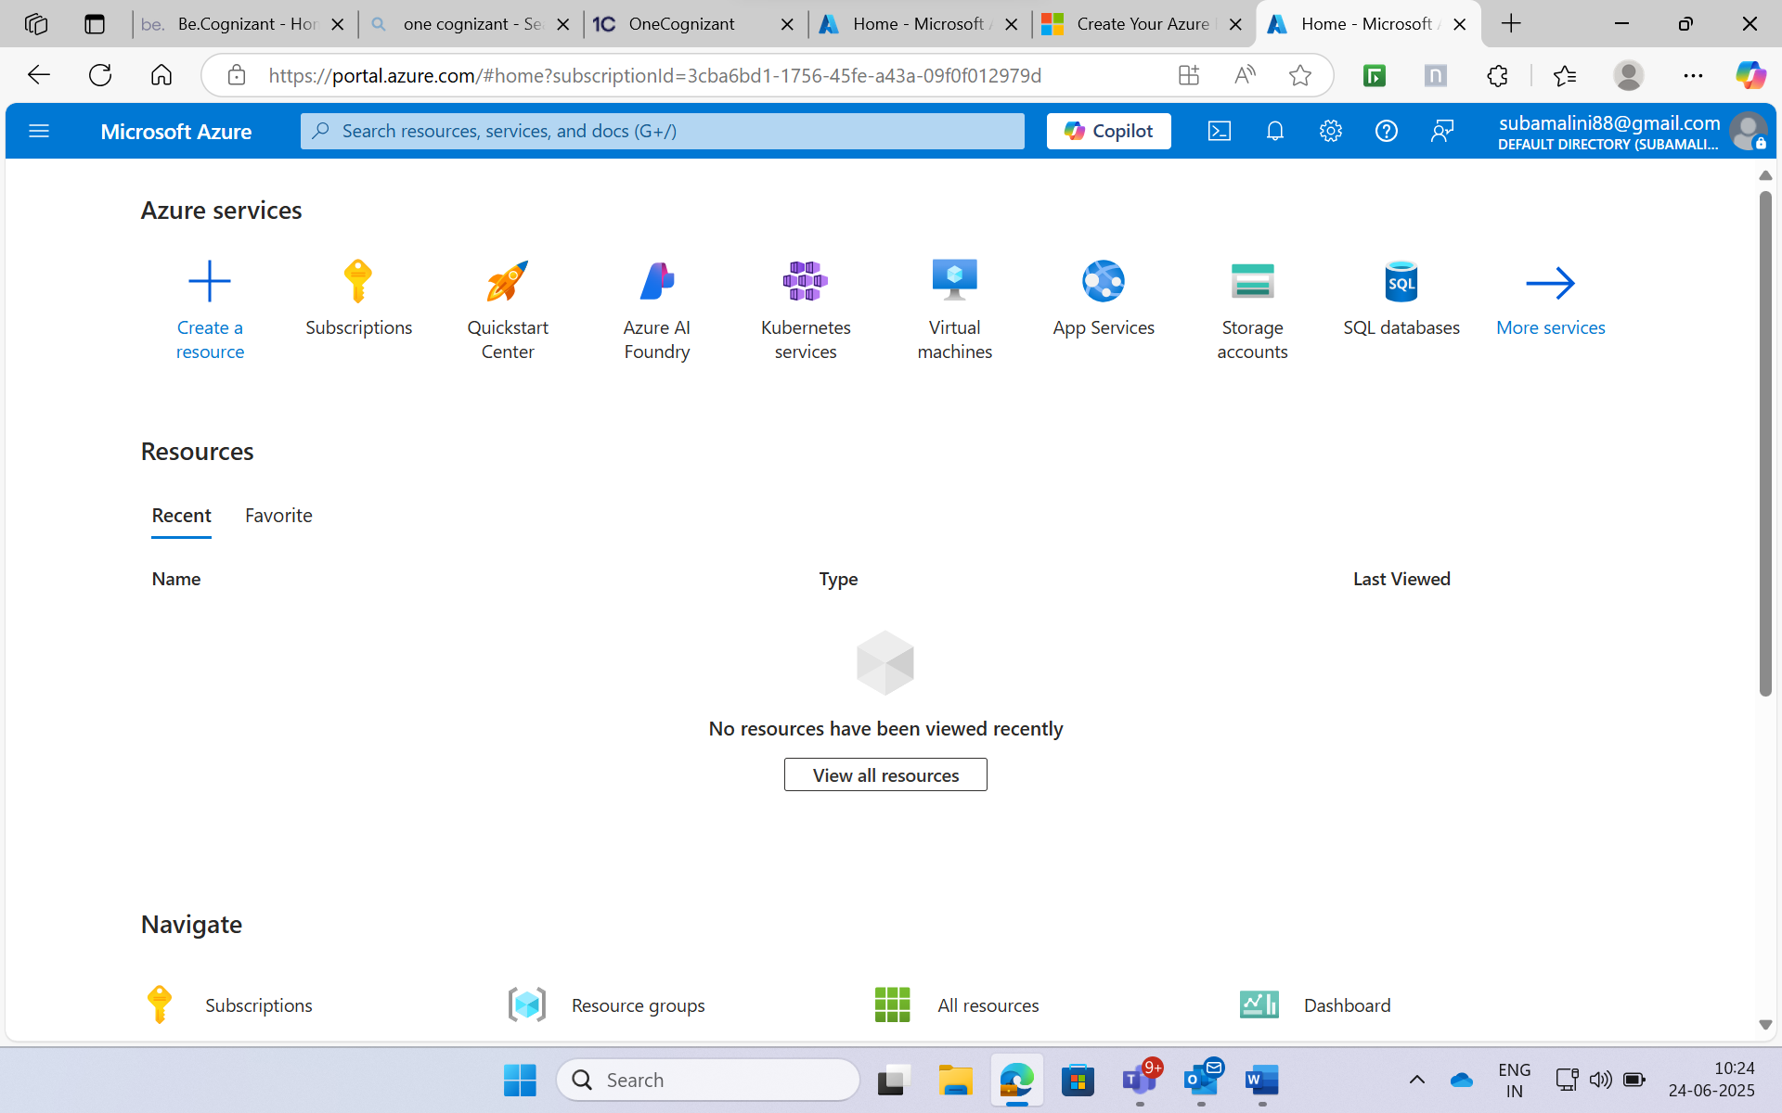

Then, switch to the Bash shell in the Azure Cloud Shell environment:

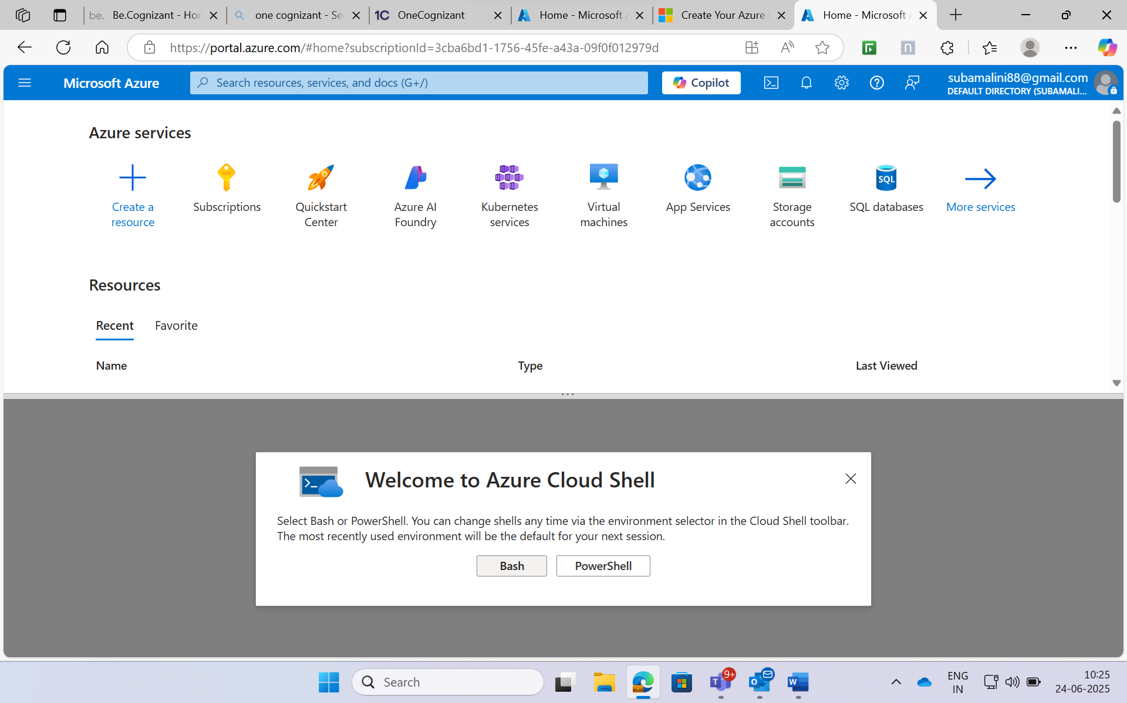

**Create an Azure Resource Group**

* **Name**: DevEnvironment-RG
* **Region**: East US
* **Purpose**: To group all resources related to this project.
* **Bash Command:** az group create --name DevEnvironment-RG --location "East US”

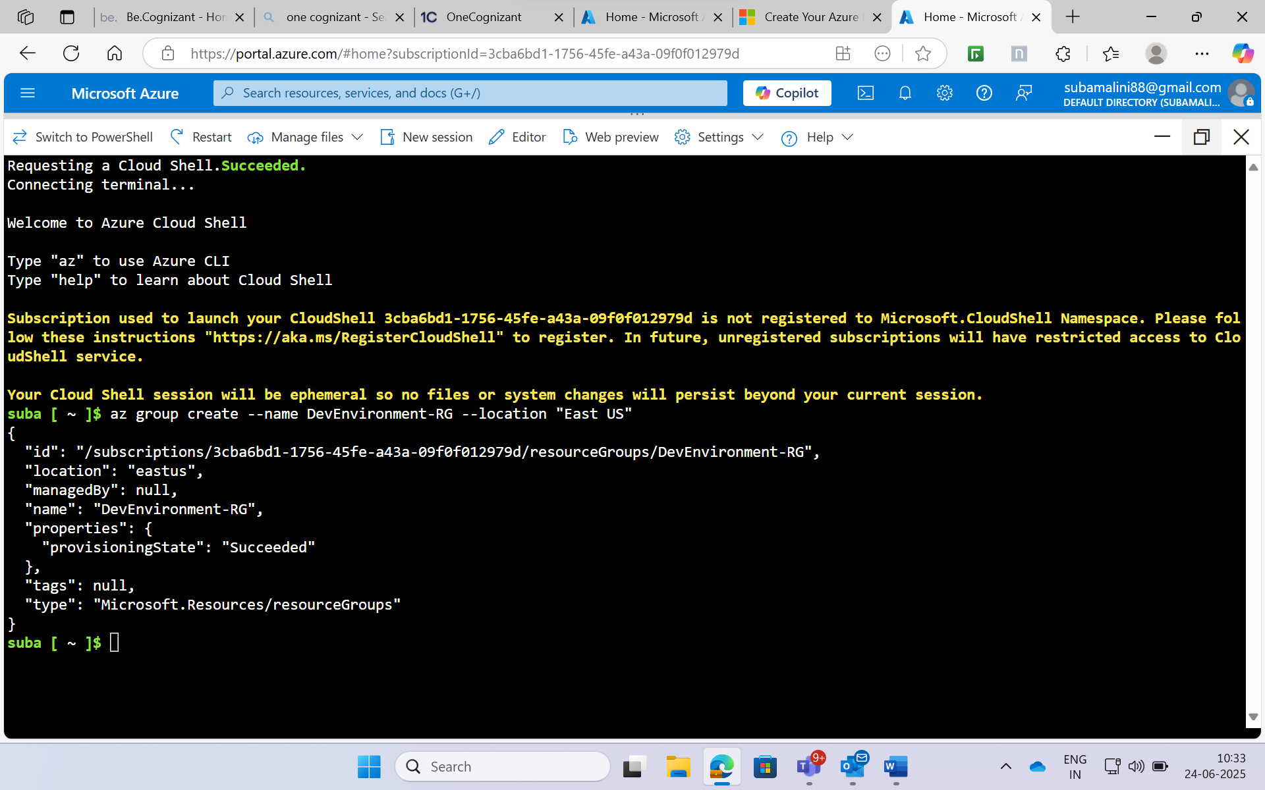

**Virtual Network (VNet)**

* **Name:** Dev-VNet
* **Address Space:** 10.0.0.0/16
* **Purpose:** Enable communication between resources in the Azure environment.
* **Bash Command:** az network vnet create \

--name Dev-VNet \

--resource-group DevEnvironment-RG \

--address-prefix 10.0.0.0/16

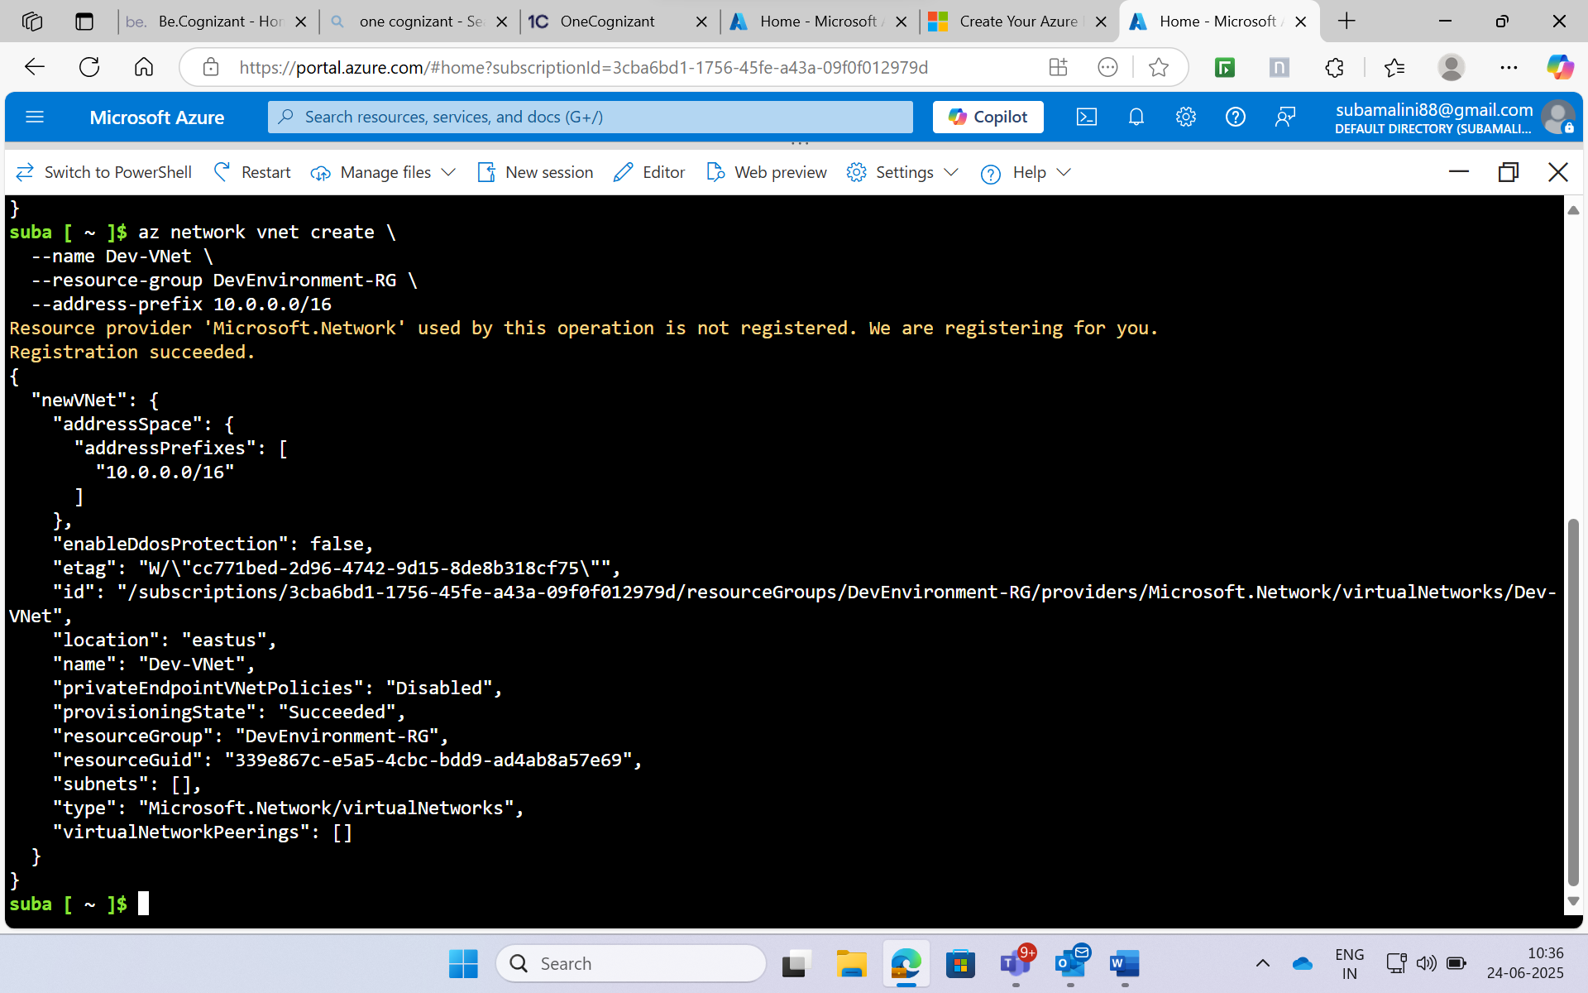

**Subnet:**

* **Name:** Dev-Subnet
* **Address Range:** 10.0.1.0/24
* **Purpose:** Assign IP addresses for resources inside the VNet.
* **Bash Command:** az network vnet subnet create \

--vnet-name Dev-VNet \

--resource-group DevEnvironment-RG \

--name Dev-Subnet \

--address-prefix 10.0.1.0/24

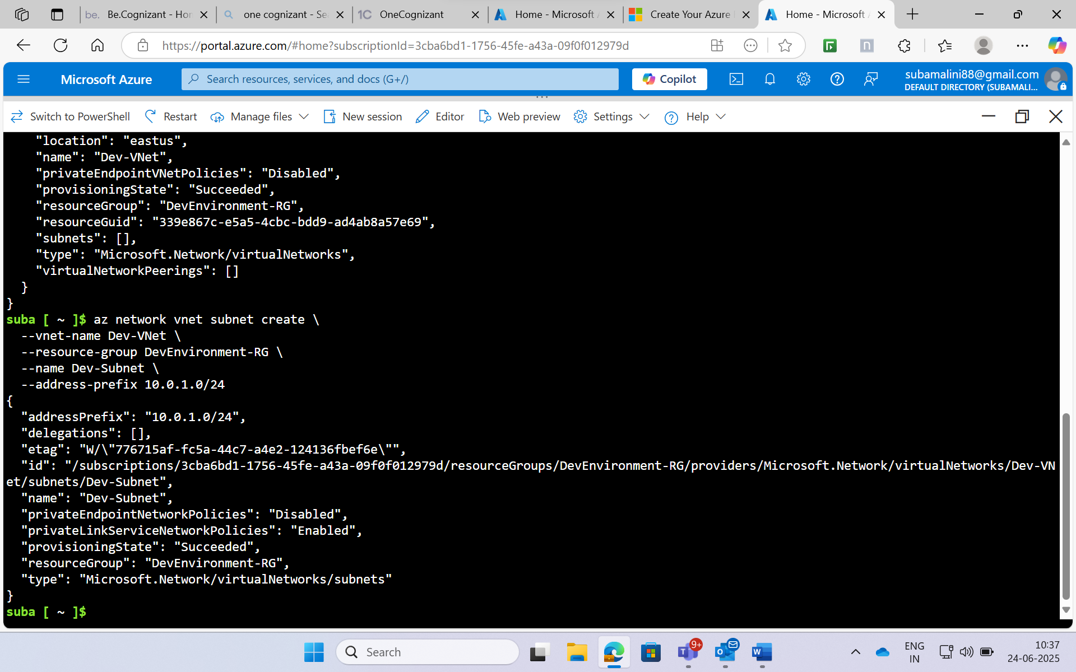

**Storage Account**

* **Name:** devstorage<uniqueid> (e.g., devstorage12345)
* **Location:** East US
* **SKU:** Standard_LRS
* **Purpose:** Store logs and application-related data.

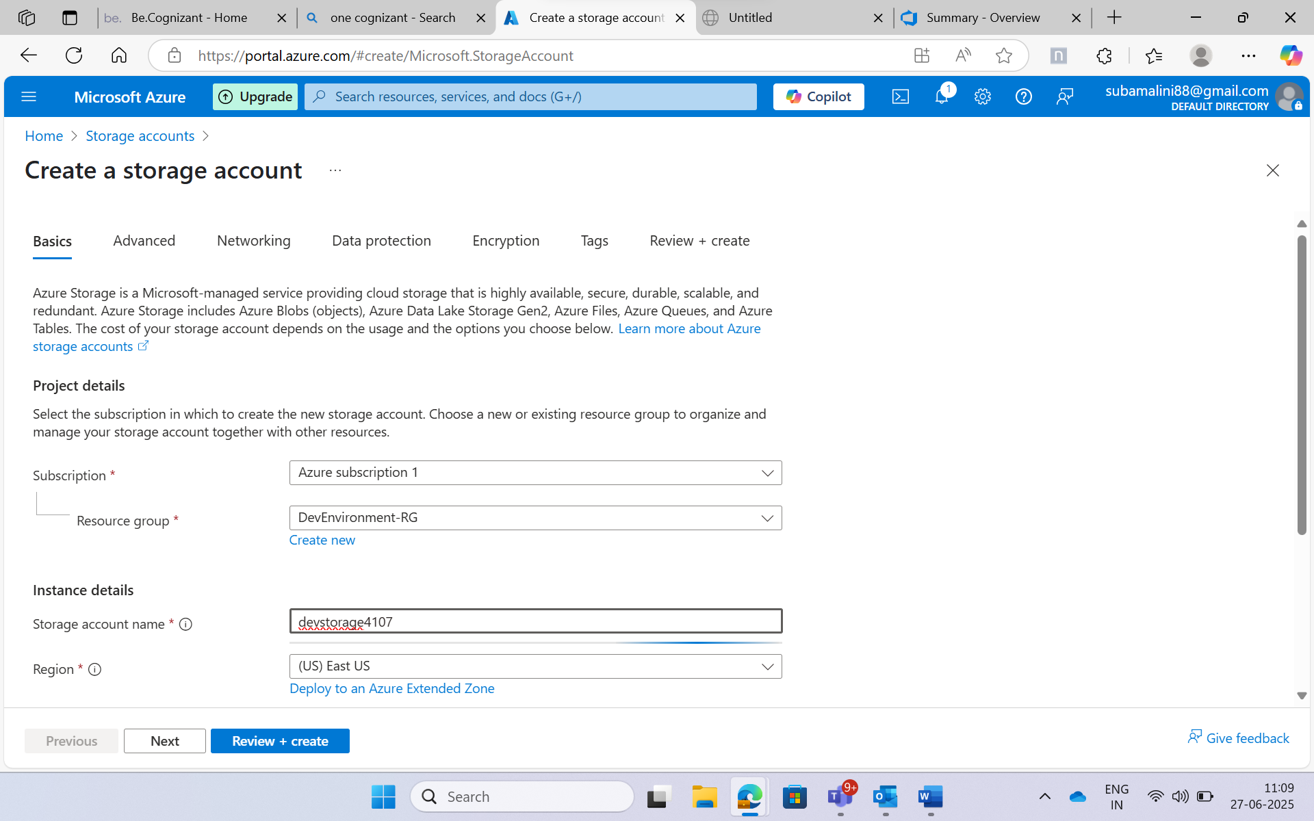

Unique Storage account name: devstorage4107

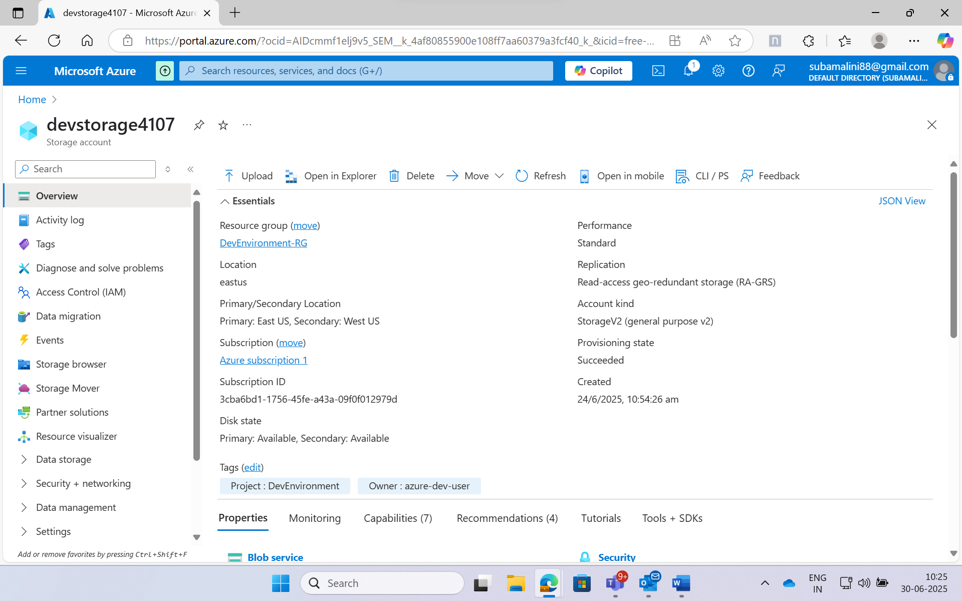

**Virtual Machine**

* **Name:** Dev-VM
* **Operating System:** Ubuntu 24.04
* **Size:** Standard_B1s (1 vCPU, 1 GB RAM, Free Tier eligible)
* **Admin Username:** azure-dev-user
* **Tags:** Project=DevEnvironment, Owner=azure-dev-user
* **Purpose:** Development environment to host tools and test applications.
* **Bash Command:**  az vm create \

--resource-group DevEnvironment-RG \

--name Dev-VM \

--image Ubuntu24.04 \

--size Standard_B1s \

--admin-username azure-dev-user \

--admin-password Suka@41963113 \

--vnet-name Dev-VNet \

--subnet Dev-Subnet \

--tags Project=DevEnvironment Owner=azure-dev-user

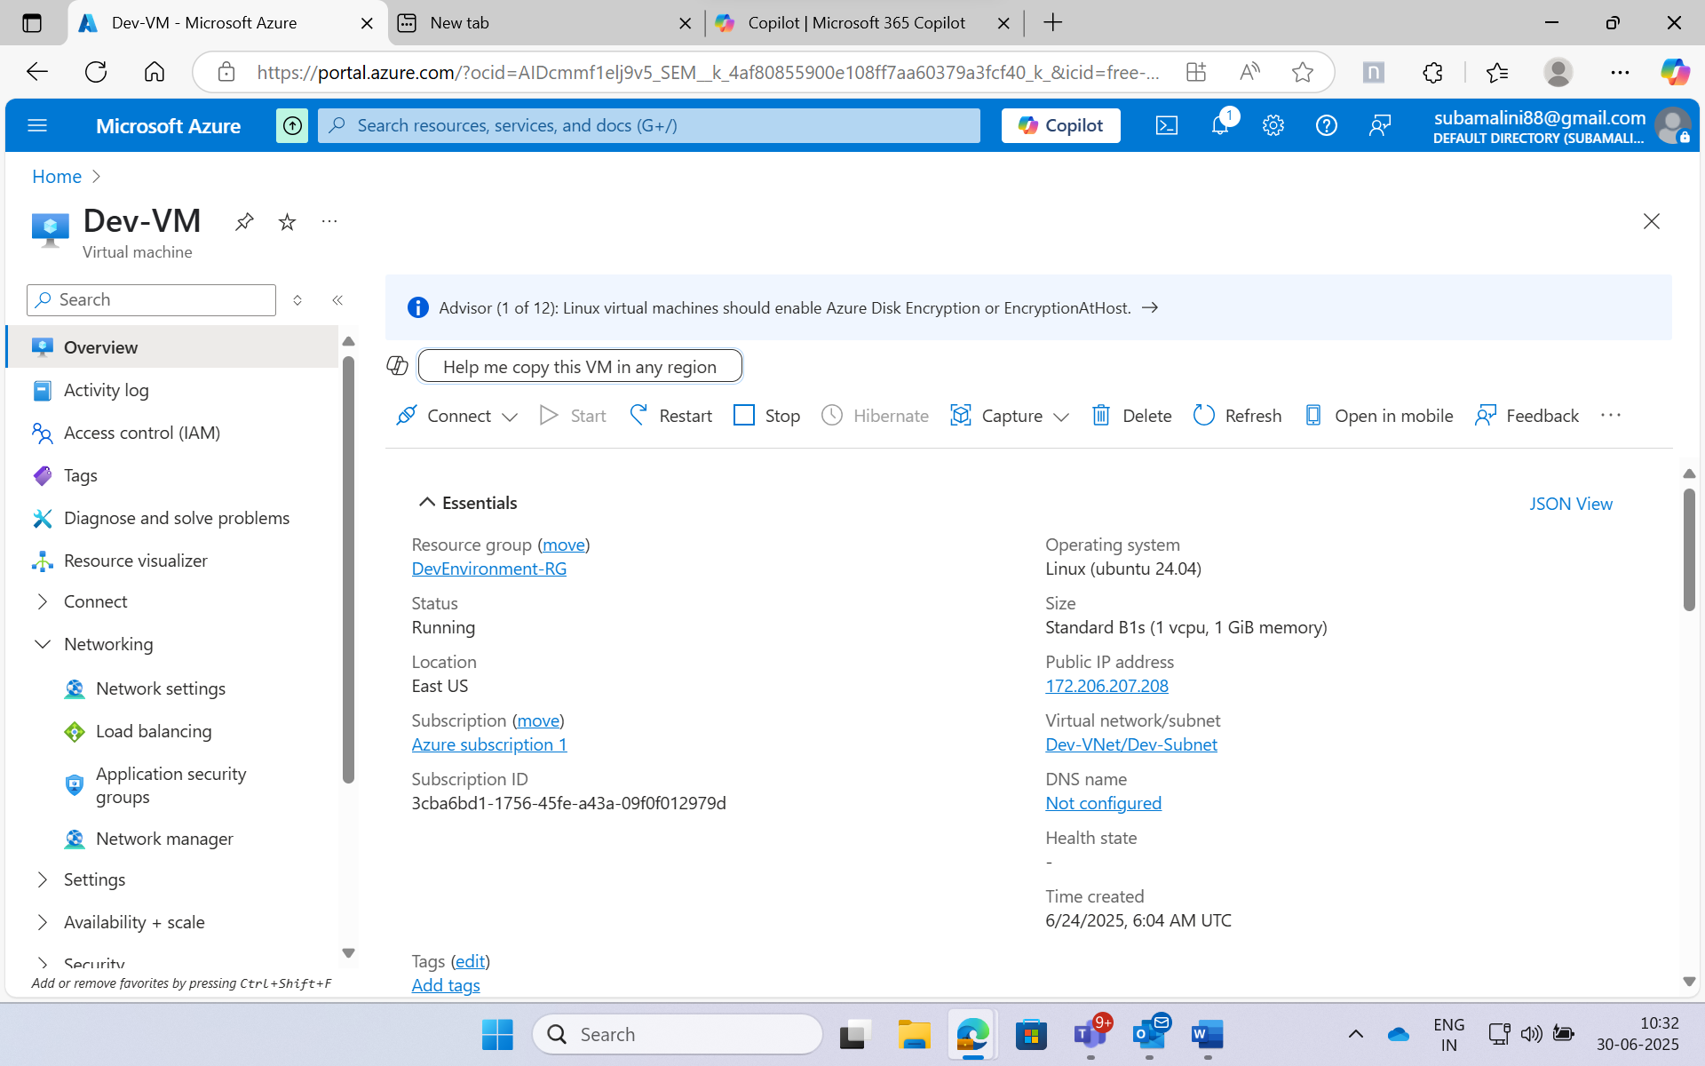

**Network Security Group (NSG)**

* **Name:** Dev-NSG
* **Rules:** Allow HTTP traffic on port 80 and SSH traffic on port 22.
* **Bash Command to Create NSG:** az network nsg create --resource-group DevEnvironment-RG --name Dev-NSG

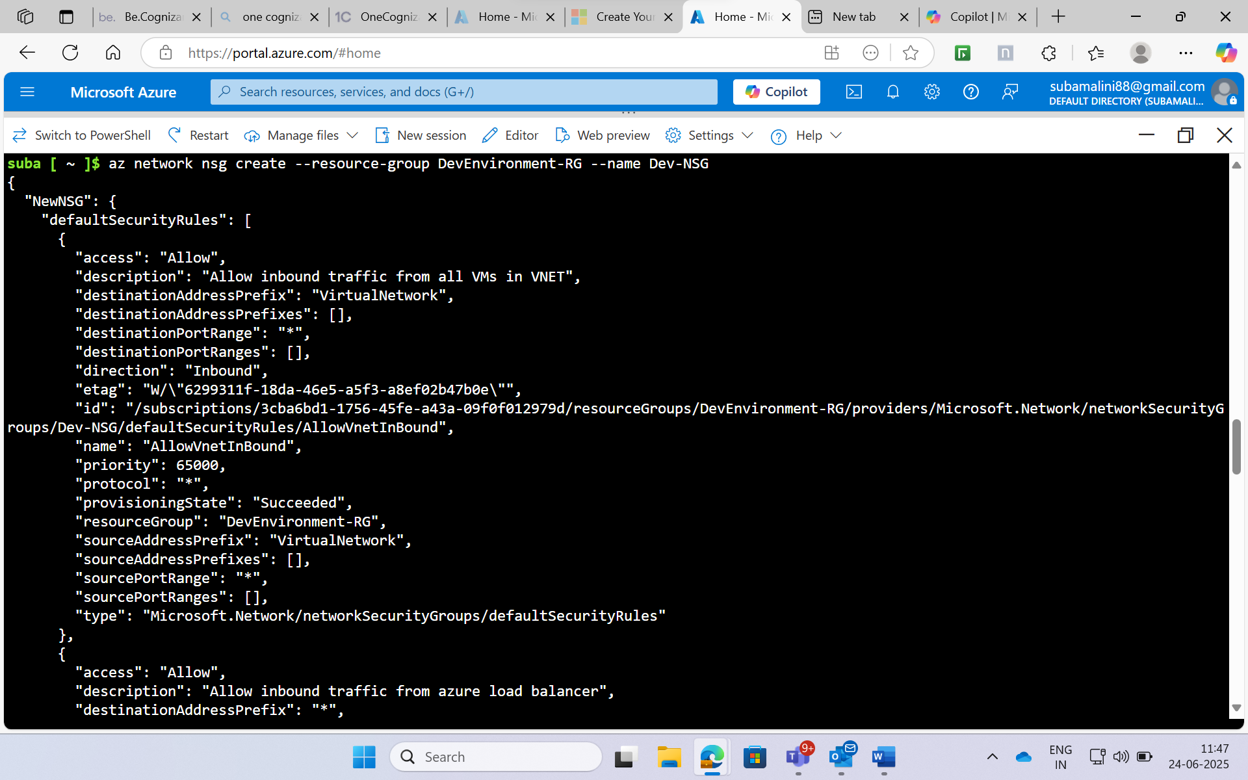

Create an inbound security rule with a priority of 100 and allow traffic on destination port 80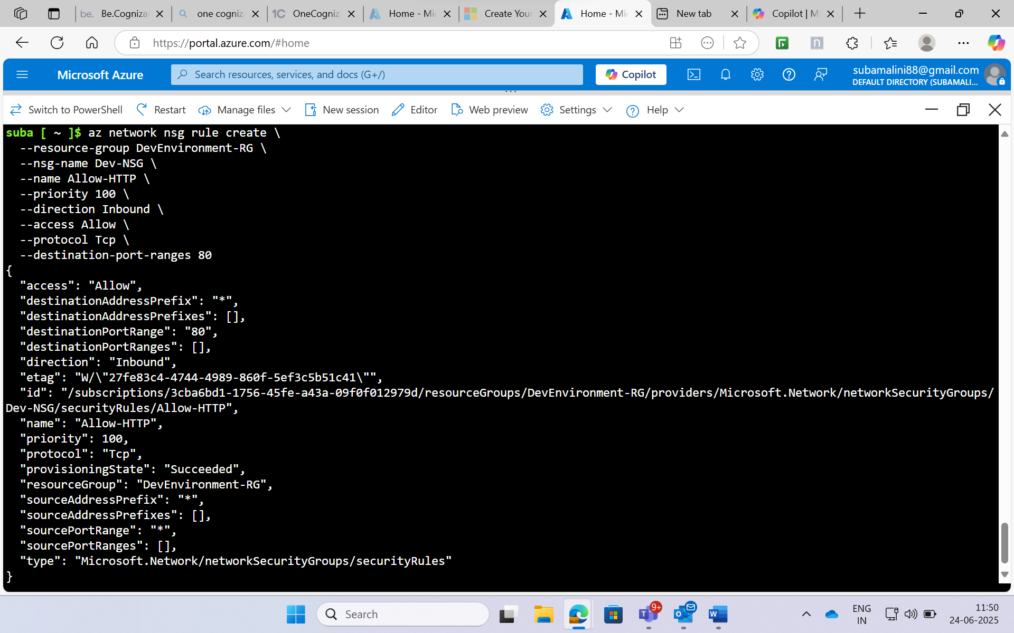

Create an inbound security rule with a priority of 110 and allow traffic on destination port 22:

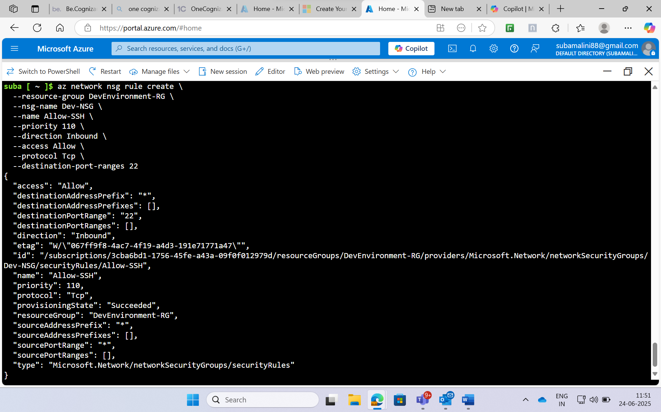

VM password:Suka@41963113

Switching to the azure-dev-user account using the public IP address: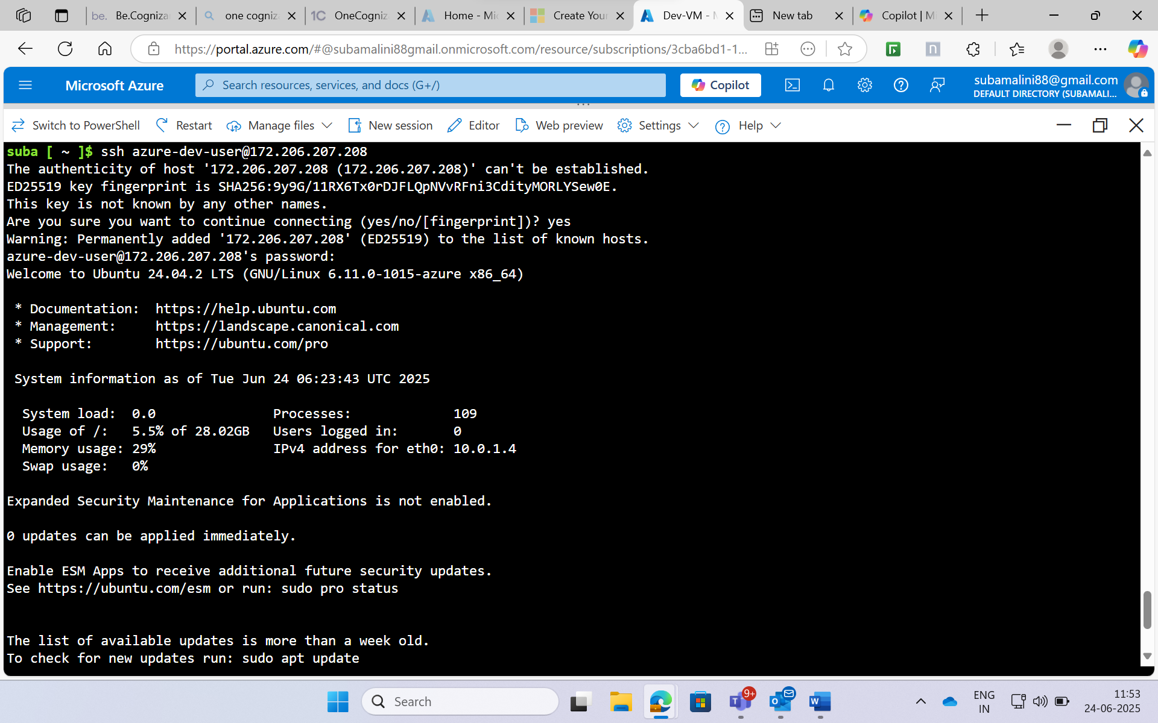

Before installing any application, it's important to update the system to ensure all packages are current: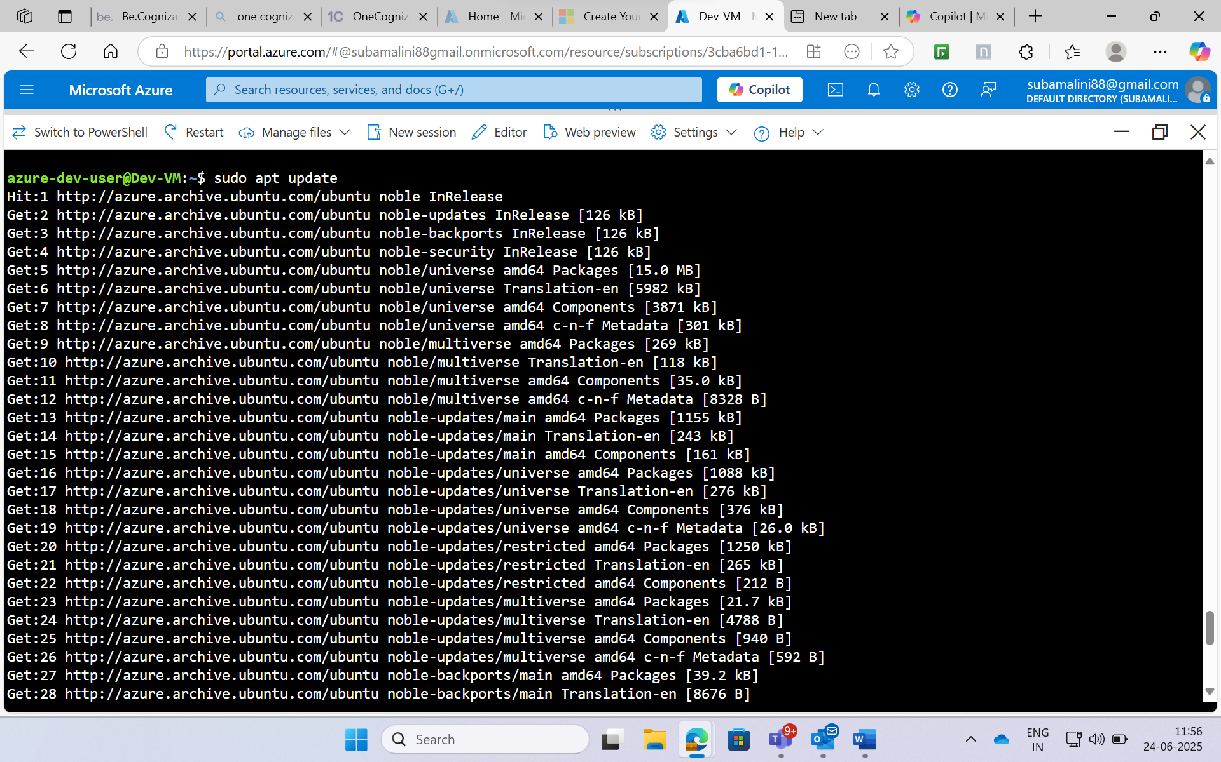

**Docker Installation on VM**

* **Version:** Latest version available via apt
* **Purpose:** Containerize the application for deployment.

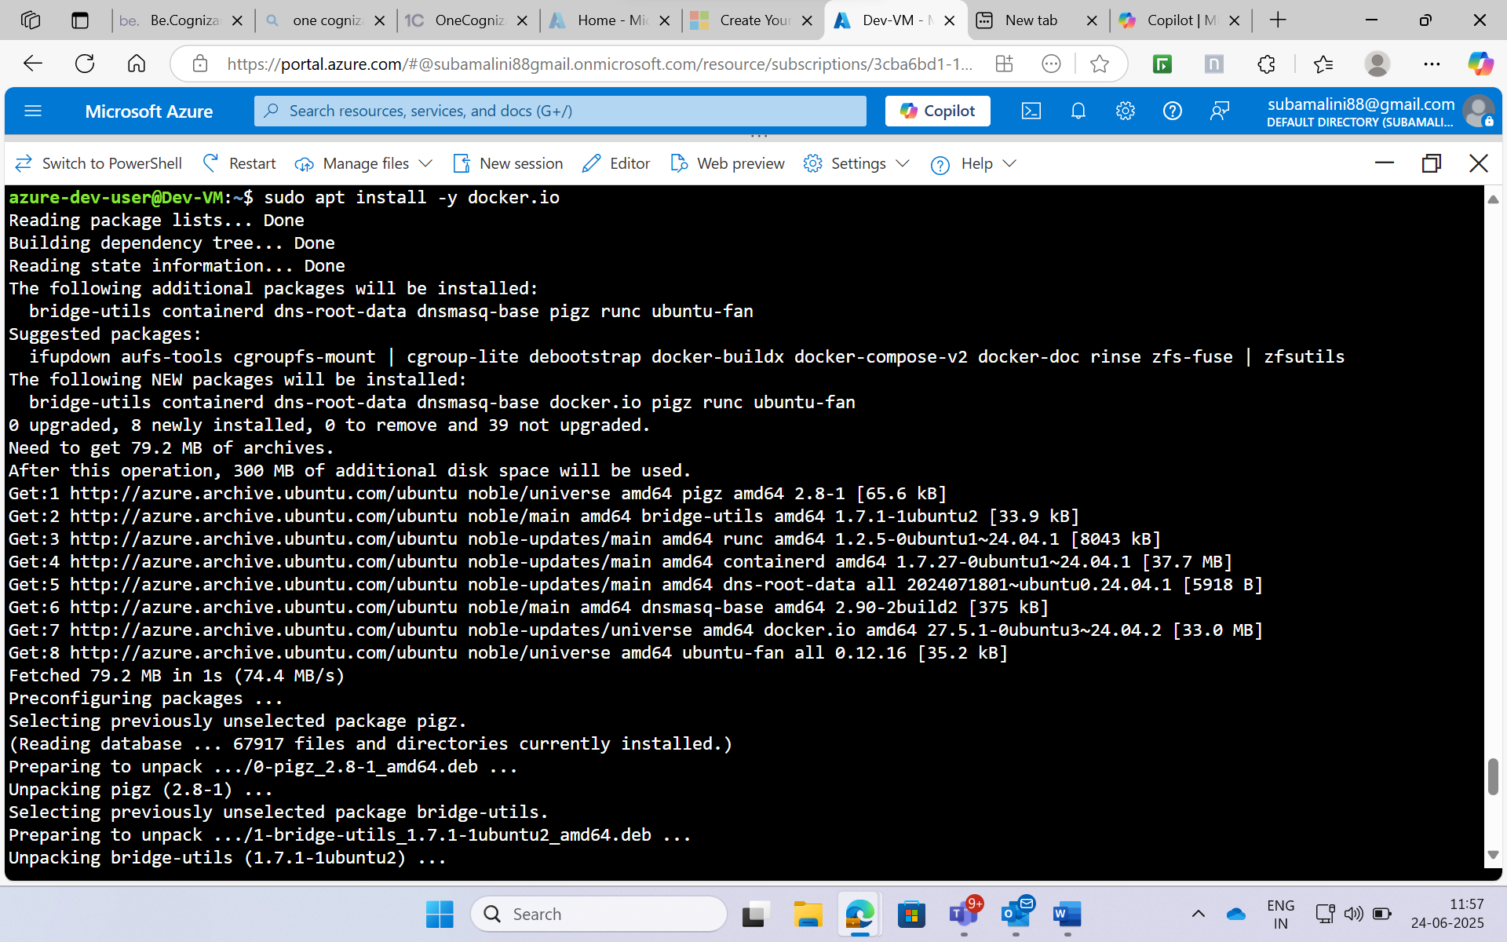

Start and enable the docker:

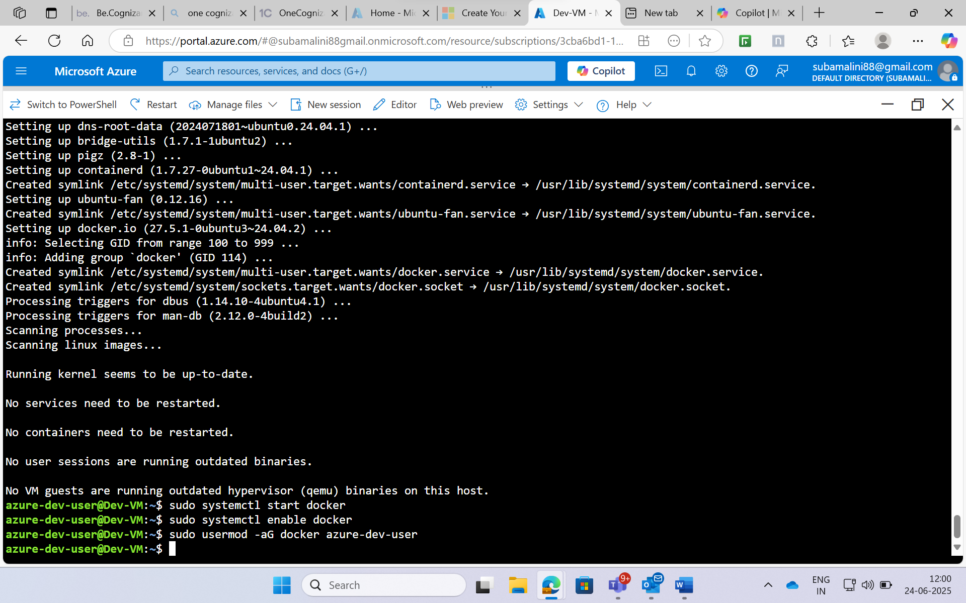

**Git Installation on VM**

* **Version:** Latest version available via apt
* **Purpose:** Version control for application files.

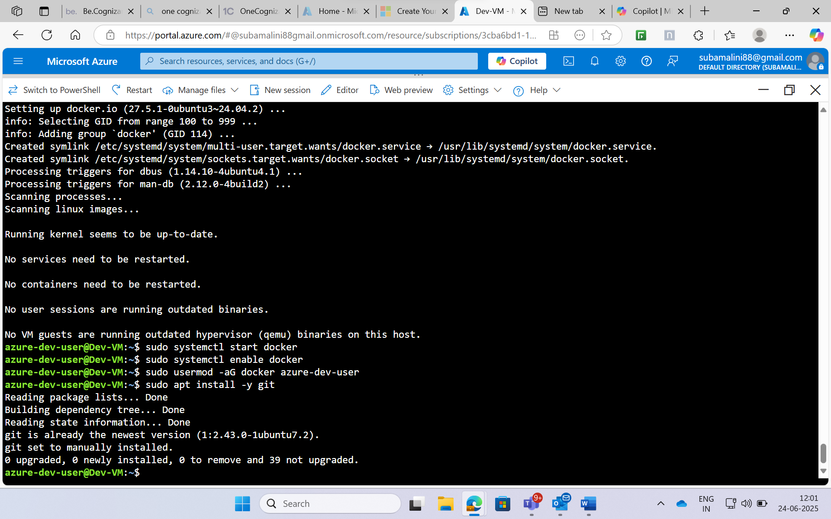**HTML and CSS Web Application**

* **Folder Name:** hello-world-app
* **File Name:** index.html

Then create the folder named “hello-world-app” then create the HTML page:

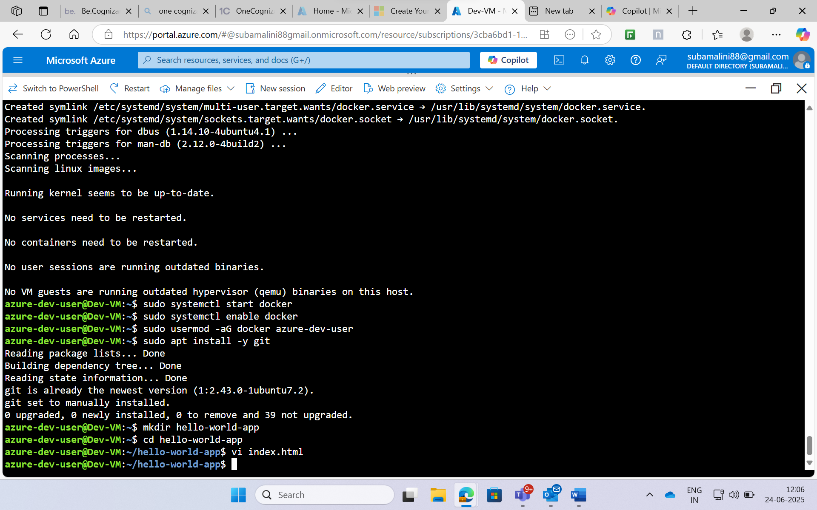

**Content of html:**

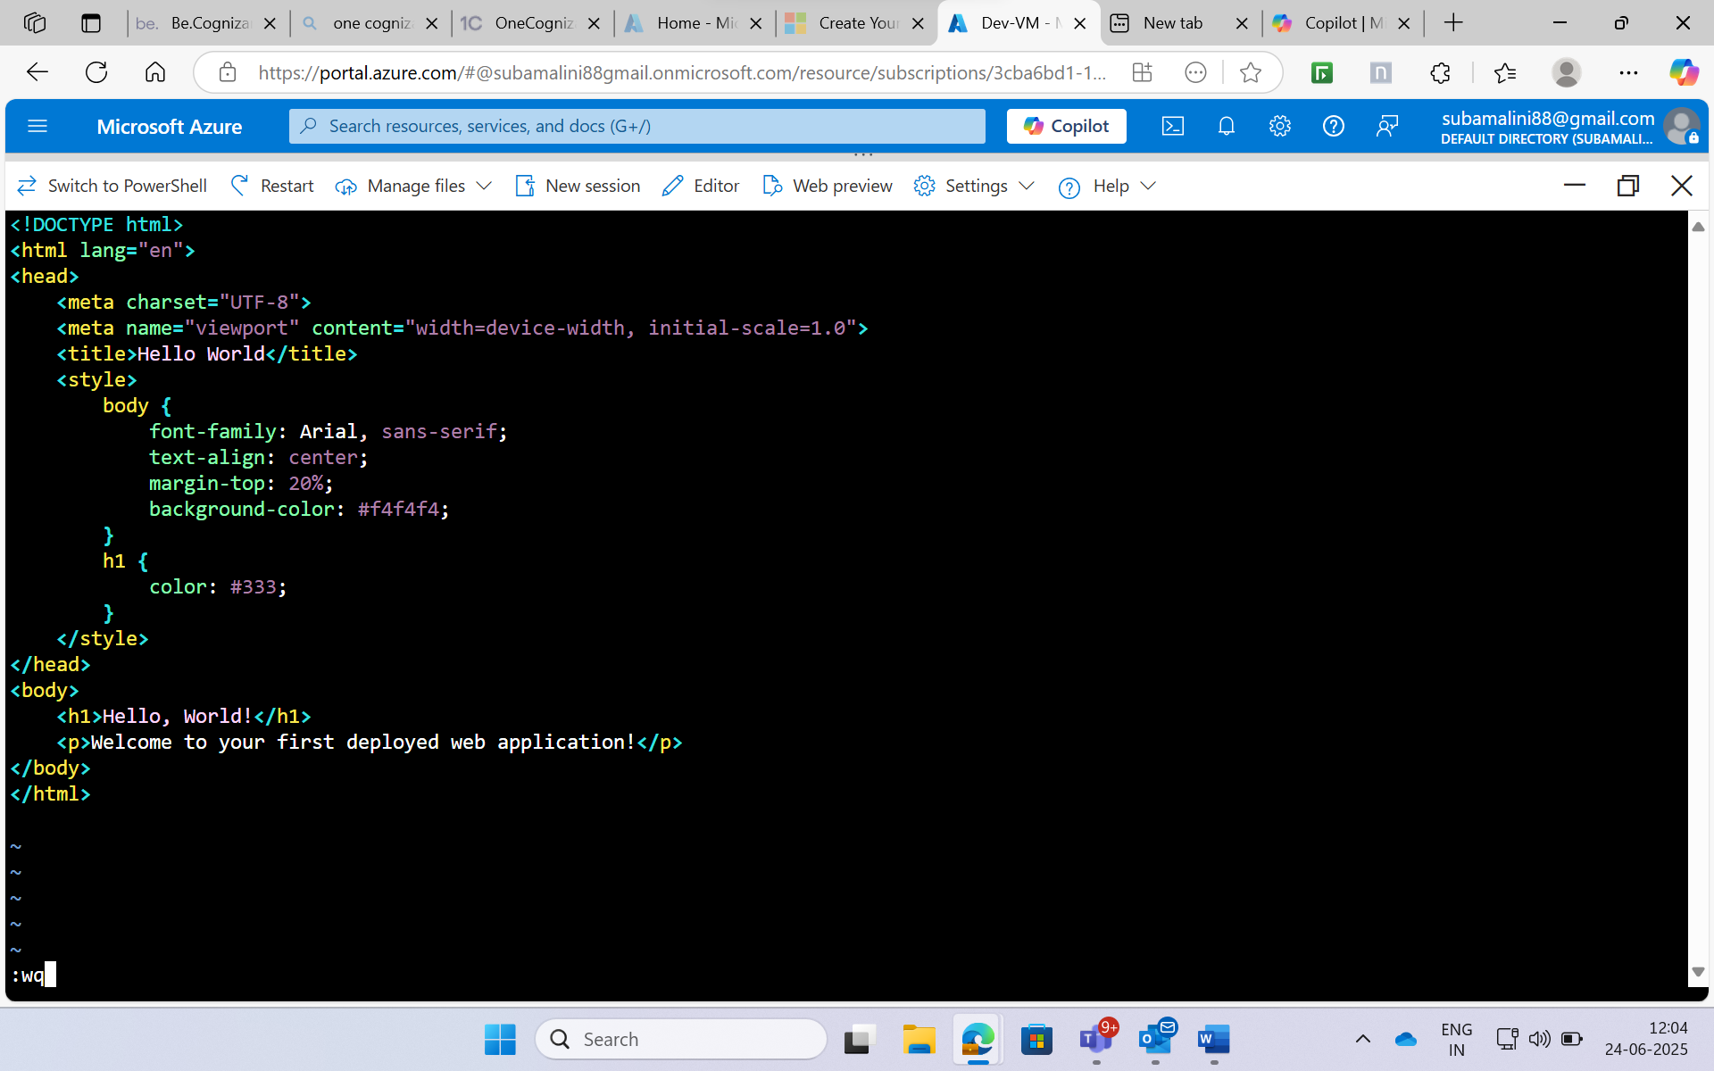

**Create a Dockerfile:**

* **Purpose:** Containerize the static web application.

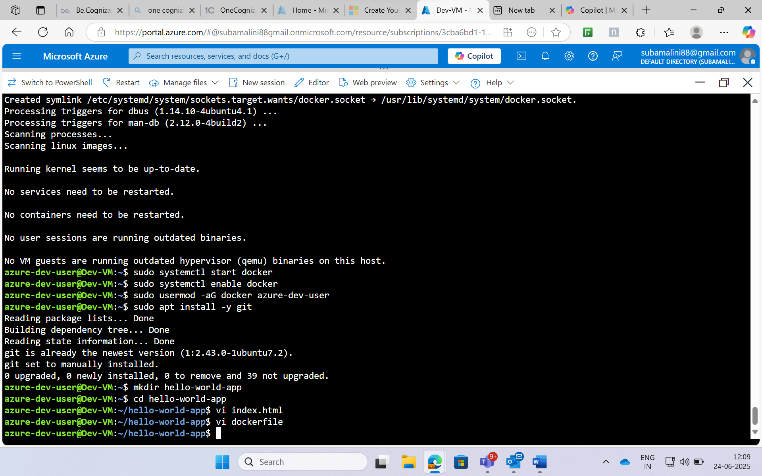

Content of dockerfile:

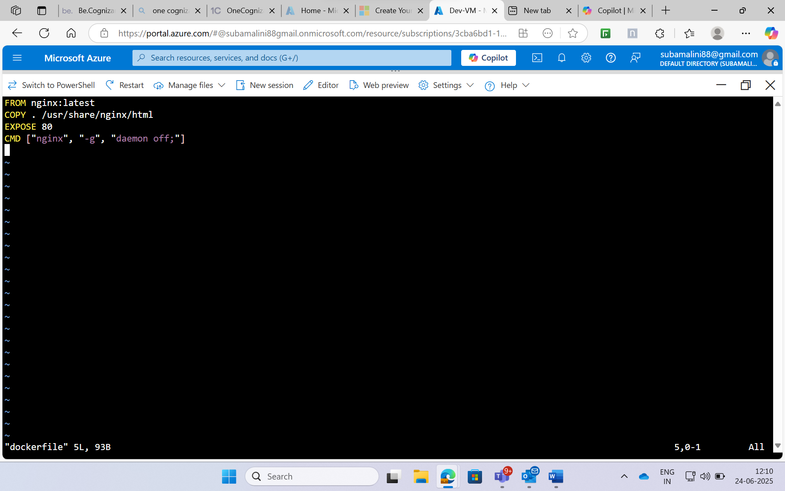

Build docker image and run it locally:

To run a Docker container in the background, we need to include the -d flag in the docker run command.

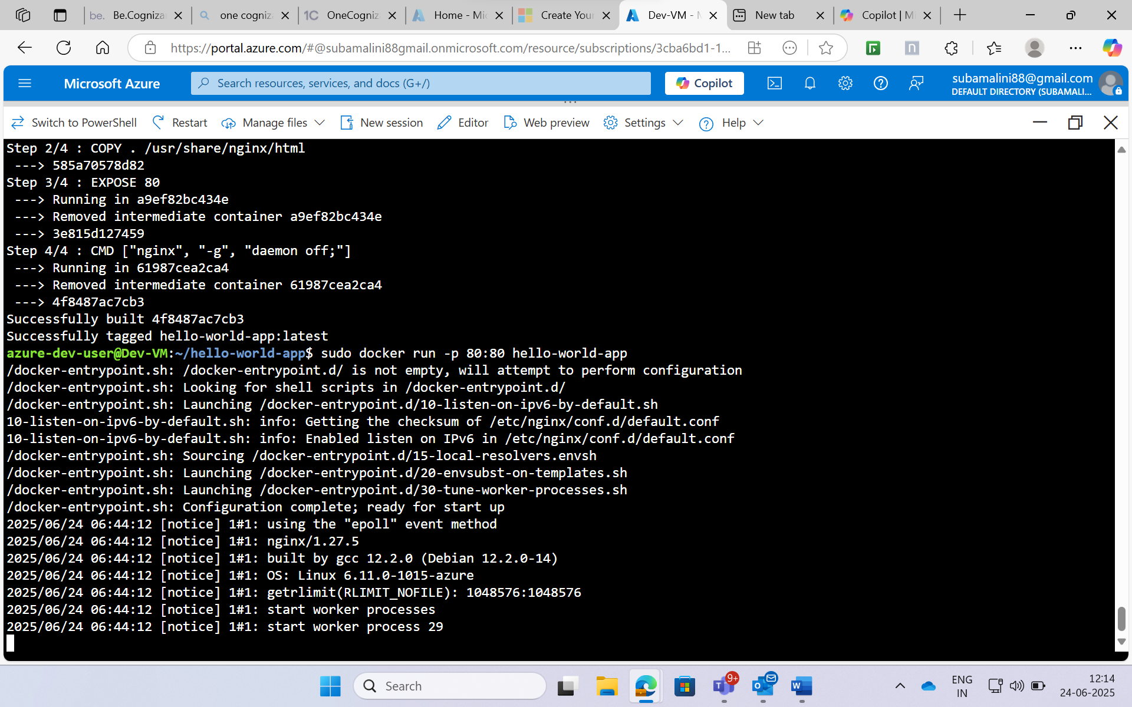

Create a container registry with unique registry name: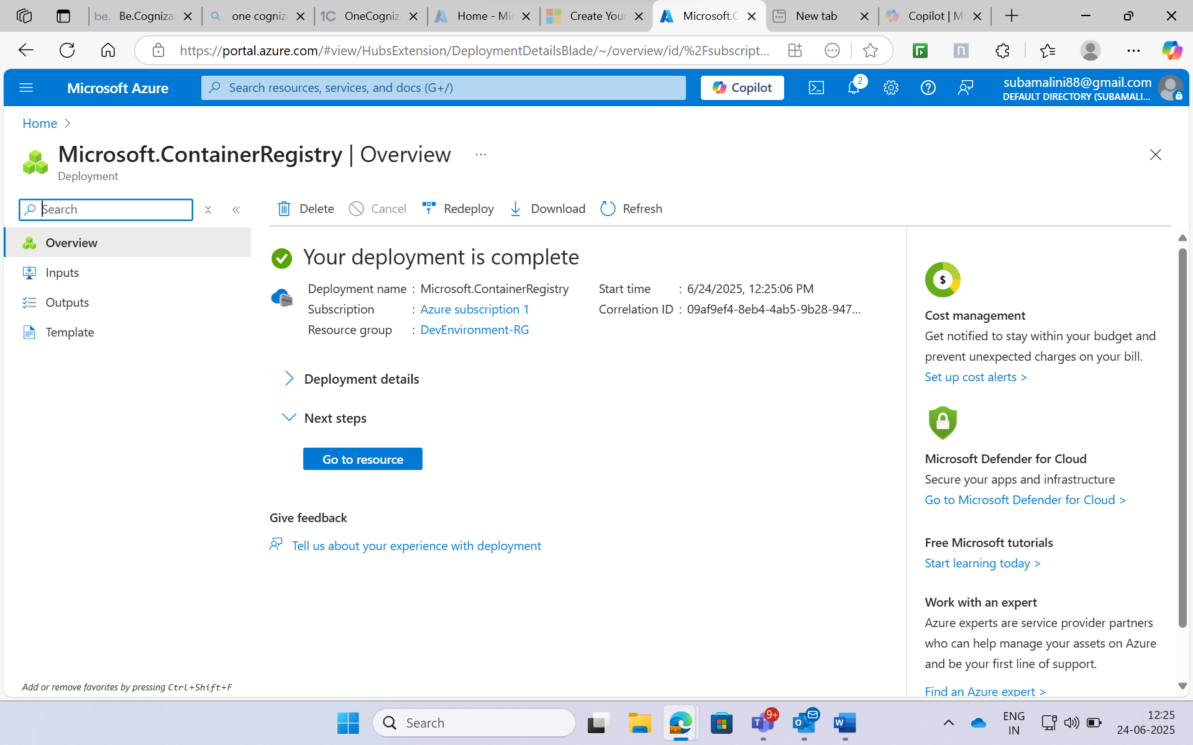

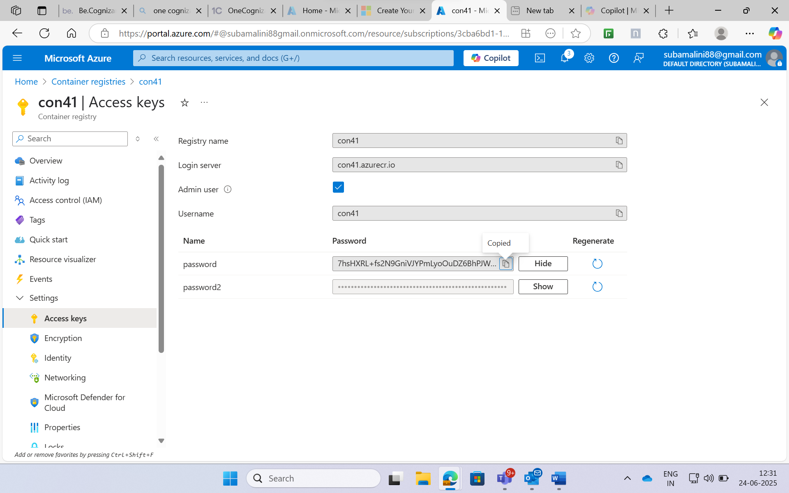

We are logging in ACR using registry name, username and password  
Then push the docker image from local to the ACR:

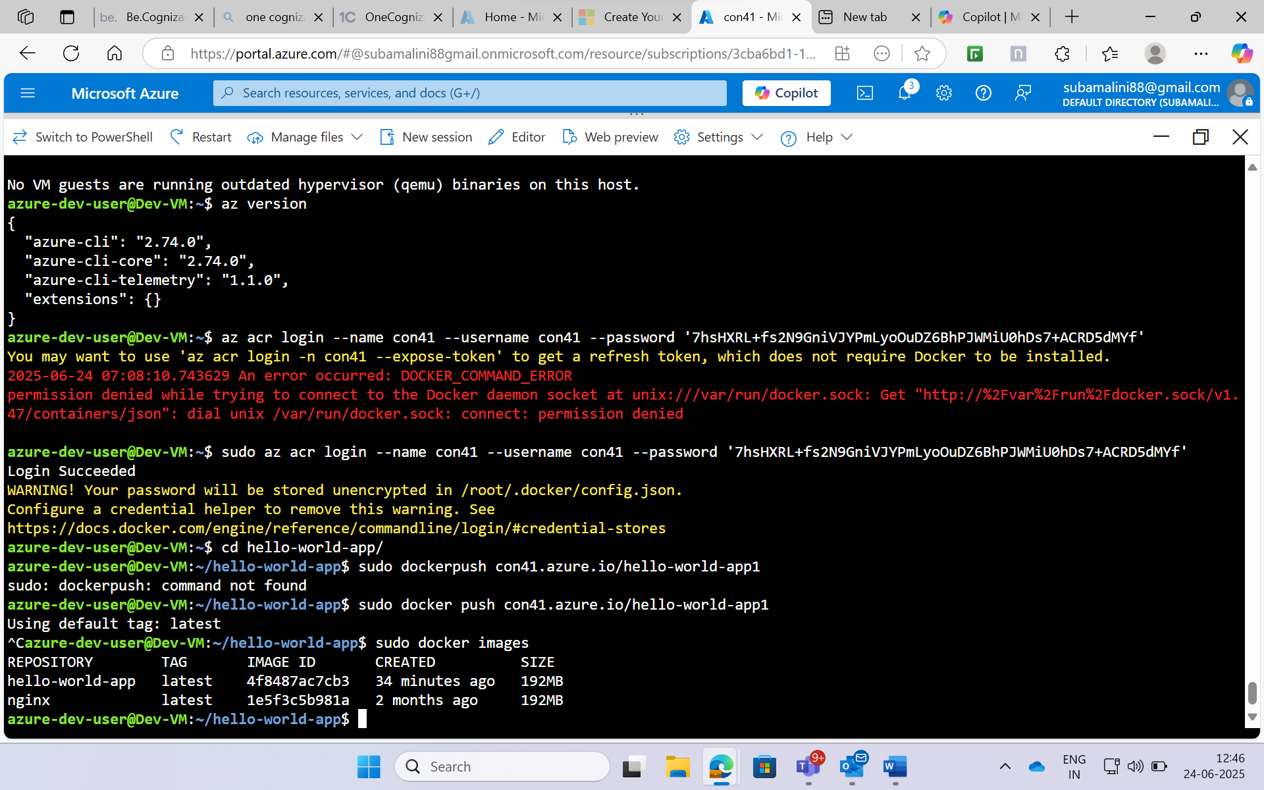

The hello-world-app file will be displayed at Repositories

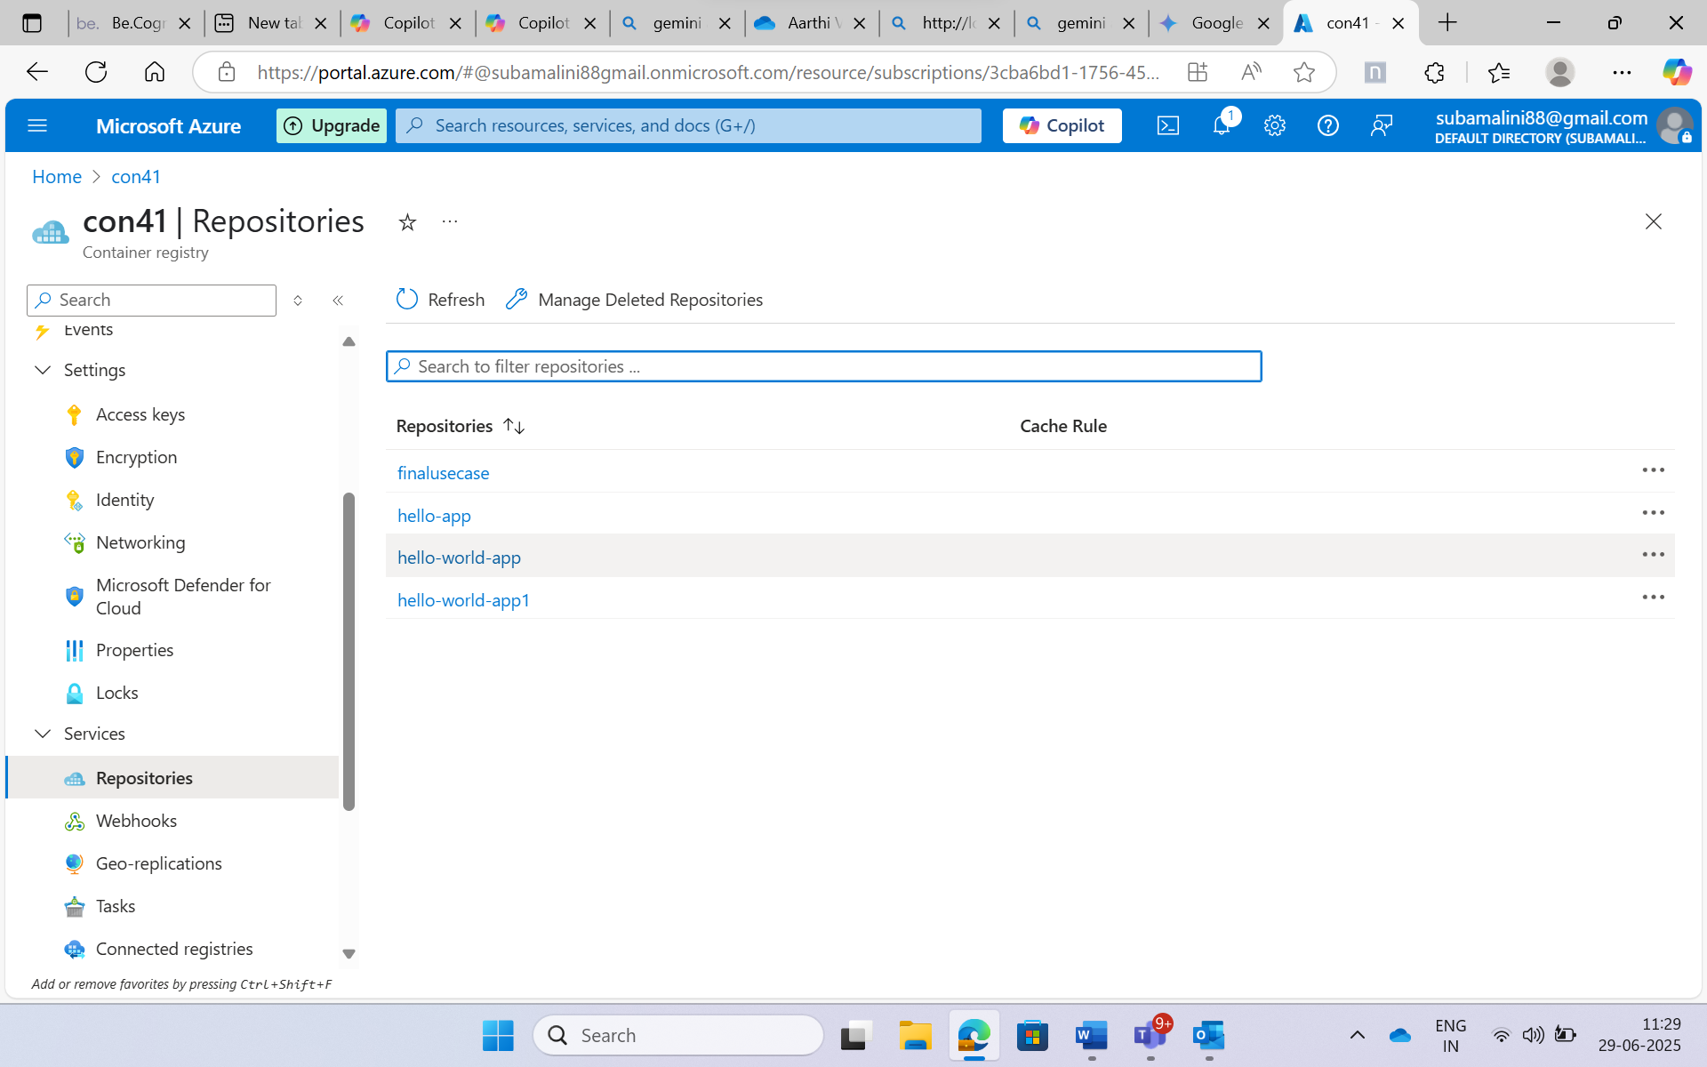

**Azure Kubernetes Service (AKS)**

* **Cluster Name:** Dev-AKS
* **Node Count:** 1
* **Node Size:** Standard B2s (Free Tier eligible)

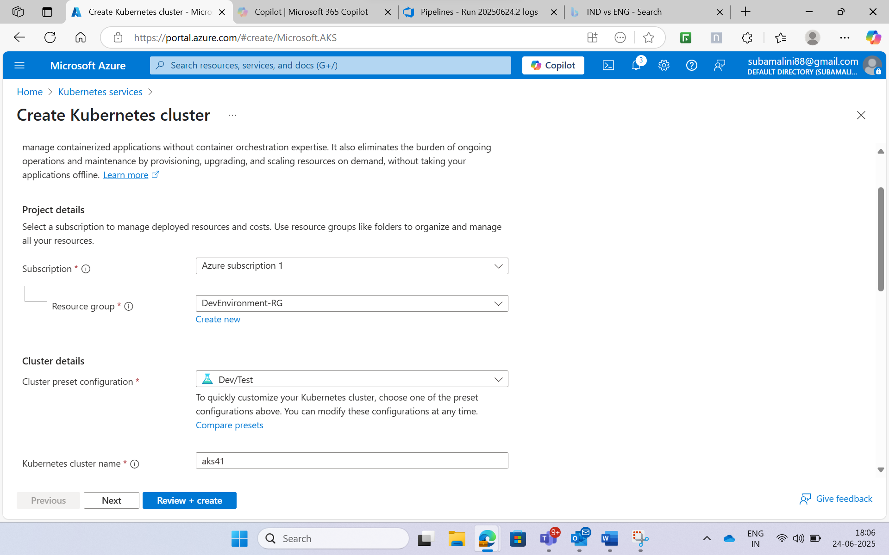

Set the node size as Standard_D2_v6 and node count to 1 and set max pods as 30

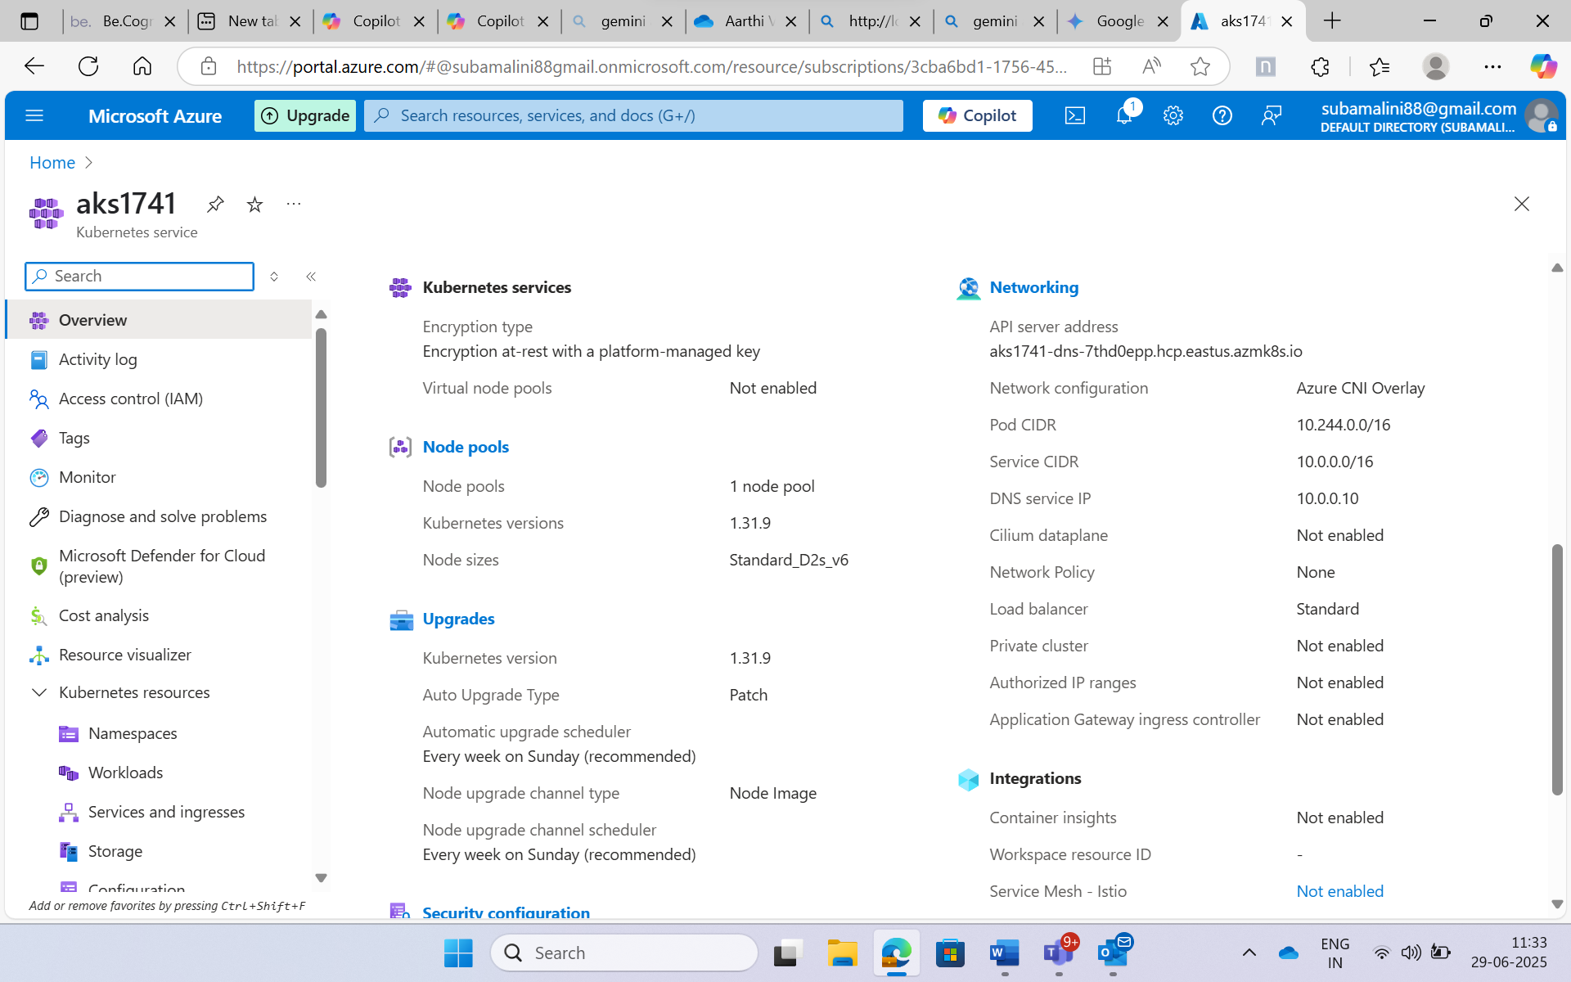

Make sure the AKS is connected with your container registry:

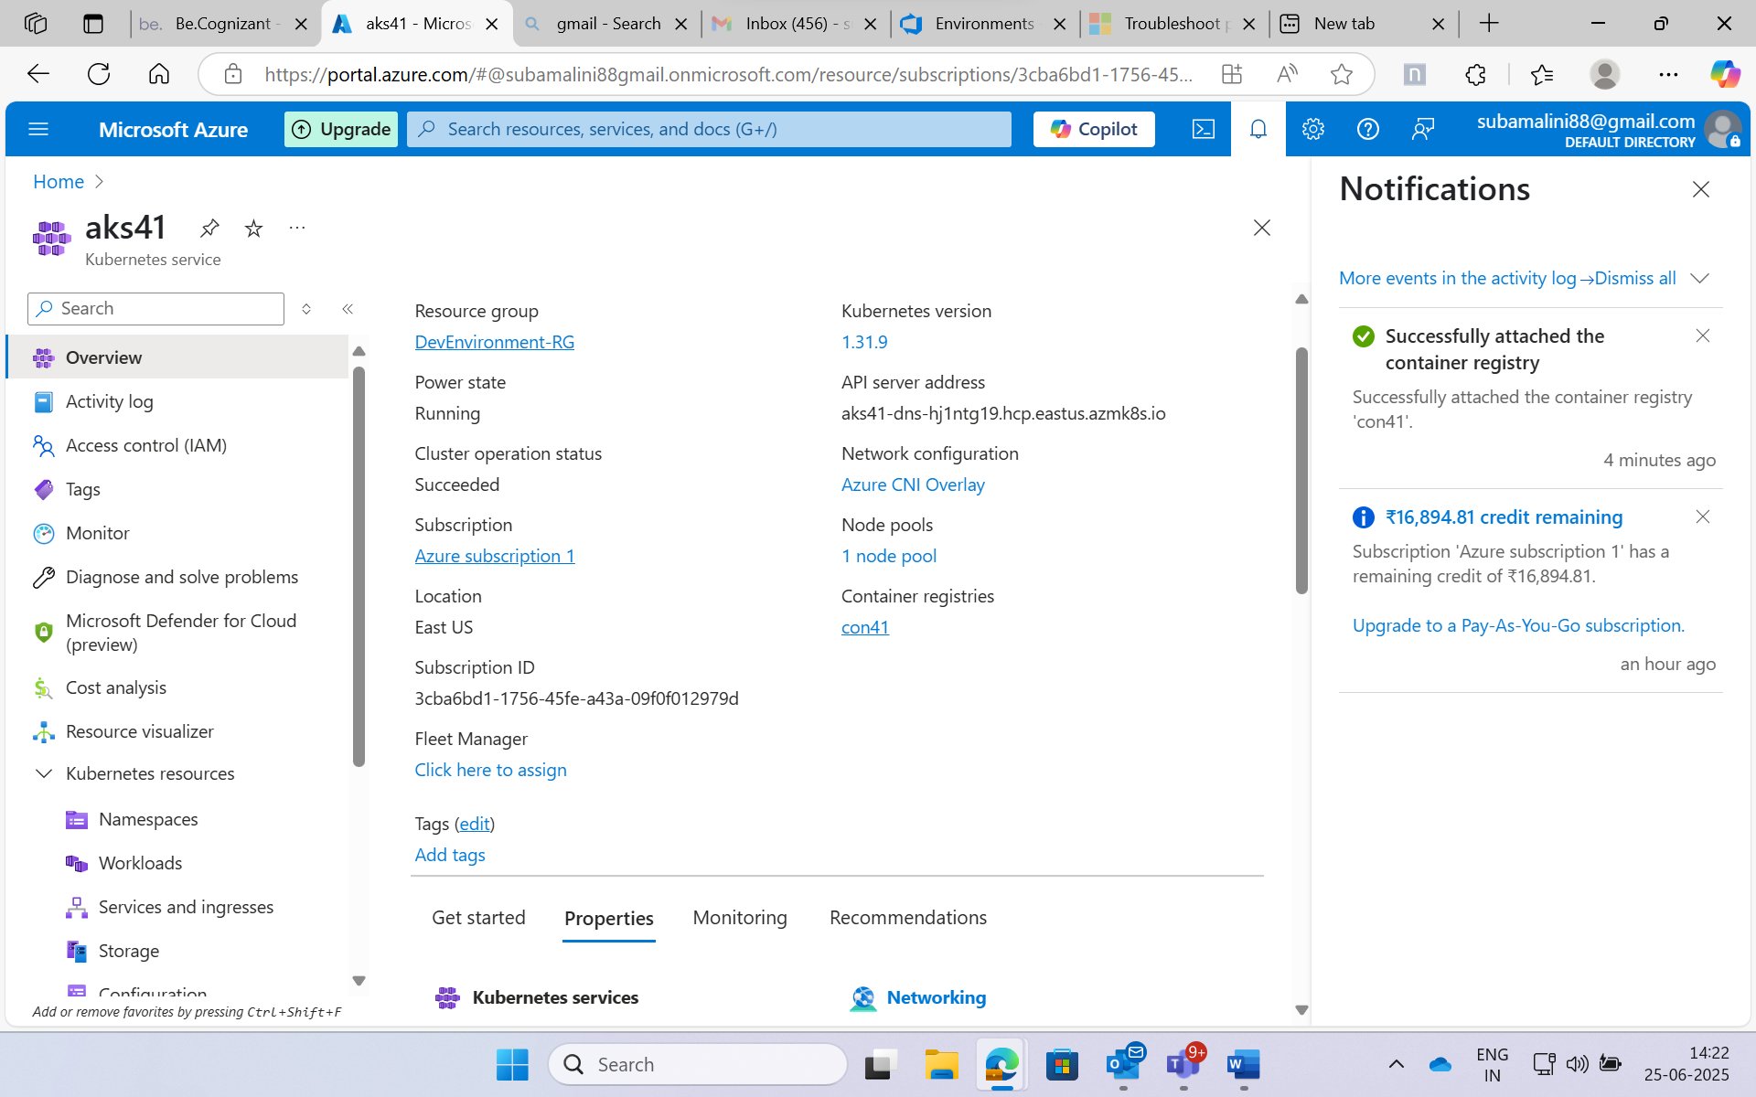

After applied deployment.yml under Workloads.

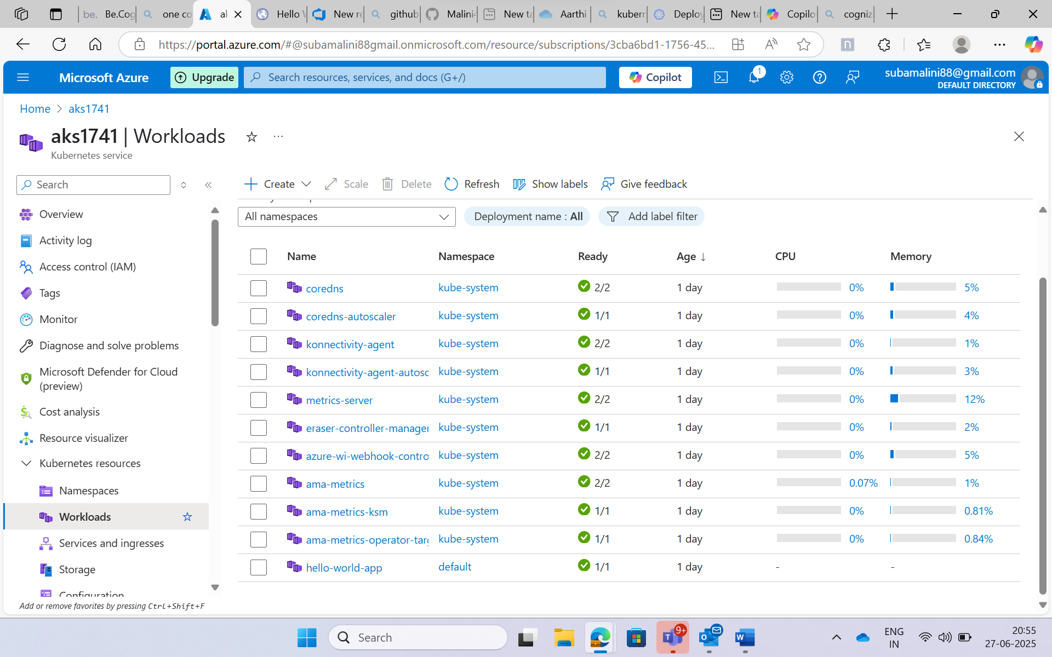

After applied service.yml under Services and ingresses:

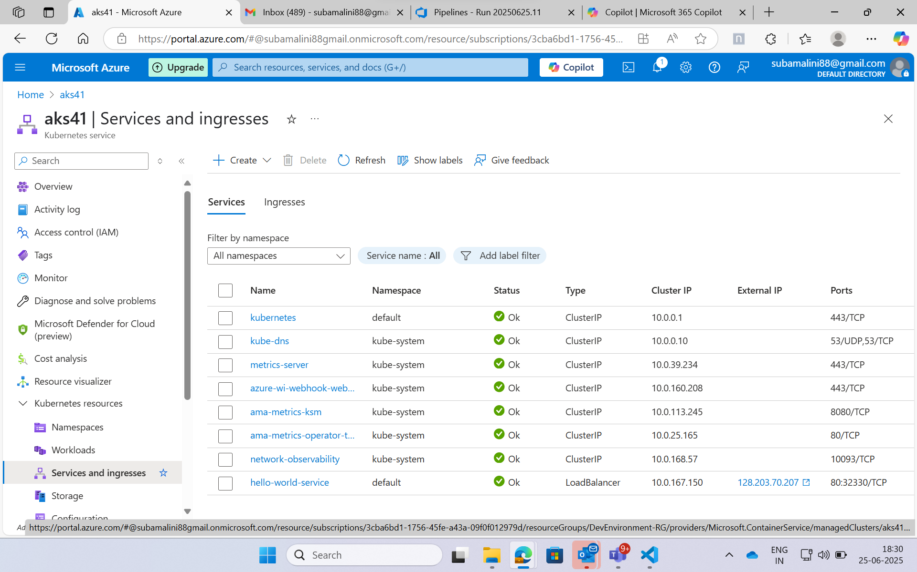

The service.yaml got executed and IP address is created

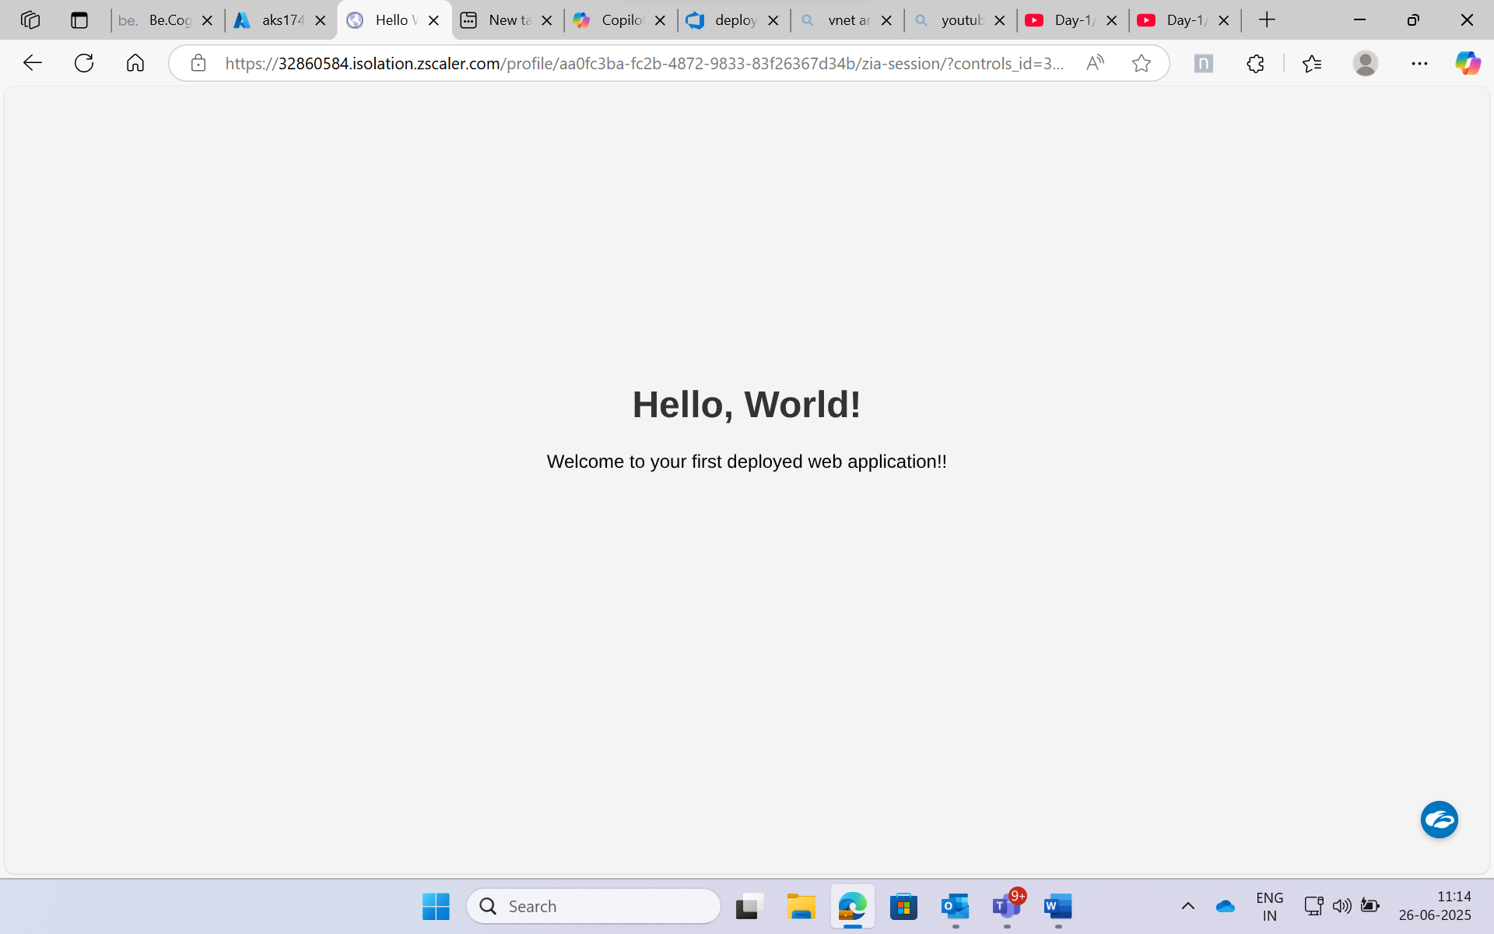

To work in the Azure devOps we first configure the self-hosted agent:

Downloaded the Azure Pipelines agent package for Linux from the official Azure DevOps portal 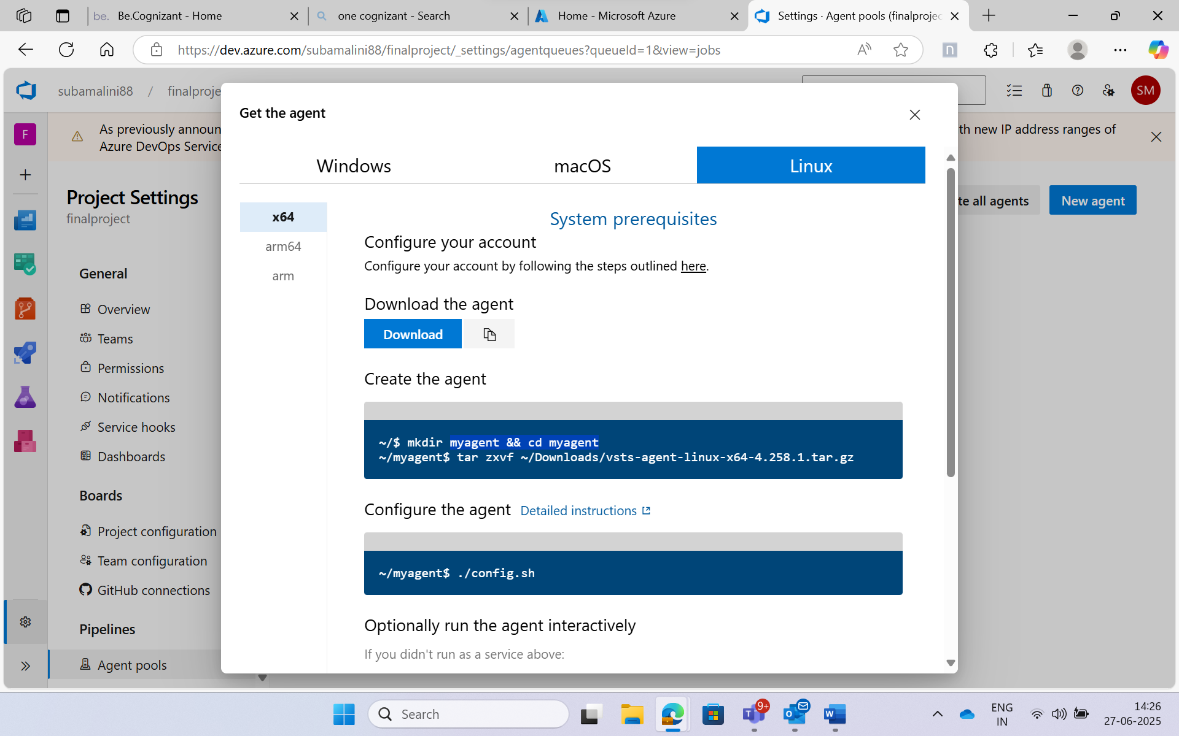

Downloading the self-hosted agent:

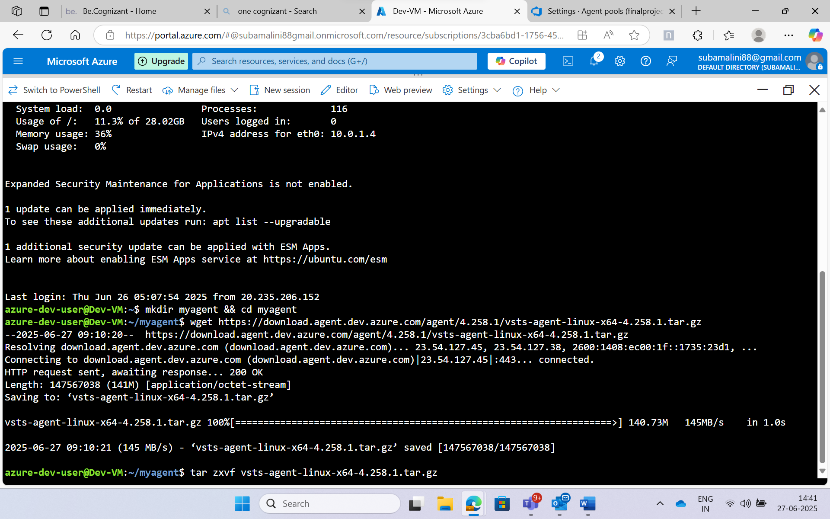

We need to provide the end user agreements to download the self-hosted agent:

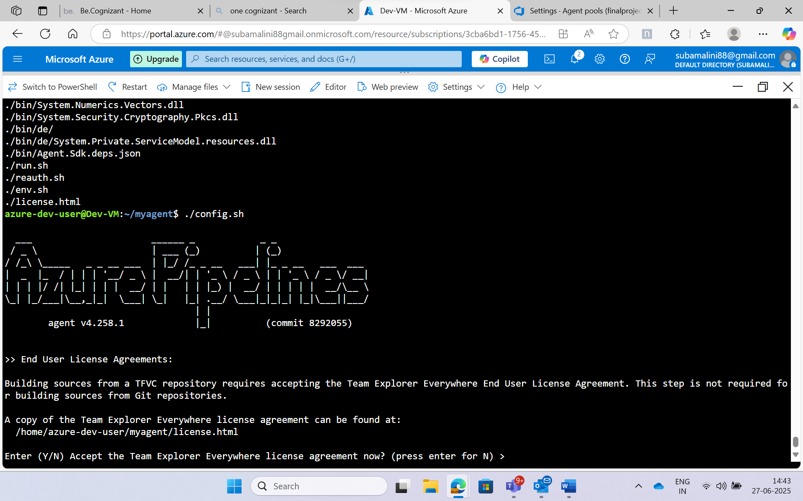

After the end user agreement, we can register the self-hosted agent using the personal access token:

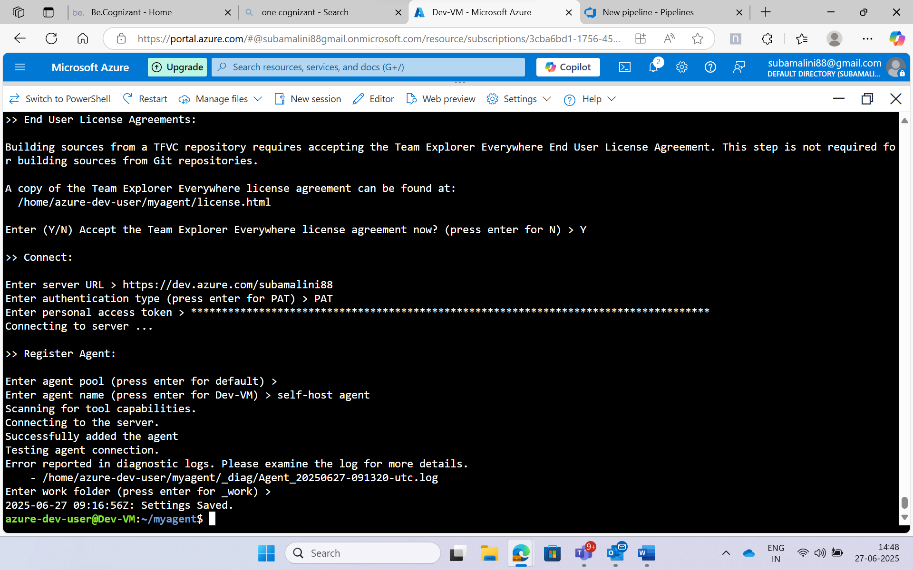

Self-hosted agent is created:

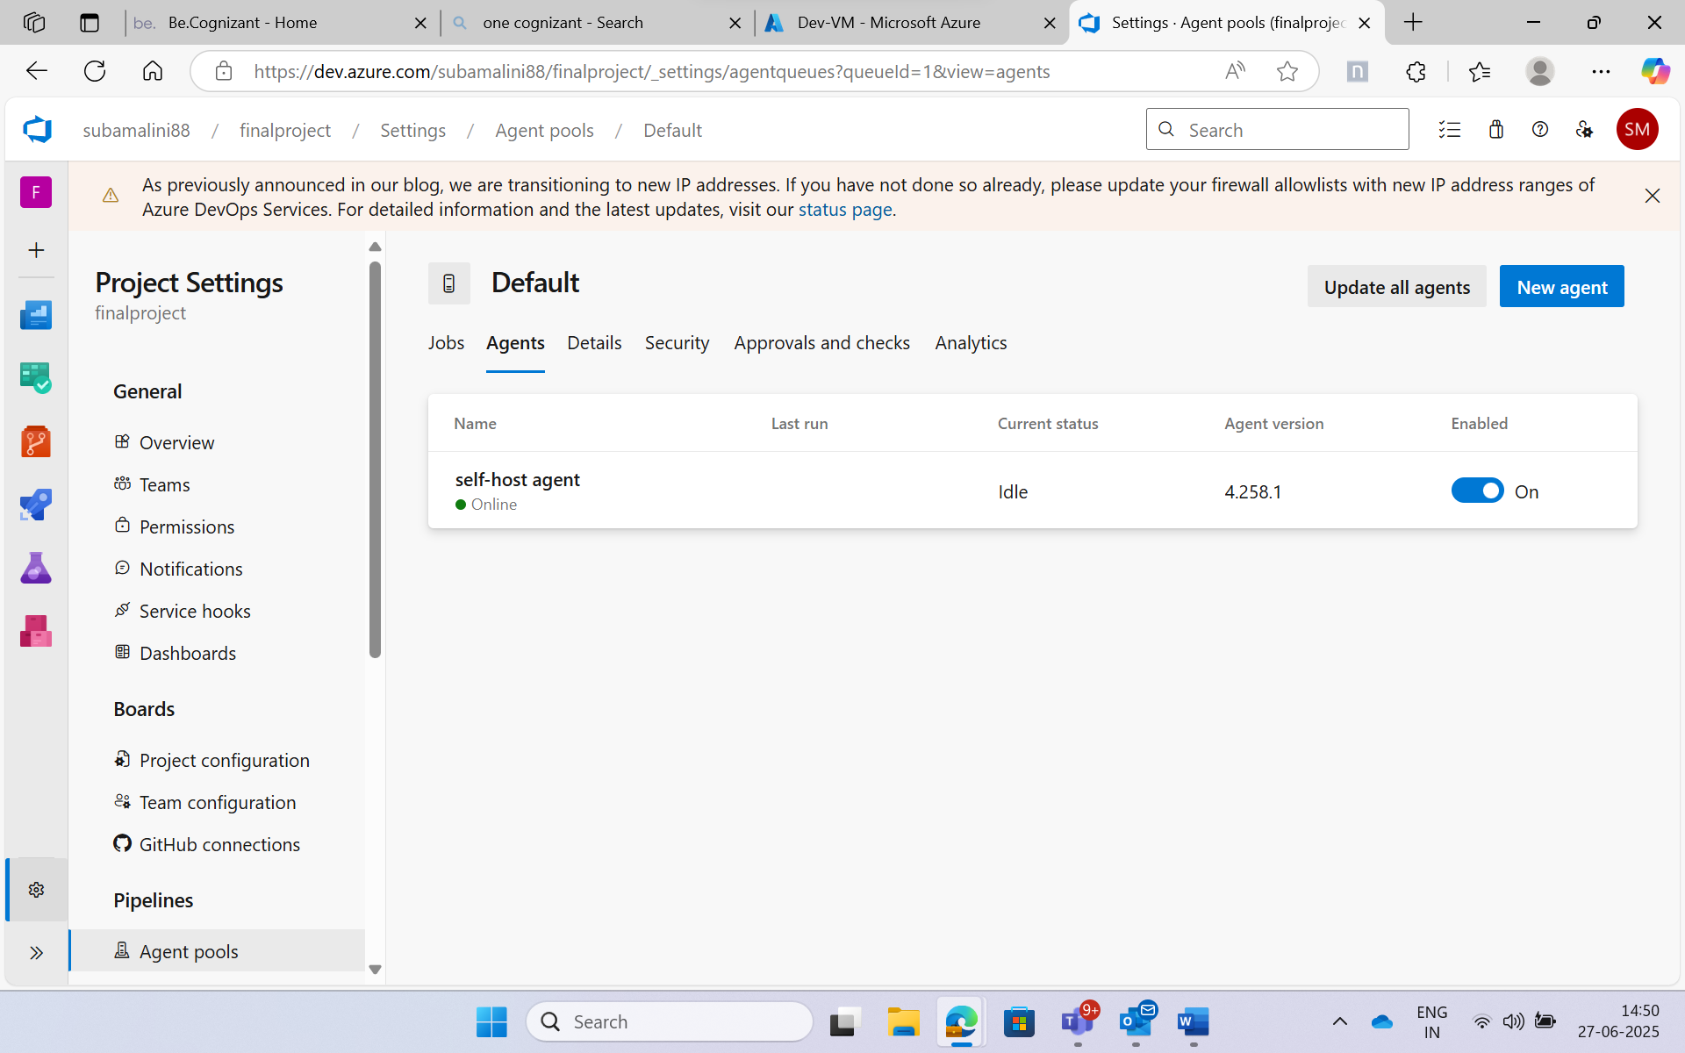

Then we need to commit our “index.html” and “Dockerfile” to the repository: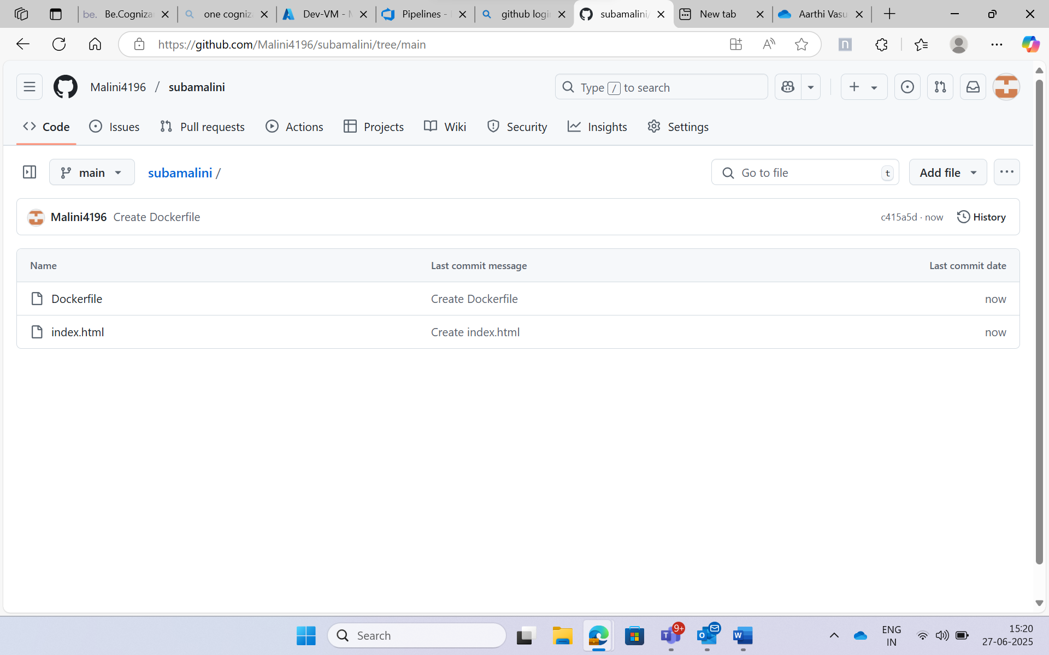

Then we need to clone the repository:

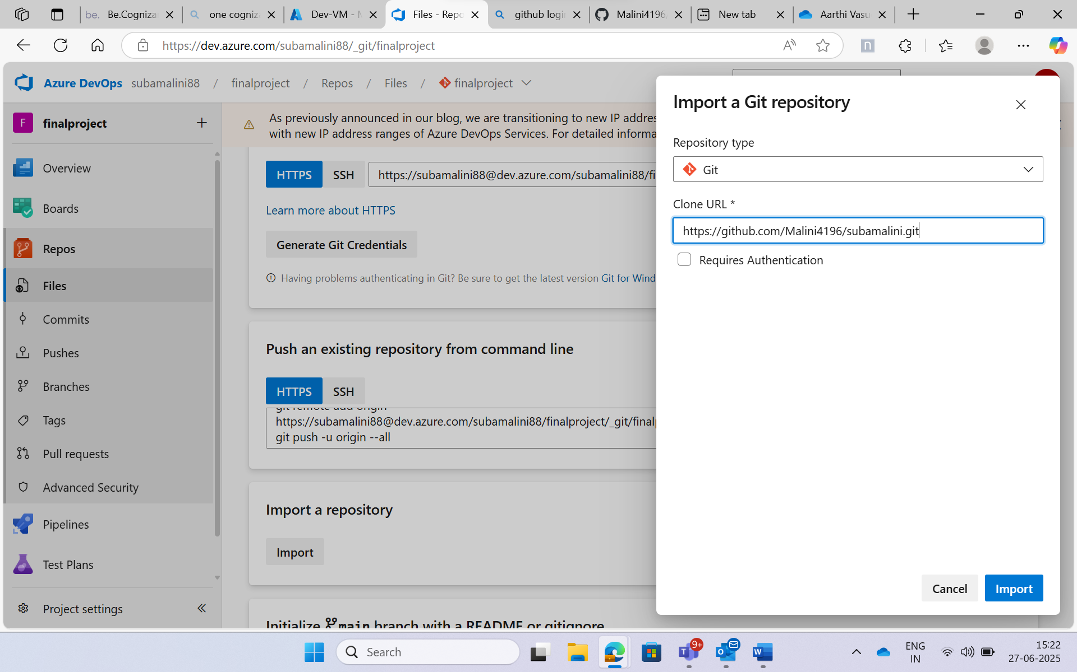

Now the files are cloned successfully:

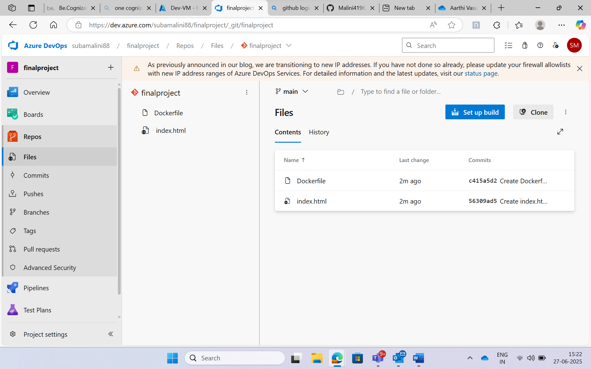

Created a pipeline using classic editor to automate the build, test, and deployment process of applications, enabling continuous integration and delivery (CI/CD) in Azure DevOps:

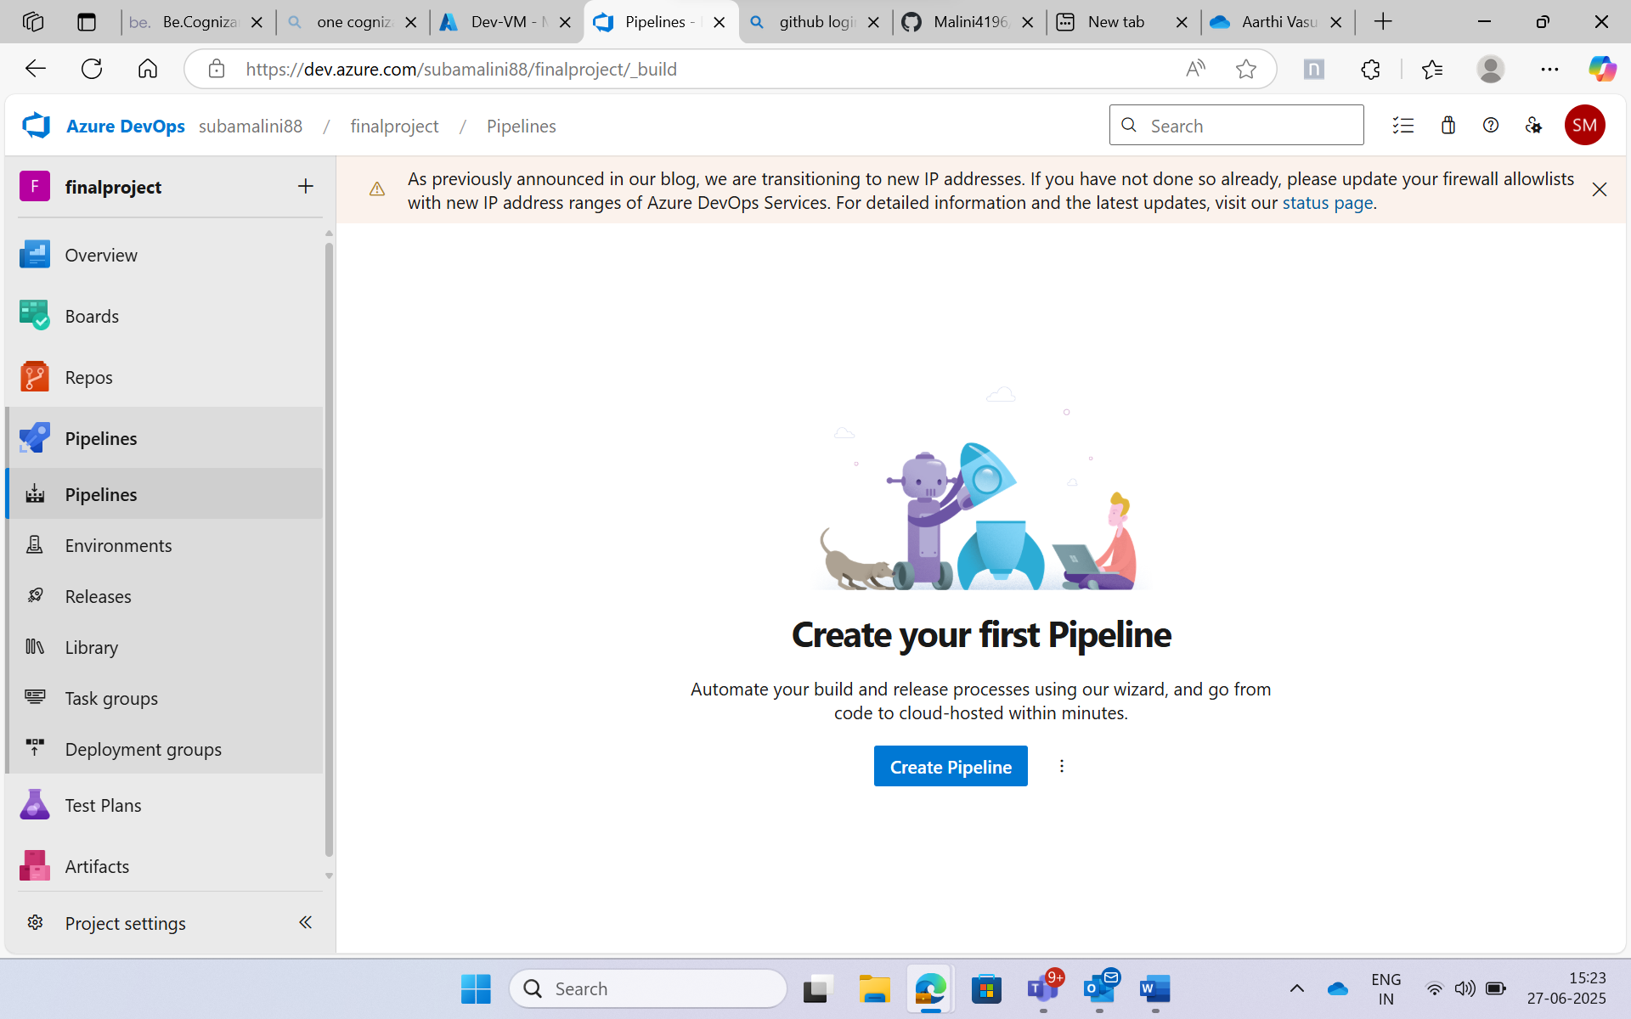

Select the classic editor:

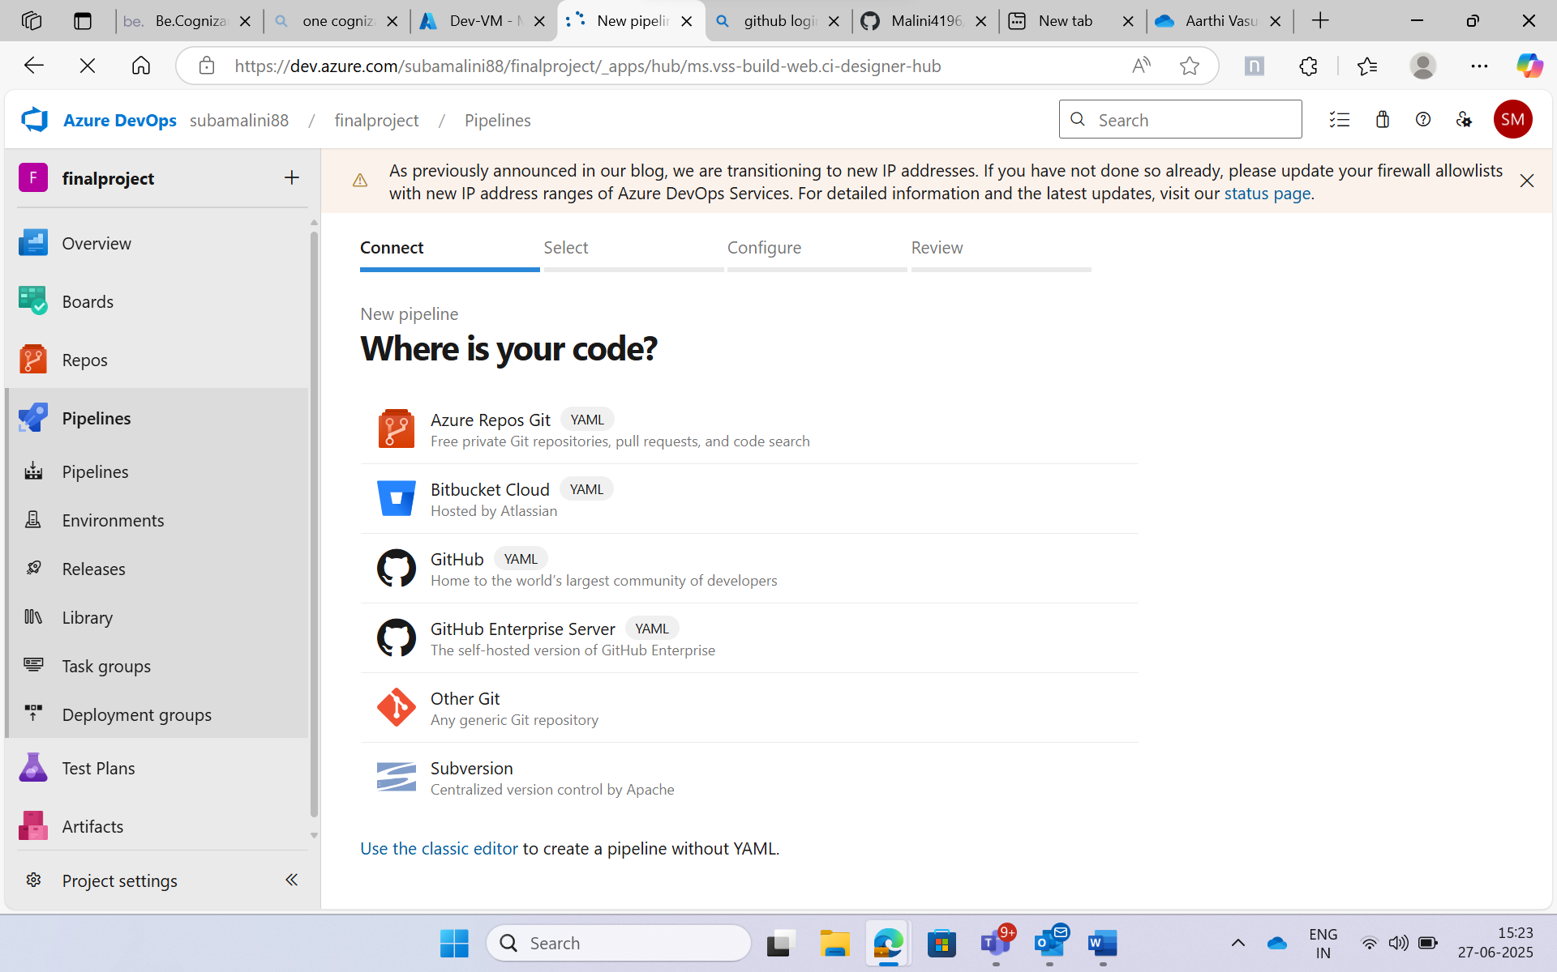

Select the source as Azure Repos Git:

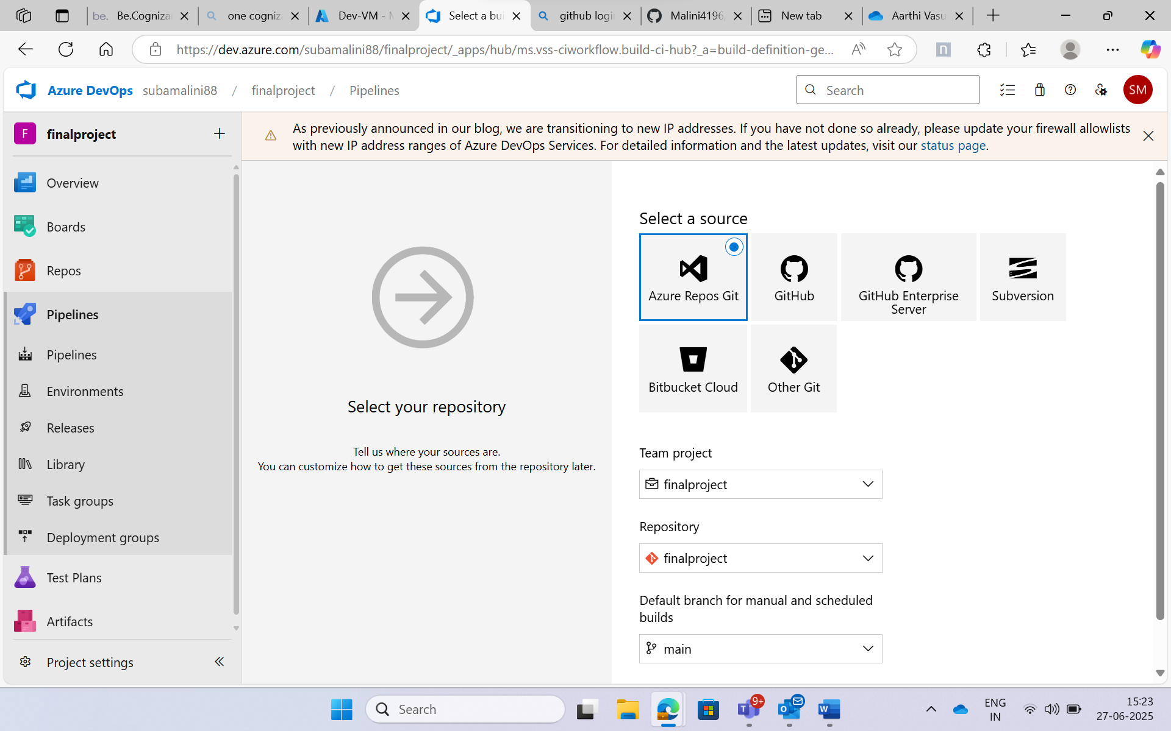

Go with the empty job:

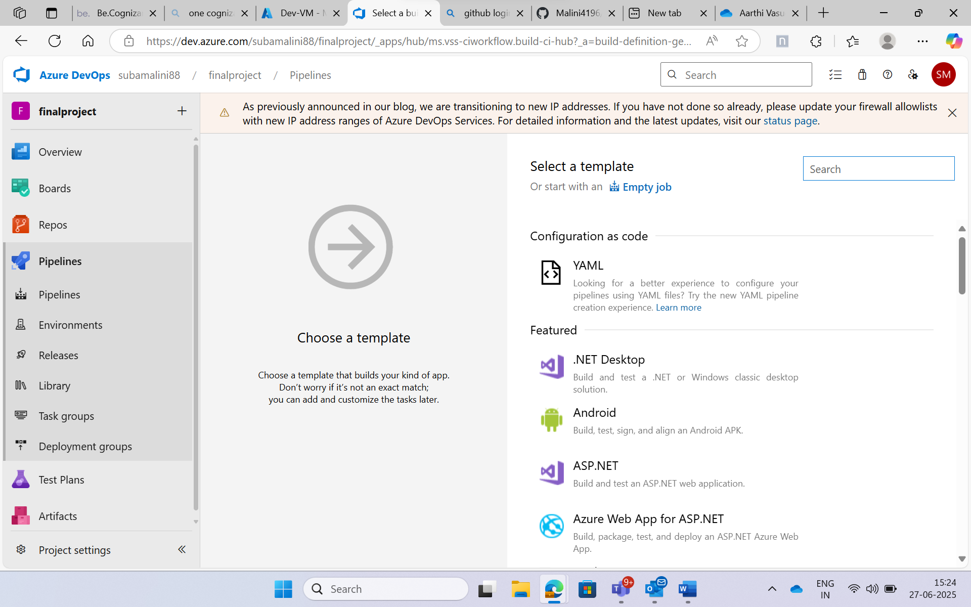

Set the Agent pool as Default since we are using classic editor.

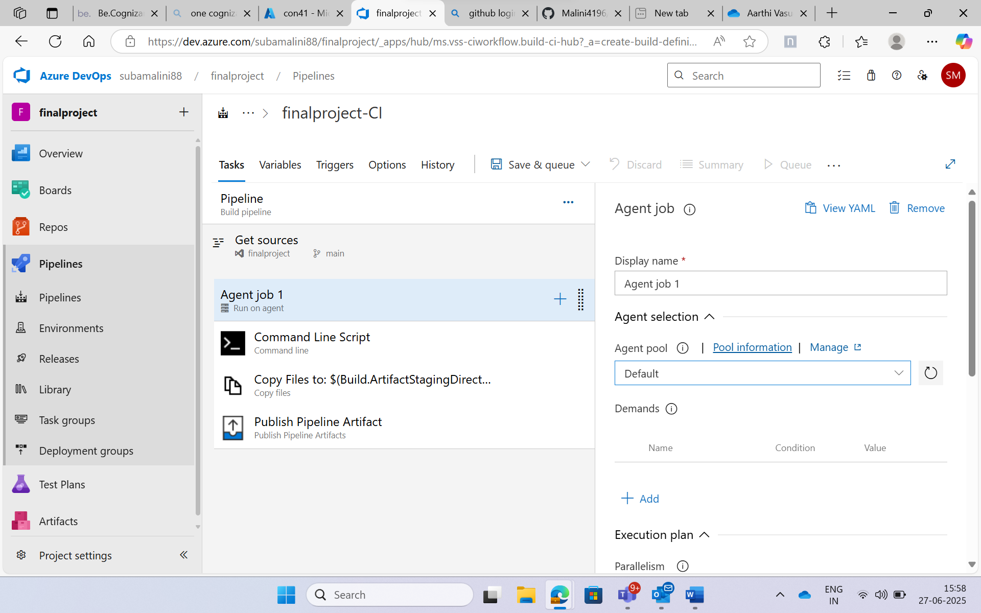

Added Command line, Copy files, Publish pipeline artifact to Agent jobs.

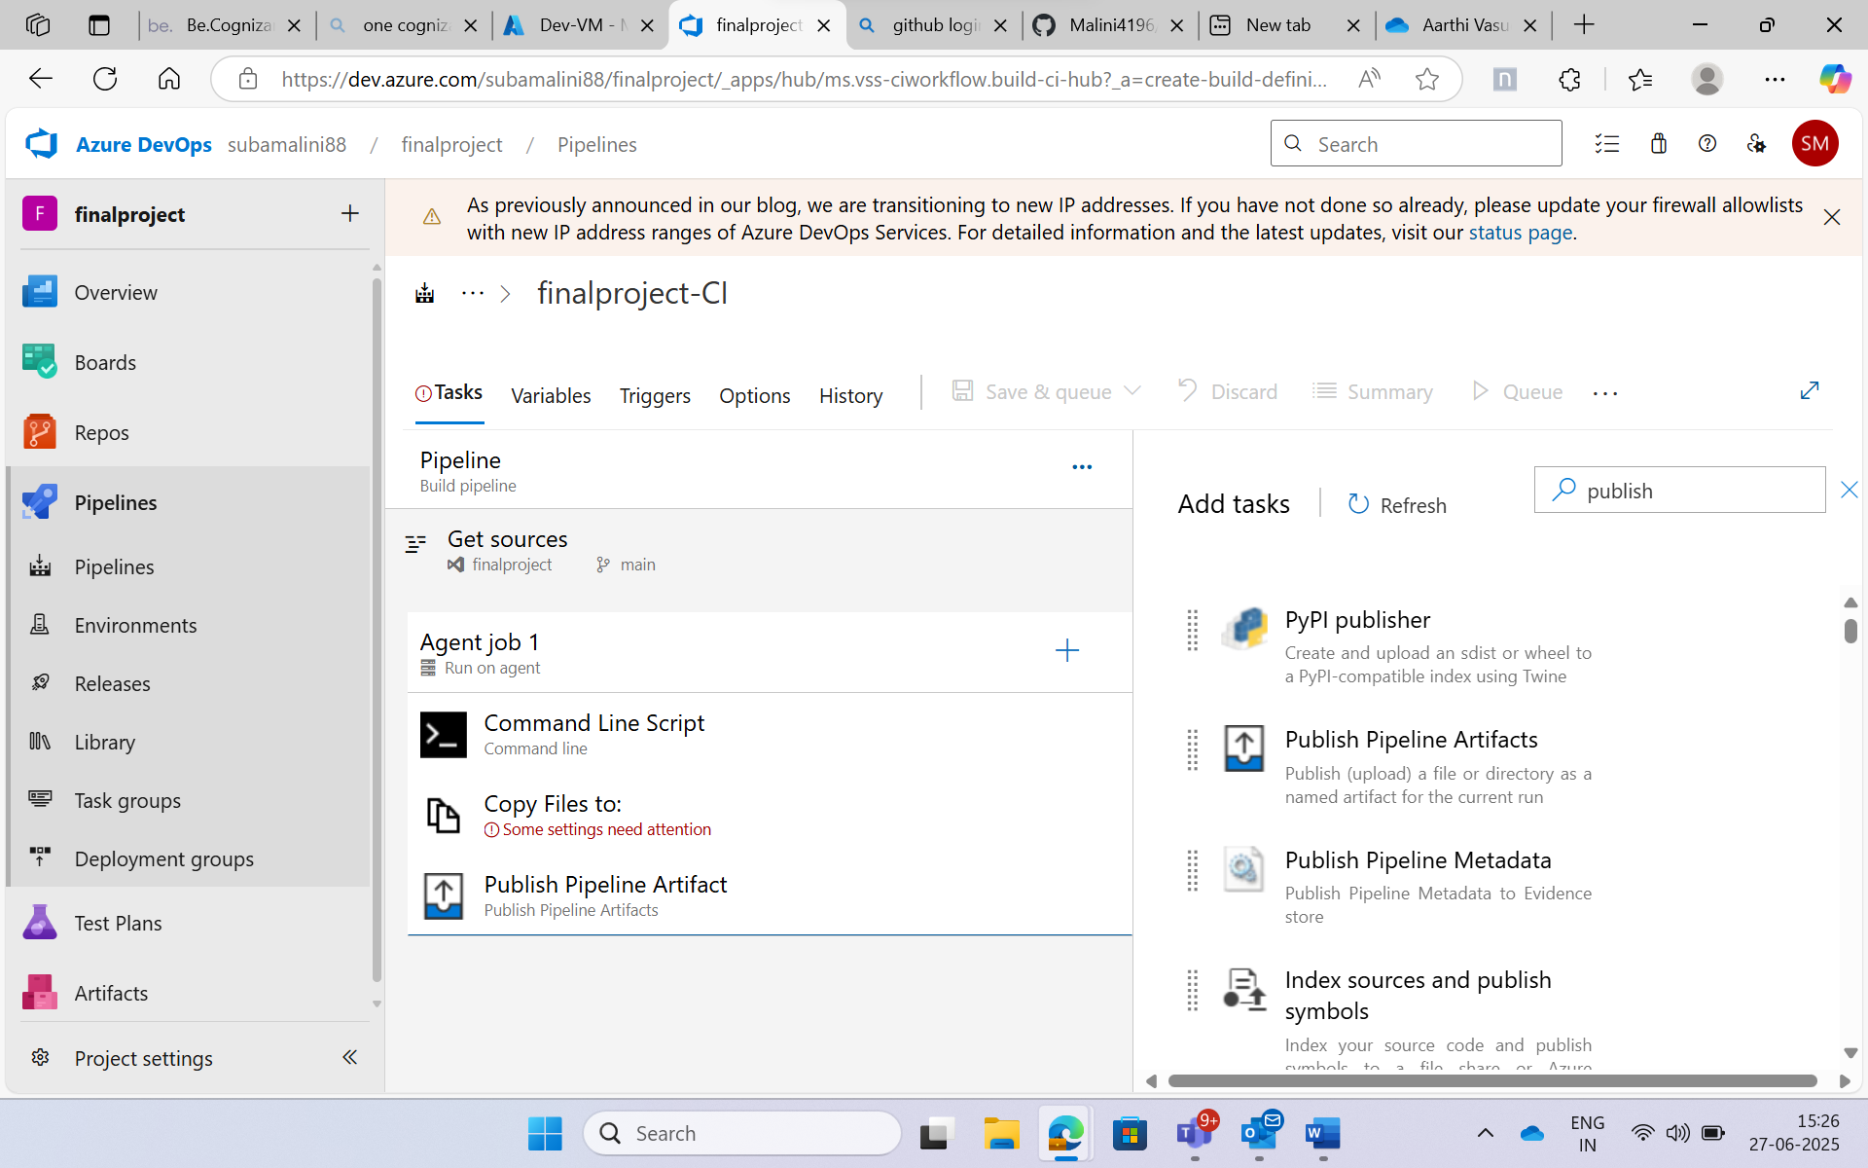

Using command line script build the dockerfile. Log into ACR using az. Push the docker image into ACR.

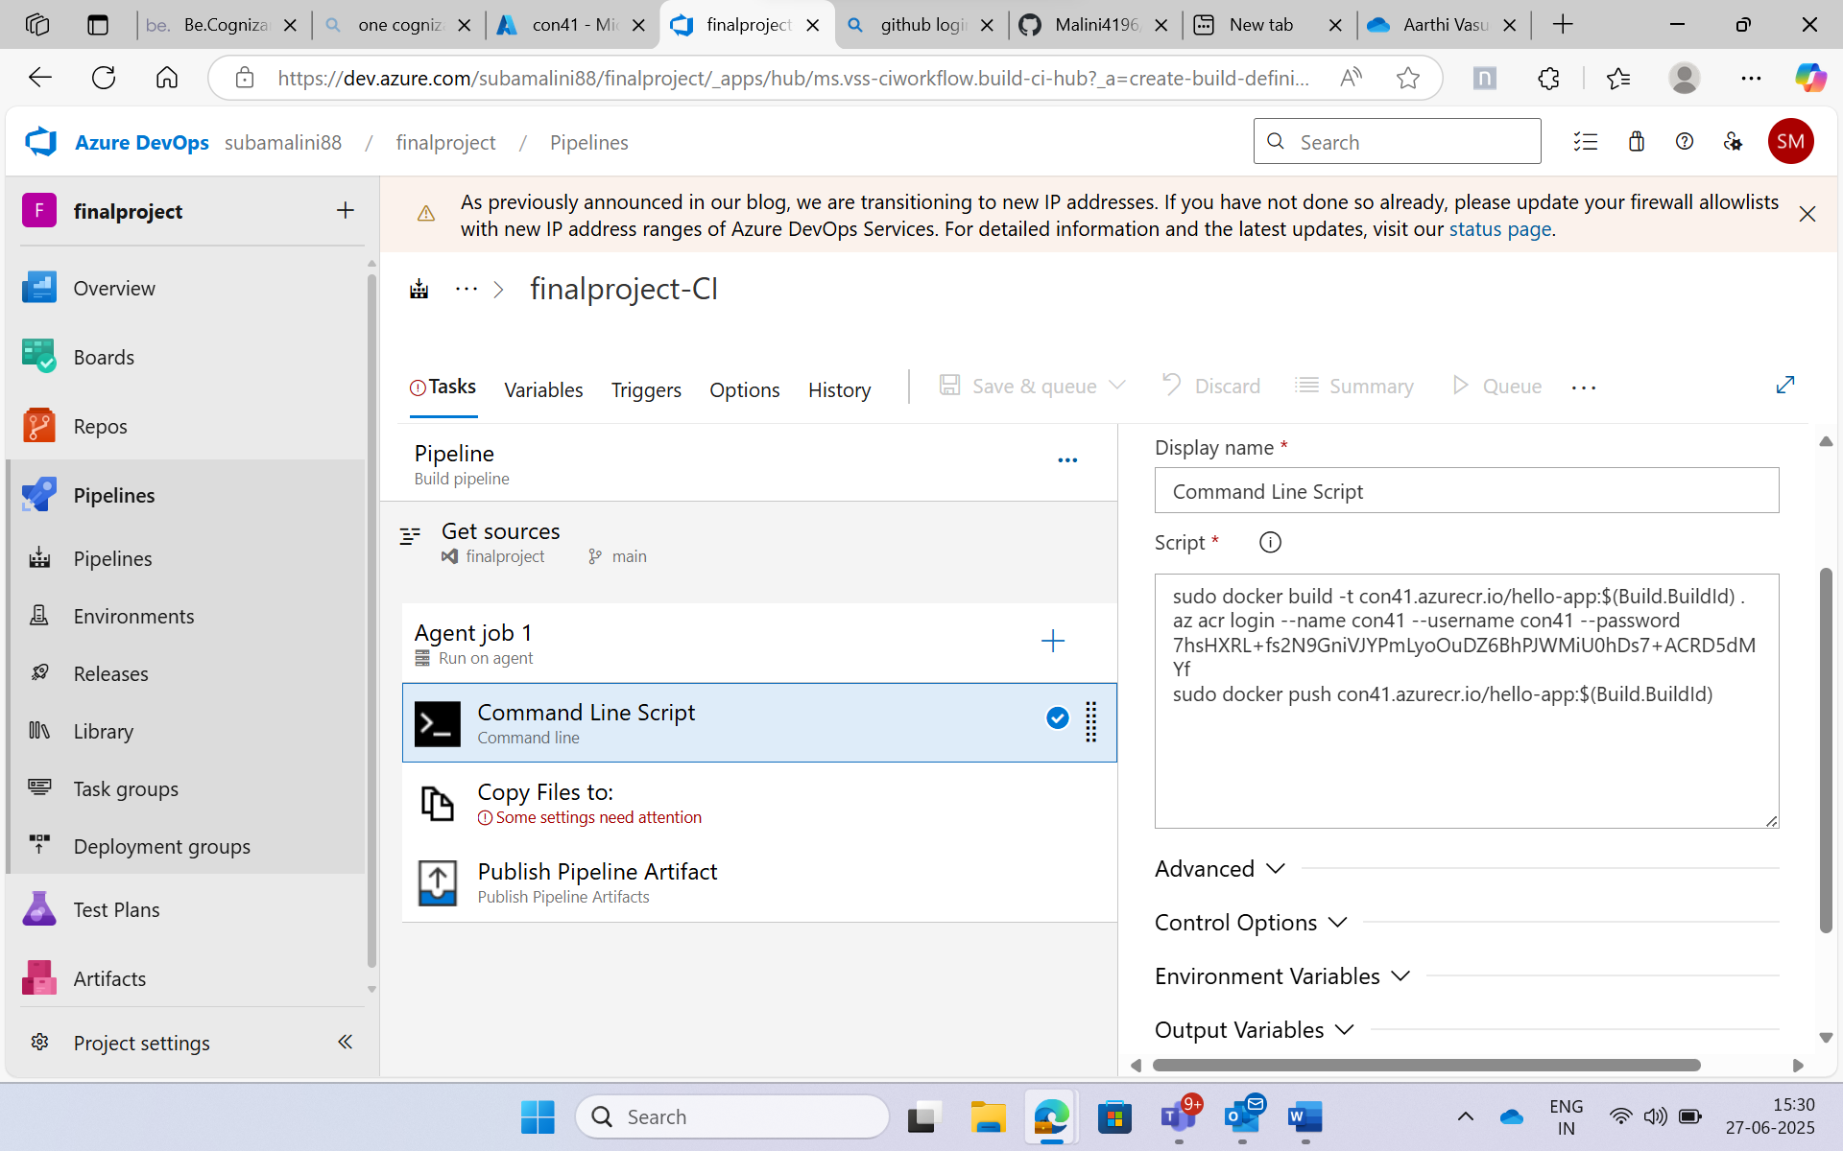

Copy files to Build.ArtifactStagingDirectory and target folder as Build.ArtifactStagingDirectory.

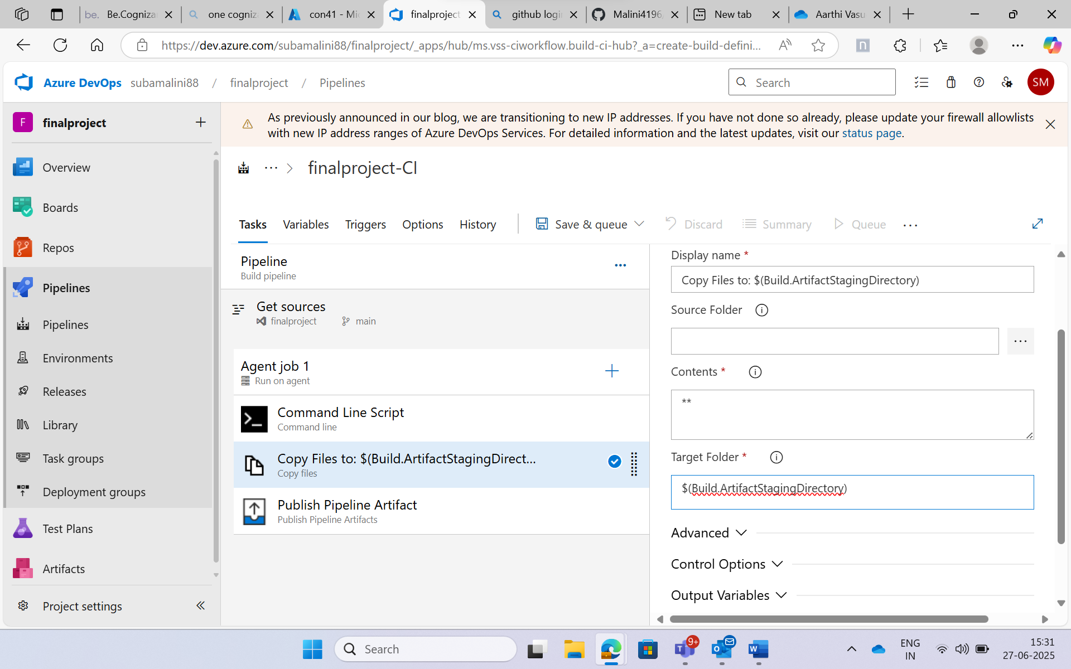

Add file or directory path as Build.ArtifactStagingDirectory

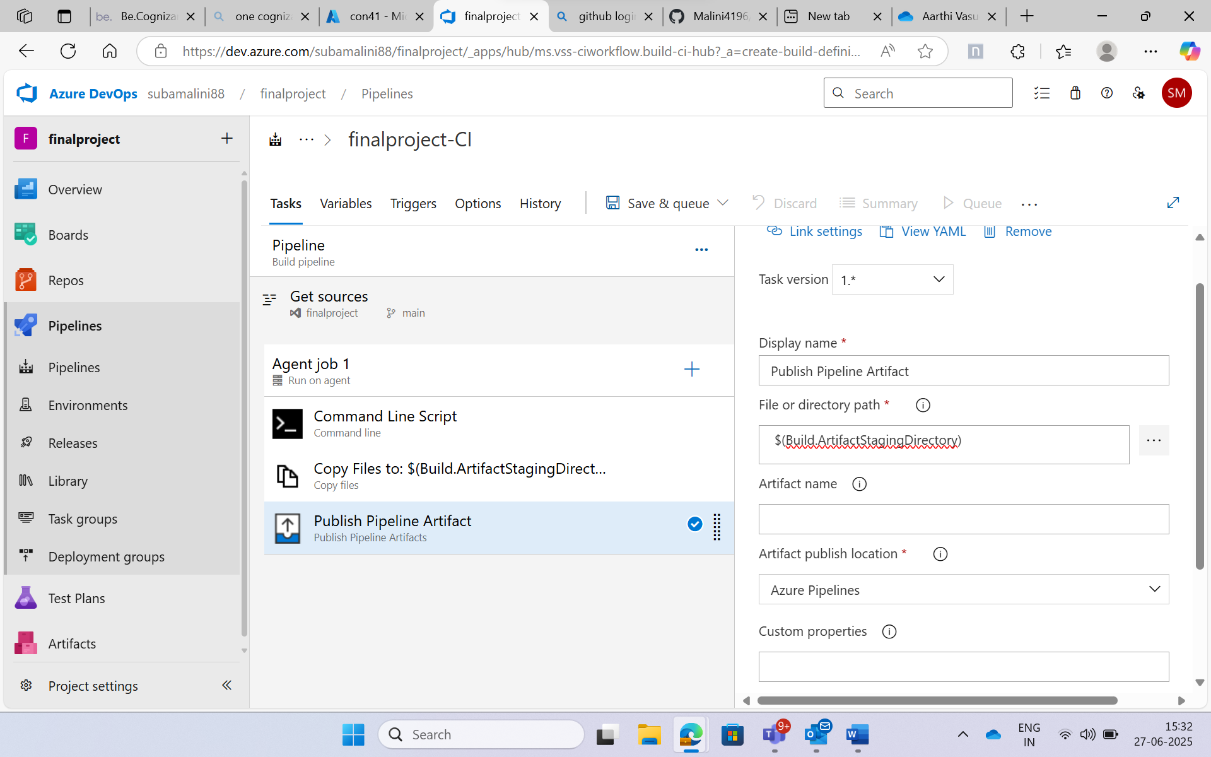

Save and Run the pipeline.

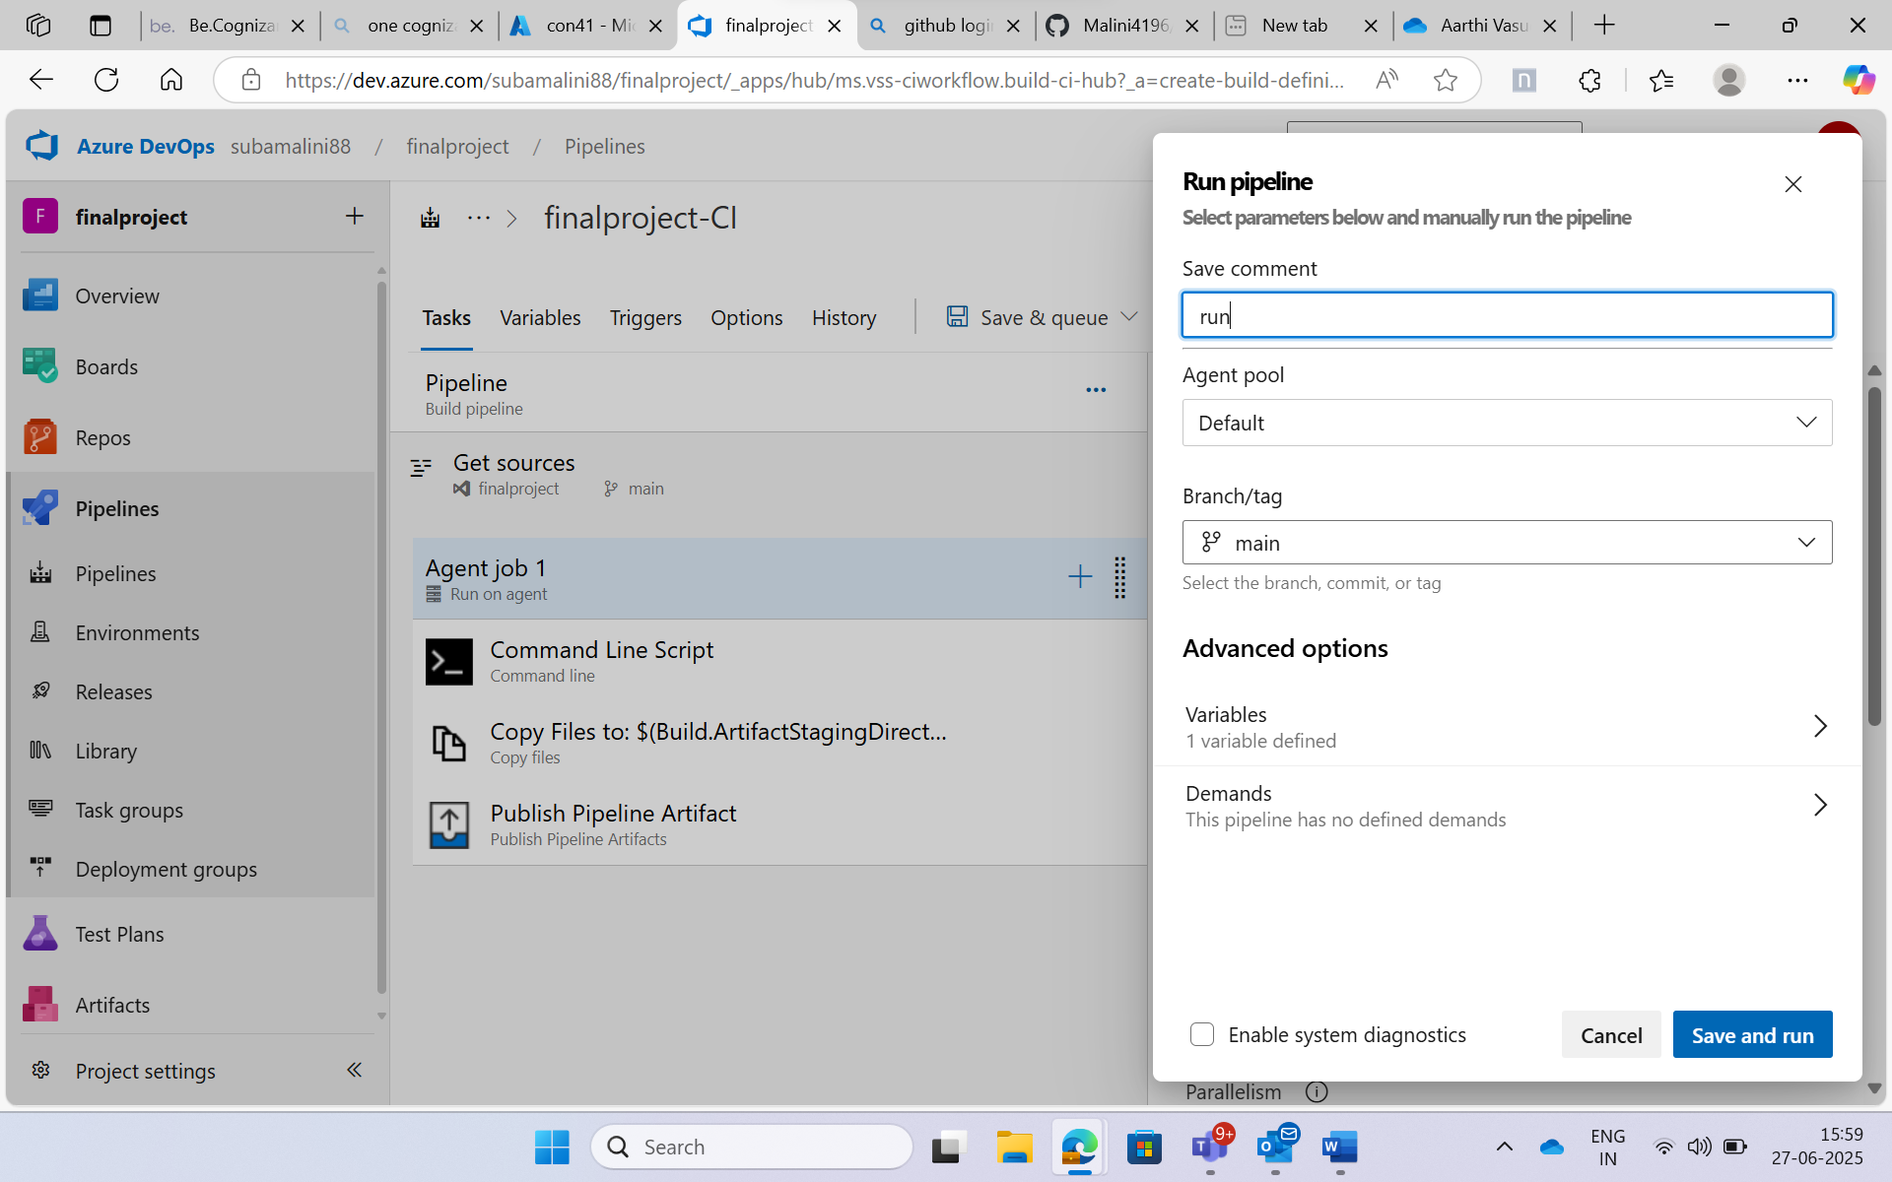

The pipeline has been created successfully.

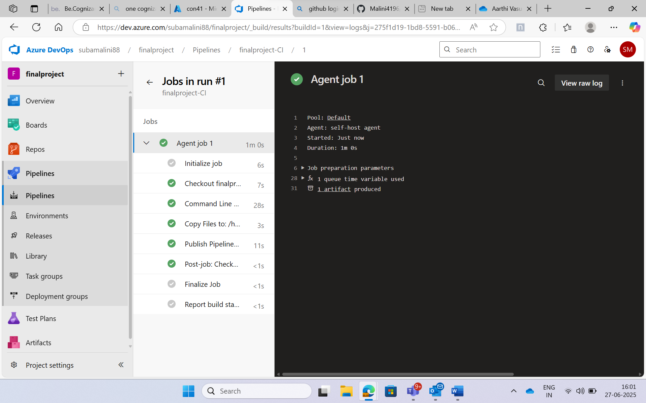

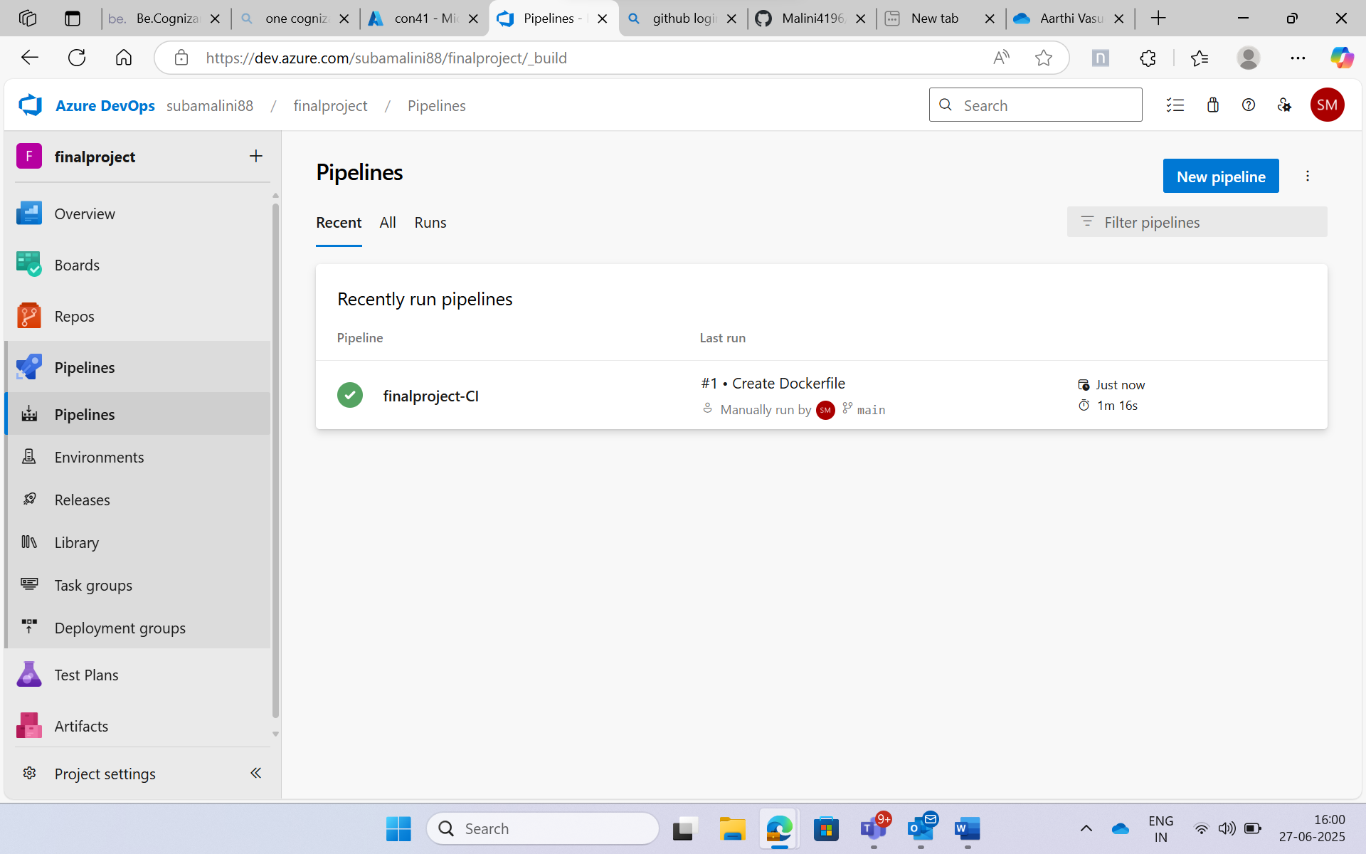

**Continuous Deployment(CD) : Release pipeline**

Created a release pipeline to automate the deployment of application builds to various environments, ensuring consistent and controlled releases with approval workflows and rollback options

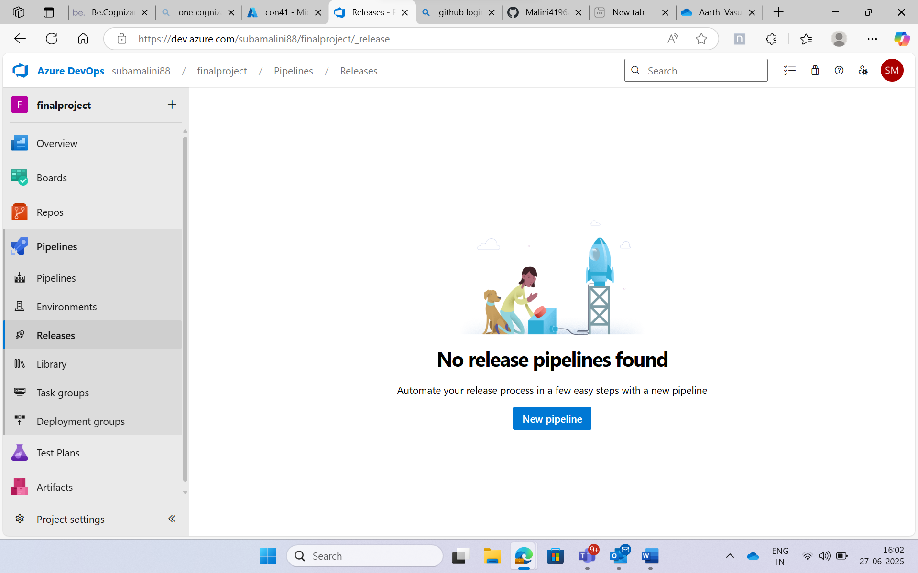

In artifact select the source as finalproject-CI

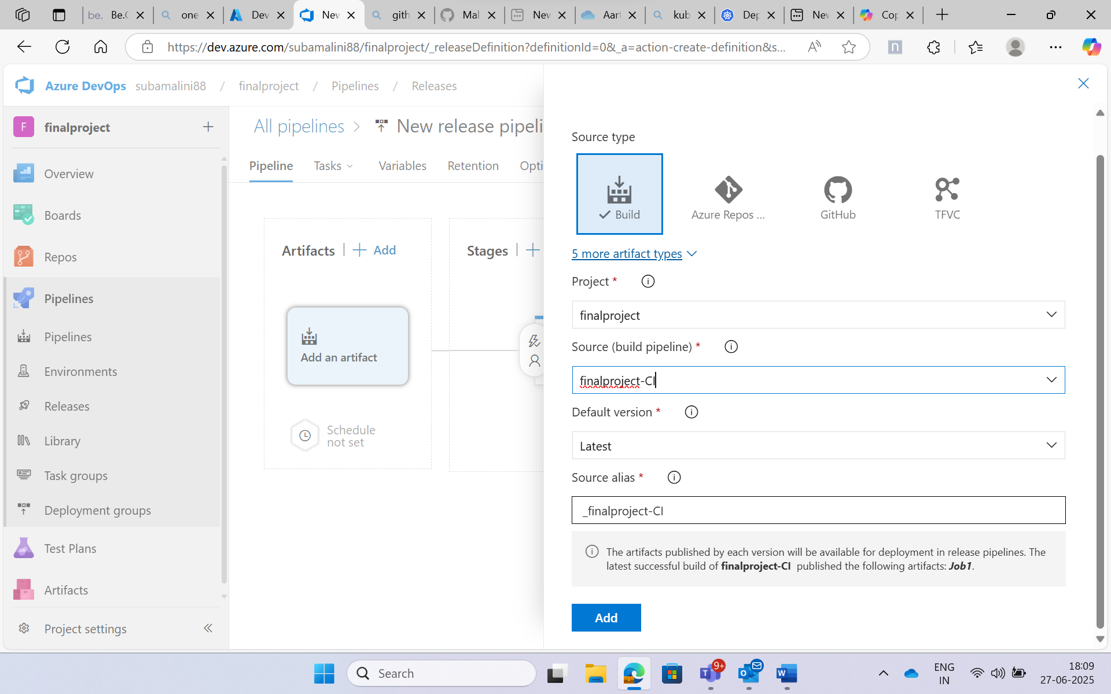

Select the stage owner name in Stage 1

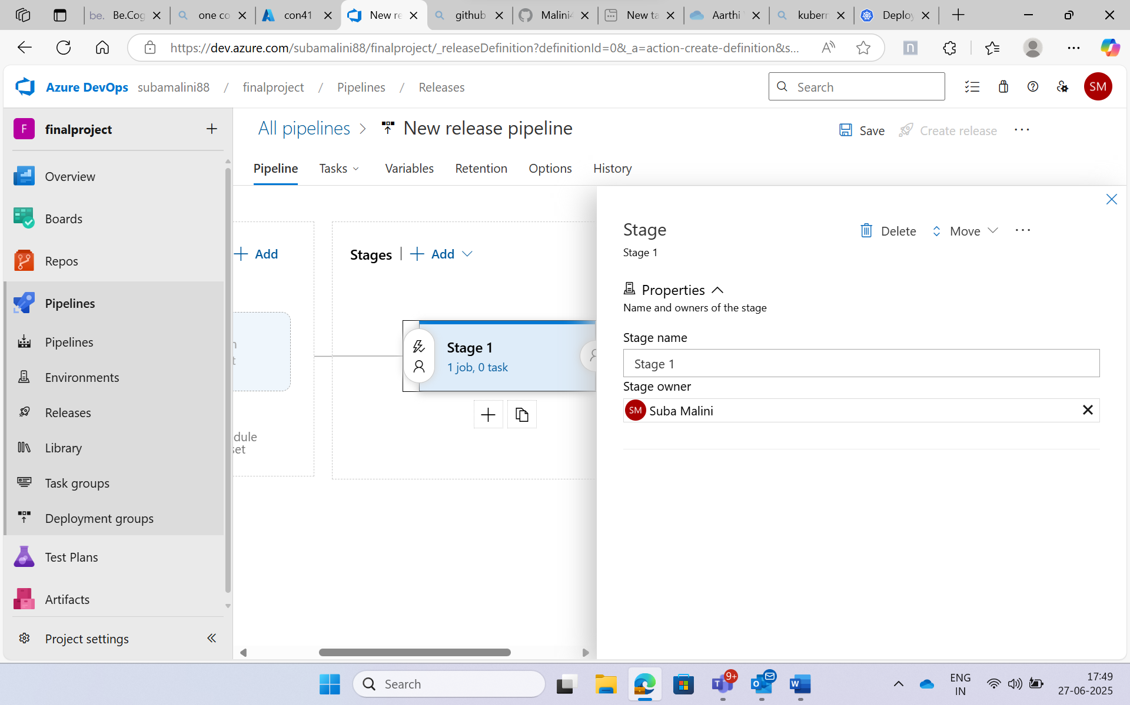

Enable continuous deployment trigger:

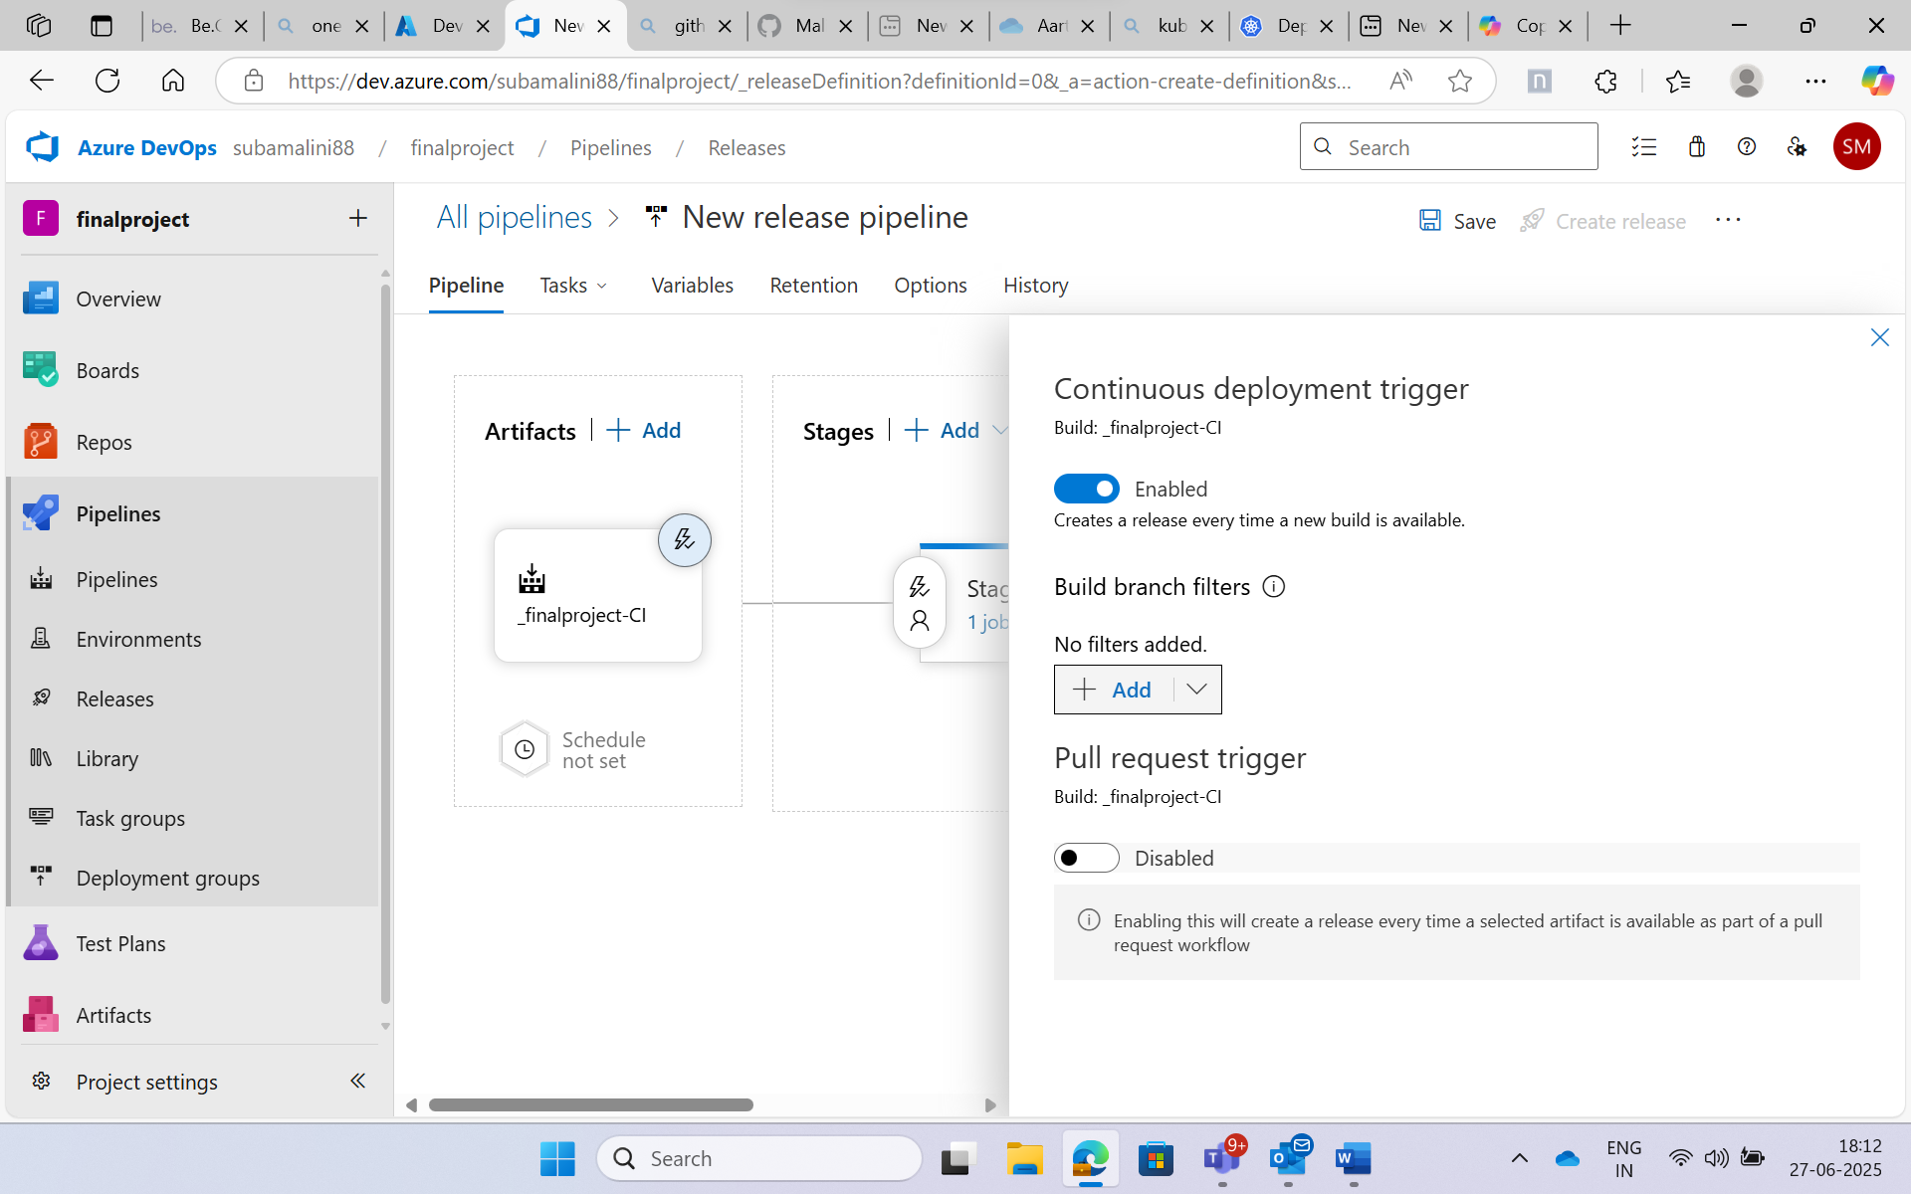

Added a manifest folder and in that add deployment.yaml and service.yaml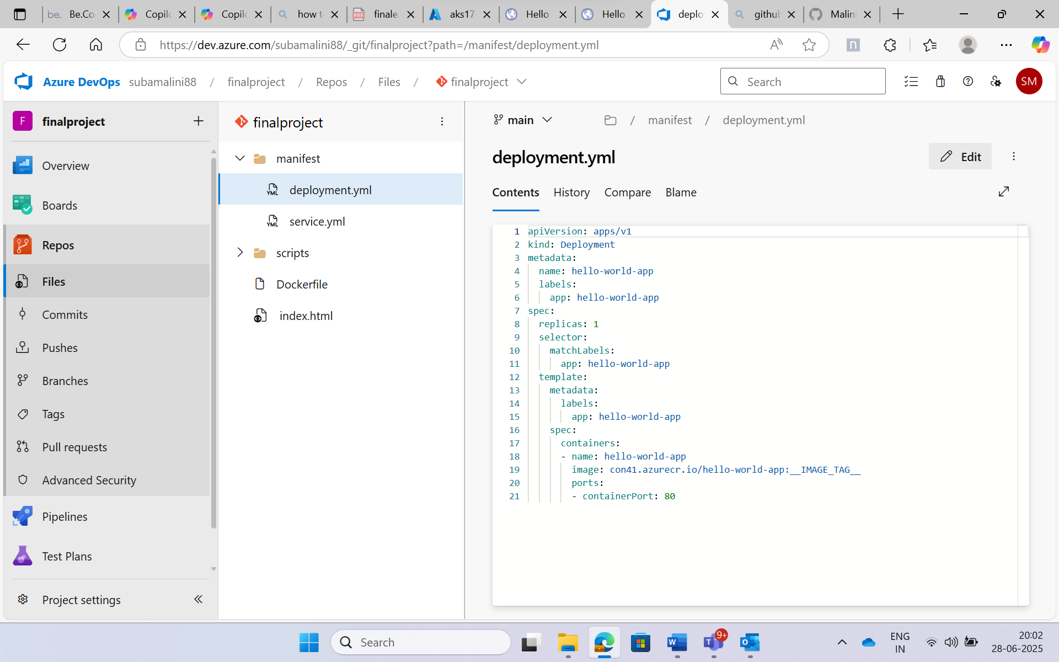

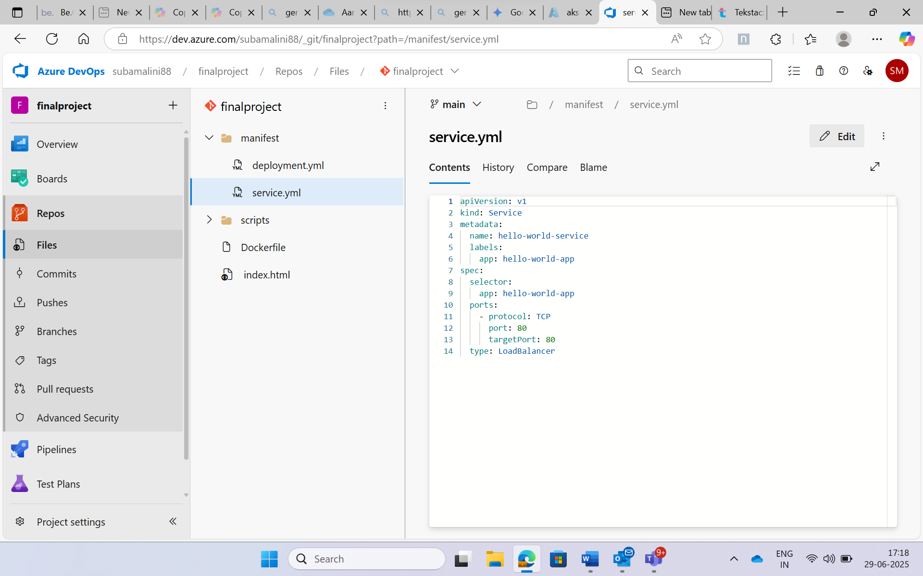

**Powershell:**

Created a folder “scripts” added a file “health-check.ps1”

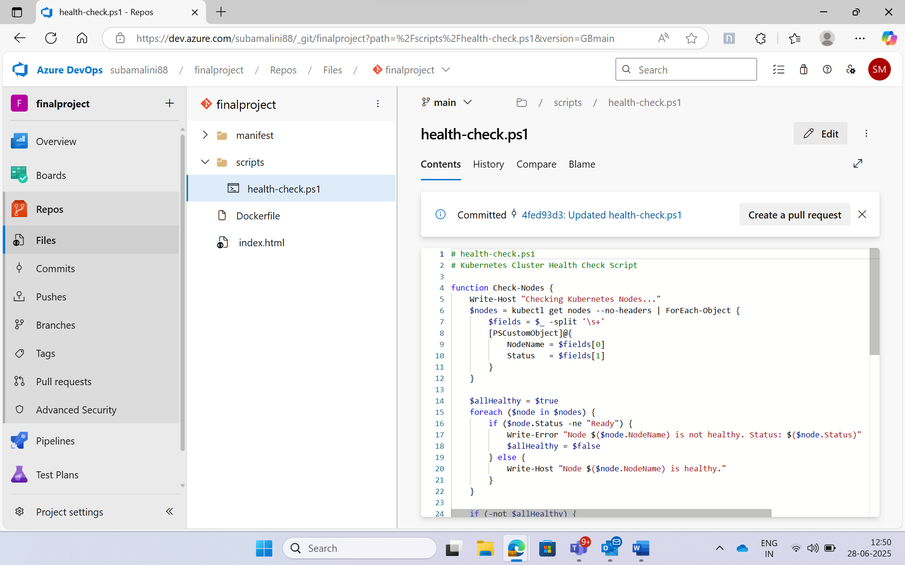

Select the Agent pool to Default in Agent job

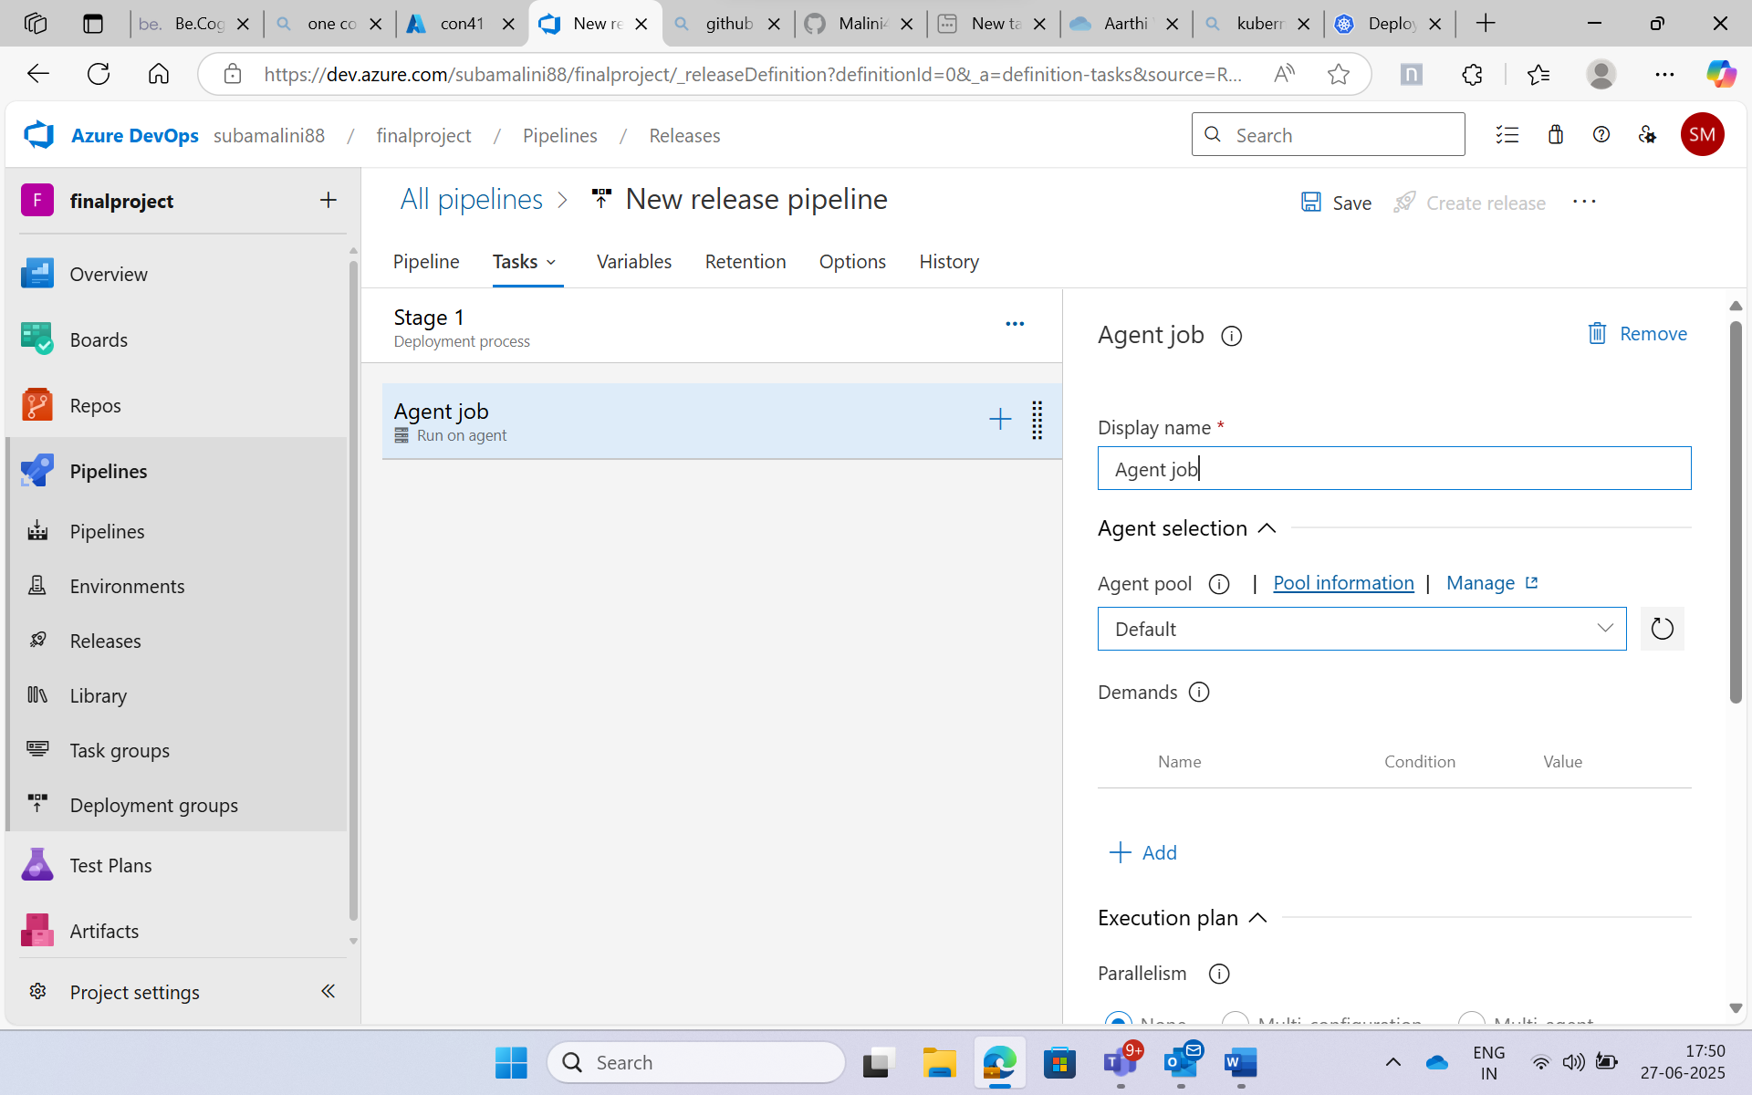

Replace Tokens is a task that searches for placeholder tokens in your files and replaces them with actual values from variable group:

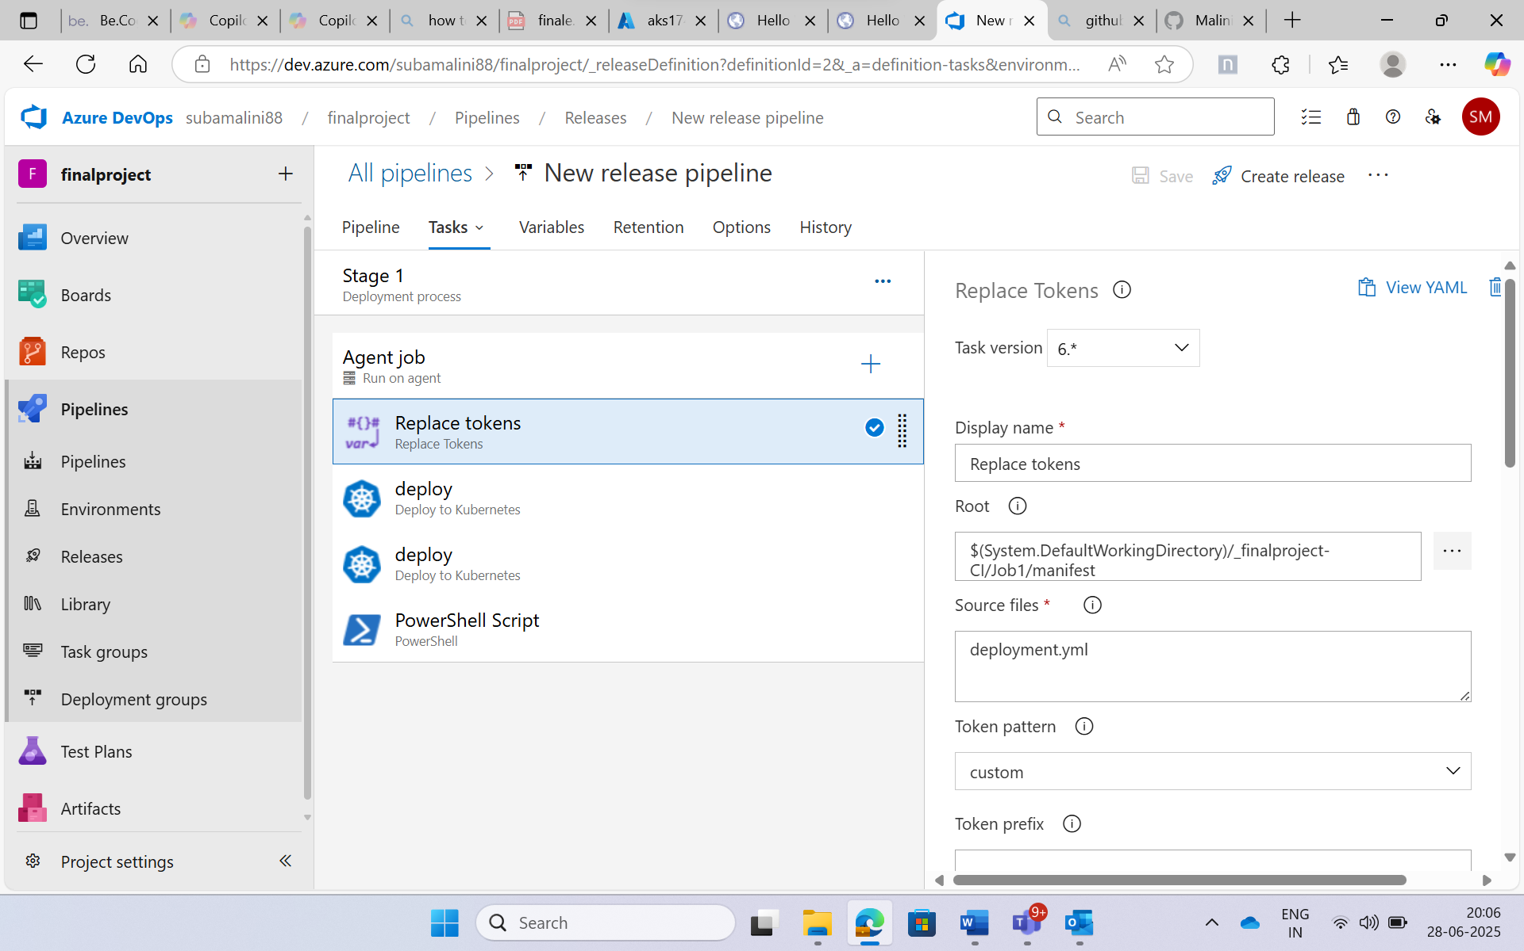

Set the variable in the deployment.yml file:

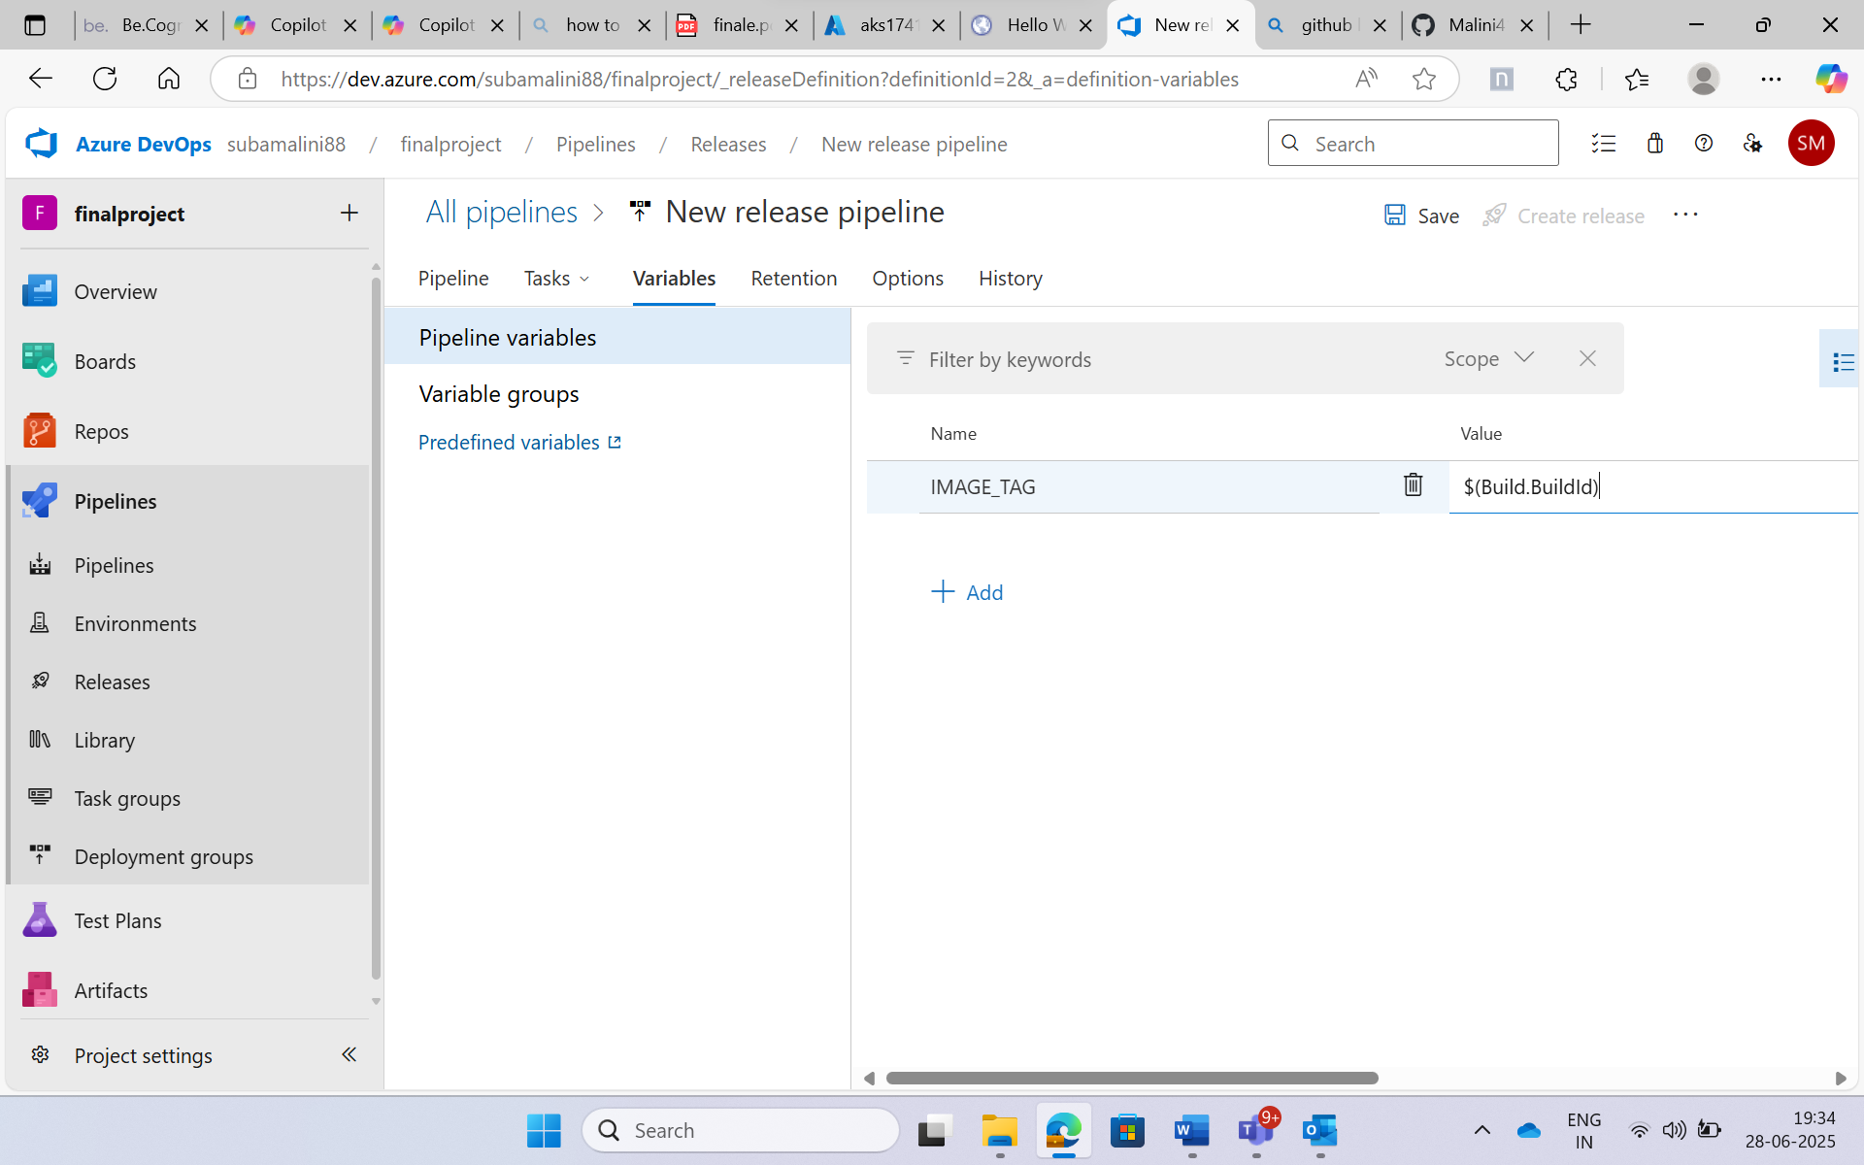

In Agent job add Kubernetes deploy for deployment and service. Select the cluster as Dev-AKS and namespace as default for service connection.

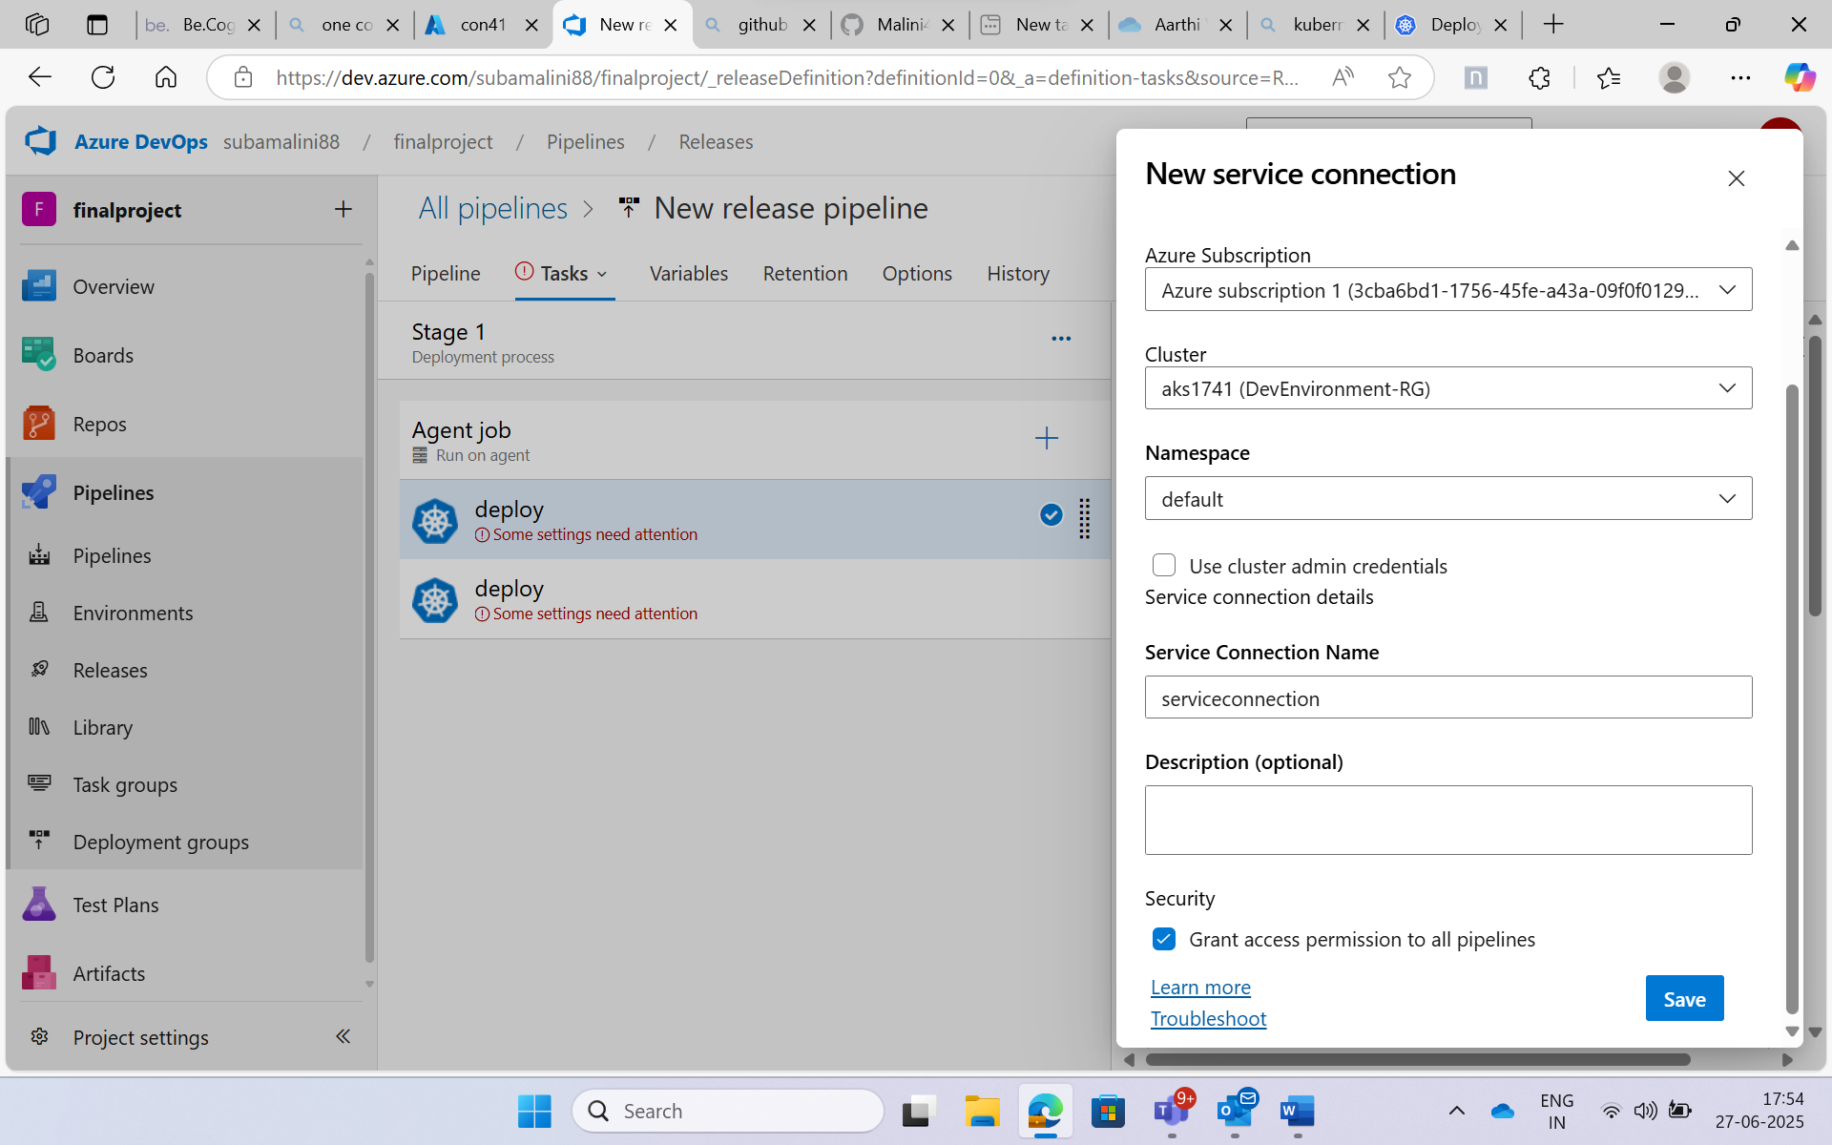

In first deploy add deployment.yaml directory and in second deploy add service.yaml directory

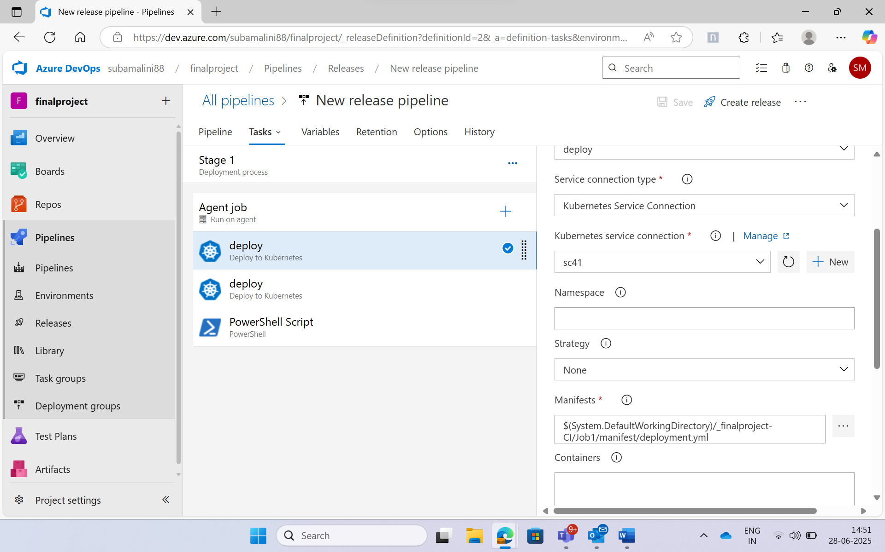

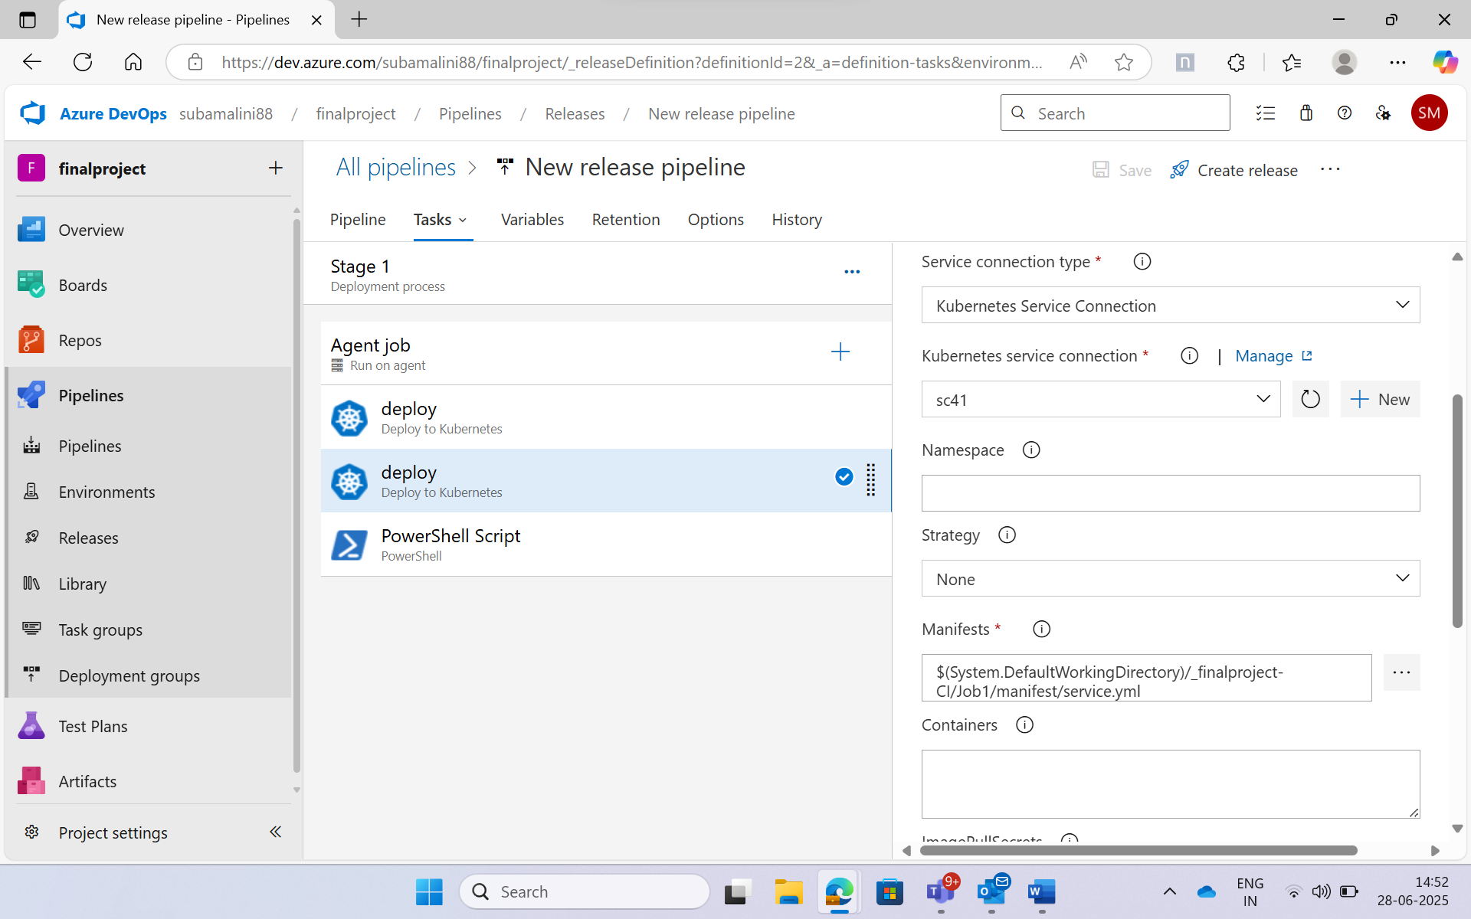

Added Powershell script at agent job and give the script path for health-check.ps1

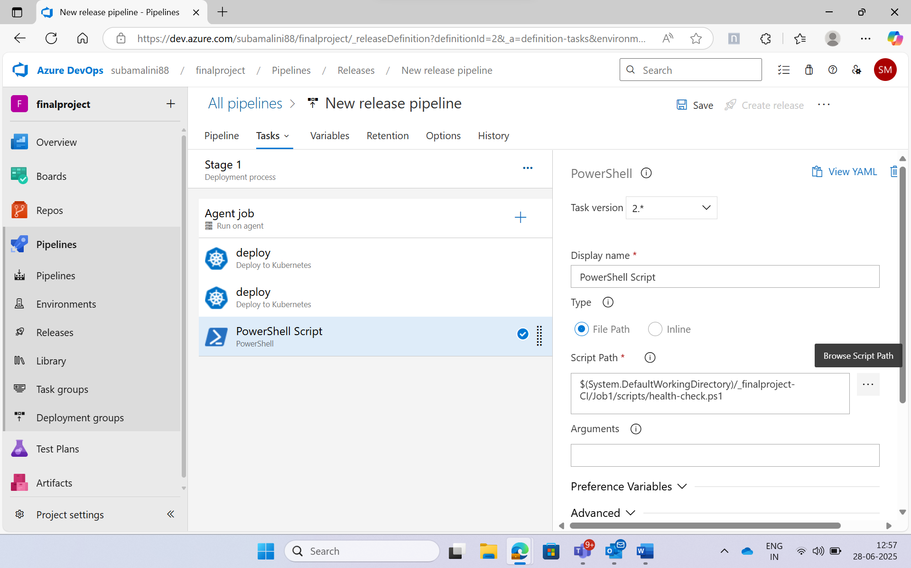

Created a new release and the release is successful:

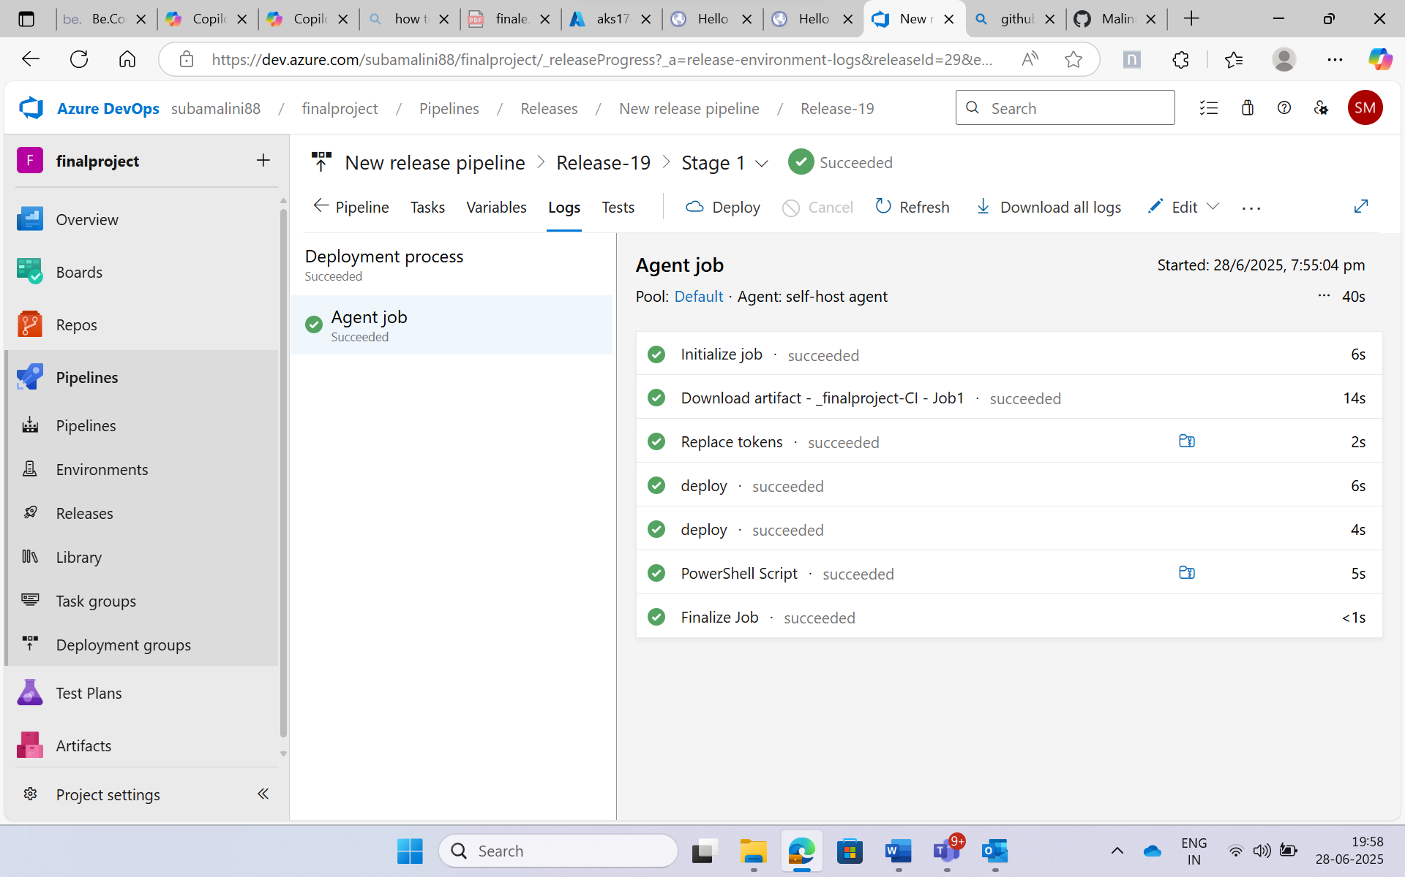

Because we got exit status as 0 it got deployed successfully

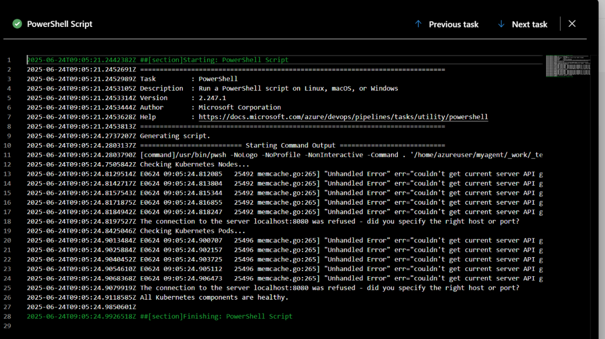

Health of the pods and nodes are healthy in Azure portal:



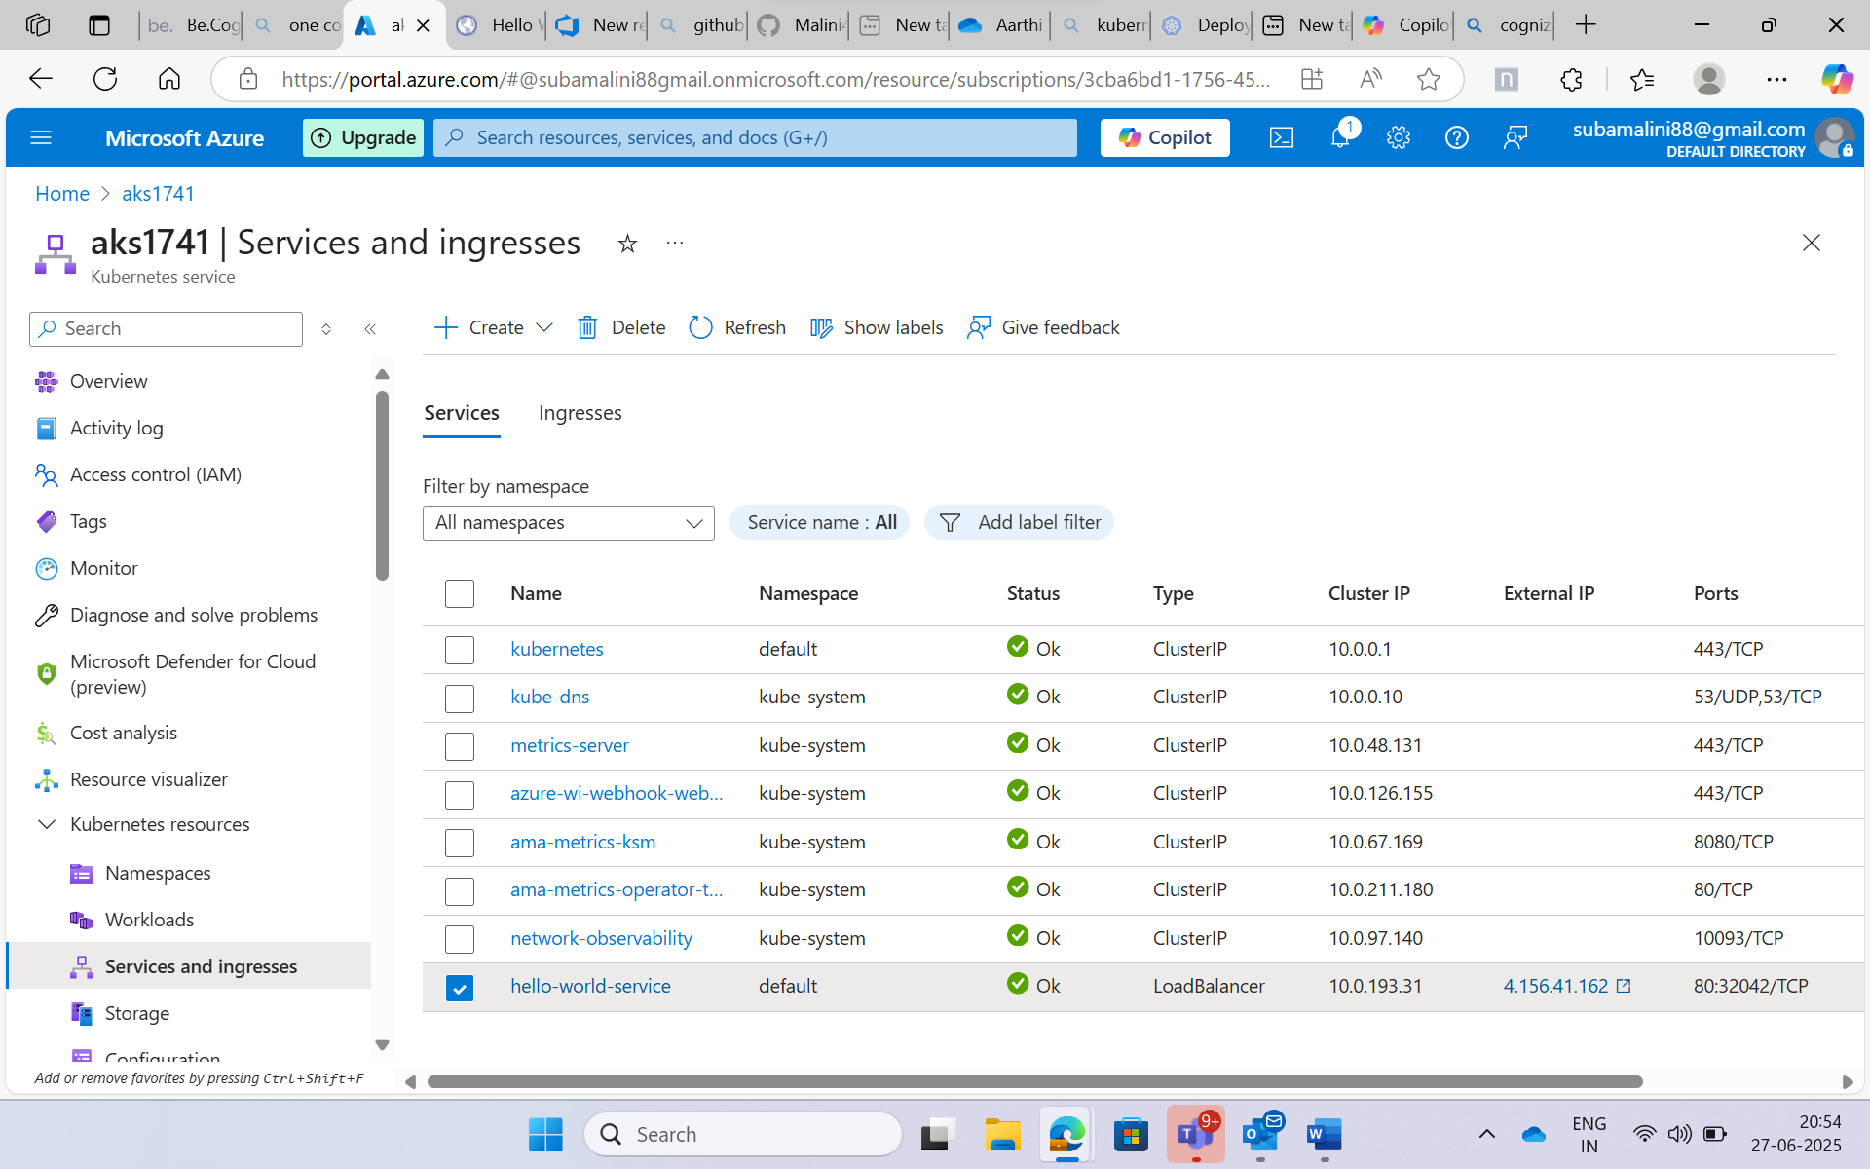

The page gets executed

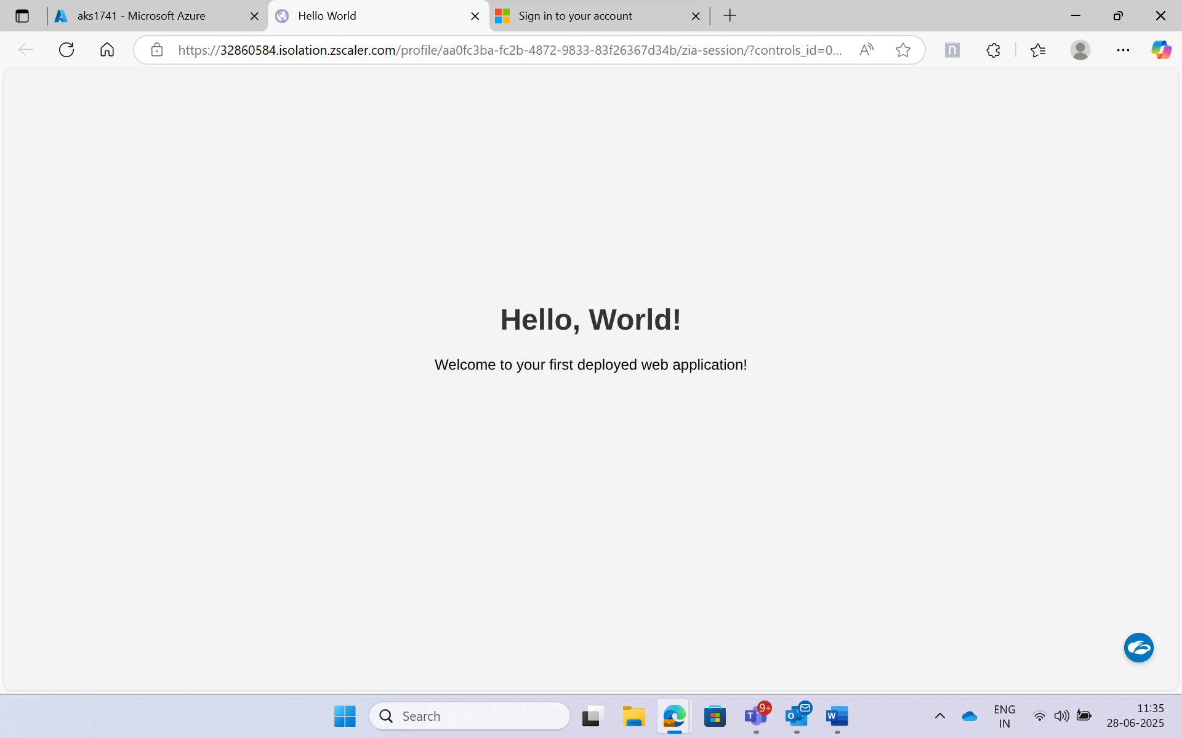

By making changes in the index.html:

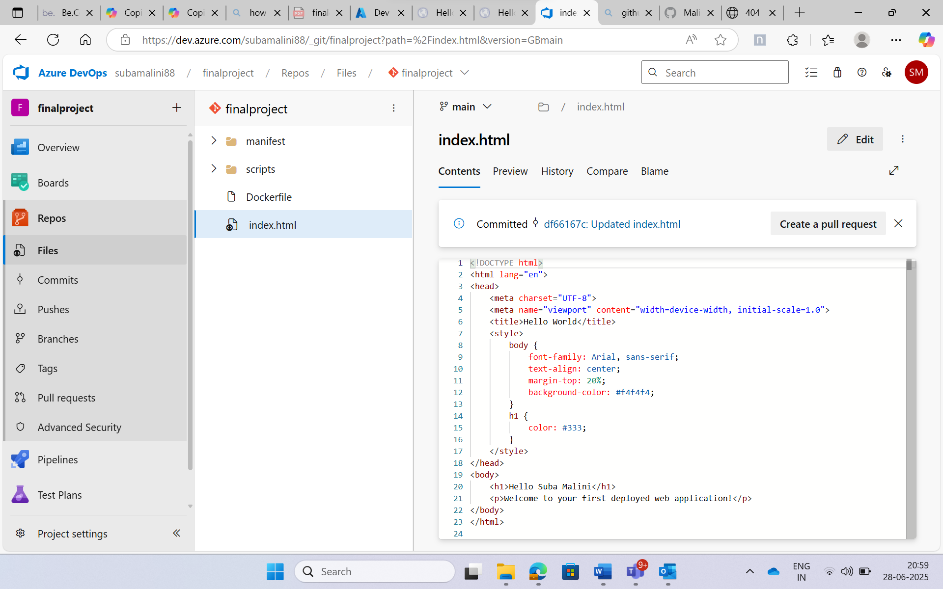

We can visualise the changes now:

